Table of Contents

UNITED STATES
SECURITIES AND EXCHANGE COMMISSION
Washington, D.C. 20549
SCHEDULE 14A
(Rule
14a-101)
INFORMATION REQUIRED IN PROXY STATEMENT
SCHEDULE 14A INFORMATION
Proxy Statement Pursuant To Section 14(a) of the
Securities Exchange Act of 1934
Filed by the Registrant ☒ Filed by a Party other than the Registrant ☐
Check the appropriate box:

☐ |  | Preliminary Proxy Statement
☐ |  | Confidential, for Use of the Commission Only (as permitted by Rule  14a-6(e)(2))
☒ |  | Definitive Proxy Statement
☐ |  | Definitive Additional Materials
☐ |  | Soliciting Material Pursuant to  §240.14a-12
 |  | Installed Building Products, Inc.
 |  | (Name of Registrant as Specified In Its Charter)
 |  | (Name of Person(s) Filing Proxy Statement, if other than the Registrant)
Payment of Filing Fee (Check all boxes that apply):
☒ |  | No fee required.
☐ |  | Fee paid previously with preliminary materials.
☐ |  | Fee computed on table in exhibit required by Item 25(b) per Exchange Act Rules 14a-6(i)(1) and 0-11.

Table of Contents


Table of Contents


Table of Contents
Message from Our Chairman and Our Presiding
Independent Director

  Jeffrey W. Edwards  Chairman of the Board    Margot L. Carter  Presiding Independent  Director |  | Installed Building Products, Inc. (“IBP” or the “Company”) set another company record for net revenue, net income, and net income per diluted share in 2024, reinforcing our long-standing commitment to providing residential and commercial customers with high quality, efficient building product installation services. Record profitability in 2024 drove another year of strong operating cash flow. During 2024, we continued to grow the company by adding over $100 million in annual revenue through acquisitions, while distributing a combined $230 million to shareholders through dividends and share repurchases. IBP’s Board of Directors (“Board”) is encouraged by the Company’s longstanding track record, which is driven by consistent execution of our growth strategy, a focus on efficiencies, managing expenses, our disciplined approach to capital allocation, and prioritizing improvements to core functions under changing market conditions. We will continue to focus on the aspects of our business we can control and remain flexible under prevailing market conditions to realize operational and financial improvements.  IBP grew net revenue to $2.9 billion through a combination of same branch and acquisition sales growth in 2024. Growing profitably continues to be a priority at IBP. Through earnings contributed from acquisitions, including nine businesses acquired in 2024, the Company achieved record net income and net income per diluted share of $257 million and $9.10, respectively. Our acquisition pipeline continues to be strong. While the timing of acquisitions is difficult to predict, IBP intends to continue to leverage its strong balance sheet and liquidity position for geographic expansion and further penetration into existing markets throughout economic and industry cycles. A favorable capital position allows the Company to be competitive in the pursuit of well-run businesses, while having significant insider ownership ensures that a high degree of discipline is applied to expense control and capital allocation decisions and priorities that are closely aligned with those of our shareholders.  IBP’s scale buying advantage and its ability to effectively manage material availability is a key competitive advantage. 2024 was characterized by limited availability of one of our core products, fiberglass insulation, with the first additions of new manufacturing capacity in several years becoming active in late 2024. While capacity additions helped set an expectation for a more balanced market in 2025, changes in economic and trade policy, some of which have already begun to take effect, have created more uncertainty around residential and commercial construction material needs. As a company that sources a majority of its materials within U.S. borders, tariff increases and trade policy changes may not impact IBP as much as some companies with meaningful exposure to suppliers abroad. IBP’s Installation segment is currently, and has historically been, an operation whose risk is mitigated by its reliance on largely domestically-sourced material and a dedicated employee base, which we believe is an advantage in the current environment.  As a company built on the delivery of high quality, value-added service, IBP fully understands the importance of its labor force. The job of installing building products can be challenging and we value each employee across all of our more than 250 branches nationally. Because time is money, our customers also understand the value of our service when IBP installers remain on schedule for our part of the construction process. Our workforce is enhanced through consistent training, an institutional focus on safety, identifiable career paths, and comprehensive and unique benefits, resulting in higher job satisfaction and loyalty. Unlike subcontractor-based models, our approach reduces turnover and enhances accountability, which results in more consistent service quality delivered to our customers, and is crucial in today’s fluctuating market. IBP has gone beyond paying competitive wages, as the Company has developed numerous ancillary benefits for employees, which demonstrate the value each employee holds within our organization.

Table of Contents
We are dedicated to enhancing employee well-being and productivity through differentiated programs focused on essential workplace skills and emotional development. The benefits are clear on both an individual level and through a more harmonious work environment. Our multifaceted financial wellness program helps employees secure their financial futures with emergency funds, debt repayment plans, and a longevity stock program. In 2024, we awarded over $4.5 million in scholarships to support the education of our employees and their families. At IBP, employees are celebrated through our investments in their physical health and safety, emotional well-being, personal growth, and financial security.
IBP is a company that values and is committed to strong performance, excellent corporate governance, and corporate responsibility. Please read the accompanying Proxy Statement carefully and attend our Virtual Annual Meeting on May 20, 2025. Please vote your shares as soon as possible, whether or not you are planning to attend the Annual Meeting. You may vote by telephone or Internet, or by signing, dating and returning the proxy card in the prepaid envelope provided if you requested printed proxy materials.
We thank you for your continued support, trust, and investment in Installed Building Products.

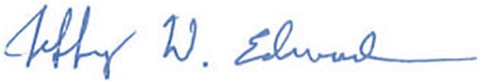  JEFFREY W. EDWARDS  CHAIRMAN OF THE BOARD |  | 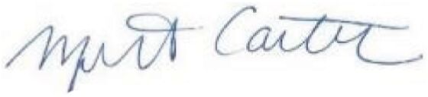  MARGOT L. CARTER  PRESIDING INDEPENDENT DIRECTOR

Table of Contents
TABLE OF CONTENTS

PROXY SUMMARY |  |  | 2
ANNUAL MEETING PROPOSALS |  |  | 2
BUSINESS OVERVIEW |  |  | 2
OUR BUSINESS STRATEGY |  |  | 3
2024 FINANCIAL HIGHLIGHTS |  |  | 5
CORPORATE RESPONSIBILITY |  |  | 6
BOARD OF DIRECTORS COMPOSITION AND QUALIFICATIONS |  |  | 7
2024 EXECUTIVE COMPENSATION AT A GLANCE |  |  | 8
KEY COMPENSATION PRACTICES FOR EXECUTIVES |  |  | 8
PROPOSAL 1 – ELECTION OF DIRECTORS |  |  | 9
OVERVIEW OF THE BOARD |  |  | 9
DIRECTOR QUALIFICATIONS |  |  | 9
BOARD SKILL MATRIX |  |  | 10
BOARD COMPOSITION |  |  | 11
DIRECTOR SKILLS, EXPERIENCE AND BACKGROUND |  |  | 11
DIRECTOR COMPENSATION |  |  | 21
DIRECTOR COMPENSATION TABLE |  |  | 21
DIRECTOR STOCK OWNERSHIP POLICY |  |  | 22
REQUIRED VOTE AND RECOMMENDATION OF THE BOARD |  |  | 22
CORPORATE GOVERNANCE |  |  | 23
CORPORATE GOVERNANCE HIGHLIGHTS |  |  | 23
BOARD STRUCTURE AND RESPONSIBILITIES |  |  | 23
BOARD LEADERSHIP STRUCTURE |  |  | 24
CORPORATE GOVERNANCE GUIDELINES |  |  | 24
SUCCESSION PLANNING |  |  | 25
ROLE OF THE BOARD IN RISK OVERSIGHT |  |  | 25
CYBERSECURITY OVERSIGHT |  |  | 26
CORPORATE RESPONSIBILITY OVERSIGHT |  |  | 27
BOARD COMMITTEE OVERSIGHT |  |  | 27
DIRECTOR INDEPENDENCE |  |  | 31
ANNUAL BOARD AND COMMITTEE SELF-ASSESSMENTS |  |  | 31
MEETINGS OF THE BOARD AND DIRECTOR ATTENDANCE |  |  | 31
EXECUTIVE SESSIONS OF THE BOARD |  |  | 32
CODE OF BUSINESS CONDUCT AND ETHICS |  |  | 32
INSIDER TRADING POLICY AND HEDGING AND PLEDGING PROHIBITION |  |  | 33
STOCKHOLDER ENGAGEMENT |  |  | 34
COMMUNICATION WITH DIRECTORS |  |  | 34
STOCKHOLDER NOMINATIONS OF DIRECTOR CANDIDATES |  |  | 34
CORPORATE GOVERNANCE MATERIALS |  |  | 35
CORPORATE RESPONSIBILITY |  |  | 36
GOING BEYOND THE BUILDINGS |  |  | 36
COMMITTING TO OUR PEOPLE |  |  | 38
ELEVATING OUR NEIGHBORHOODS |  |  | 40
CORPORATE RESPONSIBILITY MATERIALS |  |  | 42
PROPOSAL 2 – RATIFICATION OF THE APPOINTMENT OF OUR INDEPENDENT REGISTERED PUBLIC ACCOUNTING FIRM |  |  | 43
OVERVIEW |  |  | 43
FEES PAID TO DELOITTE |  |  | 44
PRE-APPROVAL OF SERVICES |  |  | 44
REPORT OF THE AUDIT COMMITTEE |  |  | 45
REQUIRED VOTE AND RECOMMENDATION OF THE BOARD |  |  | 45
PROPOSAL 3 – NON-BINDING ADVISORY VOTE ON EXECUTIVE COMPENSATION |  |  | 46
REQUIRED VOTE AND RECOMMENDATION OF THE BOARD |  |  | 46

EXECUTIVE OFFICERS AND CERTAIN SIGNIFICANT EMPLOYEES |  |  | 47
EXECUTIVE OFFICERS |  |  | 47
CERTAIN KEY EMPLOYEES |  |  | 48
COMPENSATION DISCUSSION AND ANALYSIS |  |  | 50
CHC COMMITTEE REPORT |  |  | 50
CD&A TABLE OF CONTENTS |  |  | 50
SECTION 1 – EXECUTIVE SUMMARY |  |  | 51
SECTION 2 – HOW WE DETERMINE PAY |  |  | 55
SECTION 3 – ELEMENTS OF OUR COMPENSATION PROGRAM |  |  | 59
SECTION 4 – WHAT WE PAID IN 2024 |  |  | 61
SECTION 5 – OTHER COMPENSATION AND POLICIES |  |  | 65
EXECUTIVE COMPENSATION |  |  | 68
SUMMARY COMPENSATION TABLE |  |  | 68
GRANTS OF PLAN-BASED AWARDS FOR 2024 |  |  | 69
OUTSTANDING EQUITY AWARDS TABLE |  |  | 70
STOCK VESTED AS OF DECEMBER 31, 2024 |  |  | 71
PENSION BENEFITS |  |  | 71
NON-QUALIFIED DEFERRED COMPENSATION |  |  | 71
EMPLOYMENT AGREEMENTS, SEVERANCE AND CHANGE IN CONTROL BENEFITS |  |  | 72
CHIEF EXECUTIVE OFFICER PAY RATIO |  |  | 74
PAY VERSUS PERFORMANCE |  |  | 76
STOCK OWNERSHIP INFORMATION |  |  | 79
STOCK OWNERSHIP TABLE |  |  | 79
SECURITIES AUTHORIZED FOR ISSUANCE UNDER EQUITY COMPENSATION PLANS |  |  | 82
RELATED PARTY TRANSACTIONS |  |  | 83
AFFILIATE SALES |  |  | 83
REAL PROPERTY LEASES |  |  | 83
AIRCRAFT LEASE AND OWNERSHIP AGREEMENT |  |  | 83
SHARE REPURCHASES |  |  | 83
POLICIES AND PROCEDURES FOR RELATED PARTY TRANSACTIONS |  |  | 84
STOCKHOLDER PROPOSALS FOR THE 2026 ANNUAL MEETING |  |  | 85
PROPOSALS FOR INCLUSION IN OUR 2026 PROXY STATEMENT |  |  | 85
DIRECTOR NOMINEES FOR INCLUSION IN OUR 2026 PROXY STATEMENT |  |  | 85
OTHER PROPOSALS FOR THE 2026 ANNUAL MEETING |  |  | 85
ADDITIONAL INFORMATION |  |  | 86
HOUSEHOLDING OF PROXY MATERIALS |  |  | 86
SOLICITATION OF PROXIES |  |  | 86
INCORPORATION BY REFERENCE |  |  | 86
FORWARD LOOKING STATEMENTS |  |  | 86
AVAILABILITY OF SEC FILINGS AND CORPORATE GOVERNANCE DOCUMENTS |  |  | 87
USE OF NON-GAAP FINANCIAL MEASURES |  |  | 87
MEETING AND VOTING INFORMATION |  |  | 88
ATTENDING THE ANNUAL MEETING |  |  | 88
WHO IS ENTITLED TO VOTE; QUORUM |  |  | 88
HOW TO VOTE |  |  | 89
REVOKING YOUR PROXY OR CHANGING YOUR VOTE |  |  | 90
VOTES REQUIRED TO APPROVE EACH PROPOSAL |  |  | 90
VOTING RESULTS |  |  | 90
OTHER MATTERS |  |  | 91

Table of Contents
Notice of 2025 Annual Meeting of Stockholders

Date and Time |  | May 20, 2025 10 a.m. Eastern Time
Virtual Meeting Audio  Webcast |  | https://meetnow.global/M4CN4WG
Record Date |  | March 25, 2025
Mailing Date for  Distribution of Proxy  Materials |  | On or about April 8, 2025, we will mail a Notice of Internet Availability of Proxy Materials to our stockholders of record on the record date. The notice has instructions on how to obtain internet access to our Proxy Statement and Annual Report, including our Form 10-K for the 2024 fiscal year. The notice also has instructions on how to request a paper copy of the proxy materials. We are making our proxy materials available to our stockholders electronically instead of mailing a full set of proxy materials, which allows us to provide you with the information you need in a timely manner, while reducing our impact on the environment and lowering the costs of printing and distributing our proxy materials.
Agenda |  | ∎ Election of Jeffrey W. Edwards, Lawrence A. Hilsheimer and Janet E. Jackson as directors to serve for three-year terms;  ∎ Ratification of the appointment of Deloitte & Touche LLP as our independent registered public accounting firm for 2025;  ∎ Approval, on an advisory basis, of the compensation of our named executive officers; and  ∎ Transaction of any other business that may properly come before the meeting or any adjournment thereof.
Voting |  | Stockholders may vote online at www.envisionreports.com/IBP or by phone at 1-800-652-8683, 24 hours a day, seven days a week. If you have a printed proxy card, you may vote by completing, signing, dating and returning each proxy card in the prepaid envelope provided. If you choose to vote during the 2025 Annual Meeting of Stockholders (“Annual Meeting”), follow the instructions posted at https://meetnow.global/M4CN4WG. All votes must be received no later than the closing of the polls at the Annual Meeting.
Meeting and Voting  Details |  | For more detailed information on attending and voting at the Annual Meeting, see “Meeting and Voting Information” beginning on page 88.
By Order of the Board of Directors


Shelley A. McBride
General Counsel and Secretary
April 8, 2025

IBP 2025 Proxy Statement
Notice of 2025 Annual Meeting of Stockholders

1

Table of Contents
PROXY SUMMARY

This Proxy Summary provides an overview of our business and highlights information contained elsewhere in this Proxy Statement. This summary does not contain all of the information you should consider. Please read the entire Proxy Statement carefully before voting.
Annual Meeting Proposals

Proposals |  | Required Vote |  | Board  Recommendation |  | Page
1. Election of Jeffrey W. Edwards, Lawrence A. Hilsheimer and Janet E. Jackson as directors to serve for three-year terms |  | Majority of the votes cast at the Annual Meeting |  | ✓ FOR  each nominee |  | 9
2. Ratification of the appointment of Deloitte & Touche LLP as our independent registered public accounting firm for 2025 |  | Majority of the shares present or represented by proxy at the Annual Meeting and entitled to vote |  | ✓ FOR |  | 43
3. Approval, on an advisory basis, of the compensation of our named executive officers |  | Majority of the shares present or represented by proxy at the Annual Meeting and entitled to vote |  | ✓ FOR |  | 46
Business Overview

Our primary business is the installation of building products, mainly insulation, in residential and commercial buildings. We also install a diversified range of other building products including waterproofing, fire-stopping, fireproofing, garage doors, rain gutters, window blinds,
shower doors, closet shelving and mirrors. We offer our services from our network of over 250 branch locations serving the 48 continental United States and the District of Columbia.  Our distribution platform consists of three regional distributors. AMD Distribution Services has eight locations serving the Midwest and Mountain West and distributes spray foam insulation, metal building insulation, residential insulation, mechanical and fabricated Styrofoam insulation and accessories. Central Aluminum Supply and Central Aluminum Supply of North Jersey distribute gutter supplies and accessories for construction projects across the Northeast and Mid-Atlantic. Insulation Supplies distributes various insulation products, including equipment and machines, in the Midwest. |  | 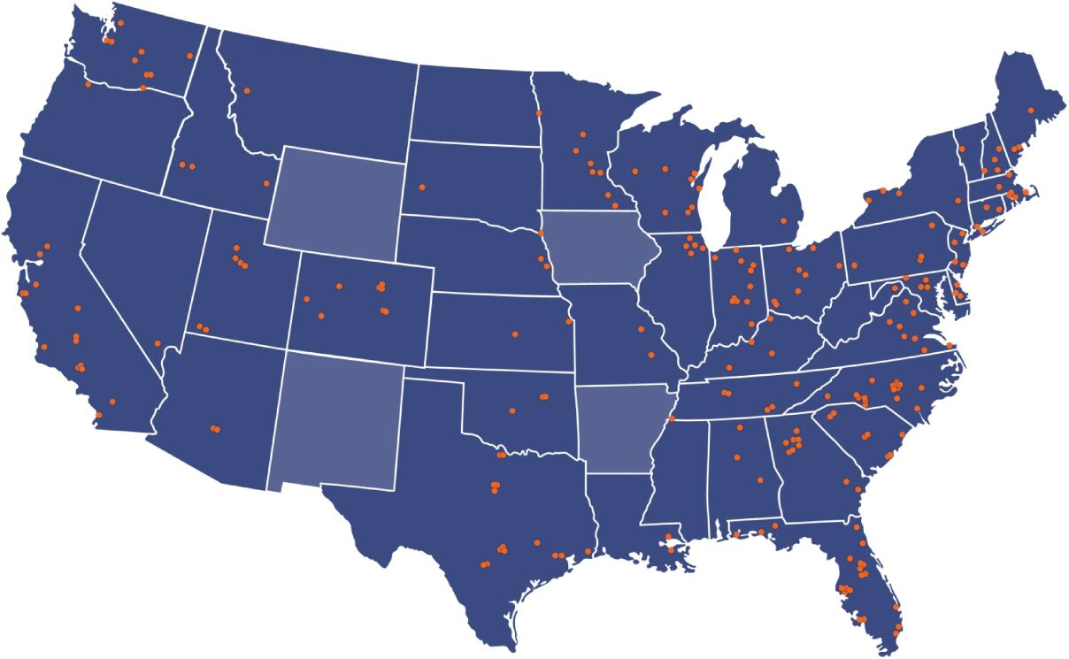  Note: Shaded states are where we have a physical presence. Some dots represent multiple locations.
We also operate a manufacturing operation located in Bucyrus, Ohio, which produces cellulose insulation with an 85% recycled wastepaper content and other specialty industrial fibers.

IBP 2025 Proxy Statement
Proxy Summary

2

Table of Contents
Our Business Strategy
Growth Strategy
We are focused on diversifying our products and services, broadening our mix of end market exposure and expanding our geographic footprint. Our growth strategy includes acquisition of residential and commercial installers in new markets, acquisitions of businesses offering complementary products, introduction of new product offerings in existing markets, pursuit of new product categories in commercial markets, and expanding our multi-family sales in existing branches.
In February 2024, we celebrated ten years as a publicly traded company. At the time of our public offering in 2014, we had approximately 3,200 employees, and we estimate that we had a national residential insulation market share of approximately 16%. We currently have approximately 10,800 employees and we estimate that we service approximately 30% of the residential insulation market. During our ten year history as a public company, we have a demonstrated record of success for each of our growth strategies:

 | ◾ |  | Product diversification - Revenue from insulation installation services represented approximately 76% of our total revenues in 2014 compared to 60% in 2024.

 | ◾ |  | End market diversification - We have decreased our single family residential new construction end market exposure from 73% in 2014 to 57% in 2024.

 | ◾ |  | Geographic expansion - We have added approximately 150 branch locations since 2014.

 |  |  |  | 2014 |  |  |  | 2024
Revenue  by  Product |  |  |  | 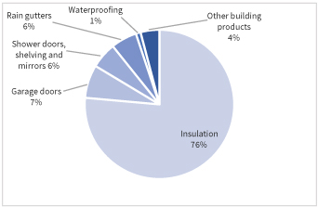 |  |  |  | 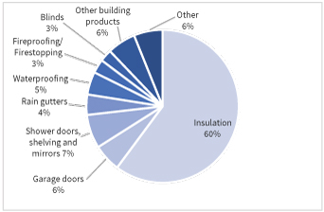
Revenue  by  End-  Market |  |  |  | 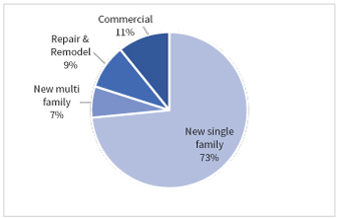 |  |  |  | 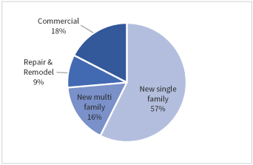

IBP 2025 Proxy Statement
Proxy Summary

3

Table of Contents
2014-2024 Branch Locations

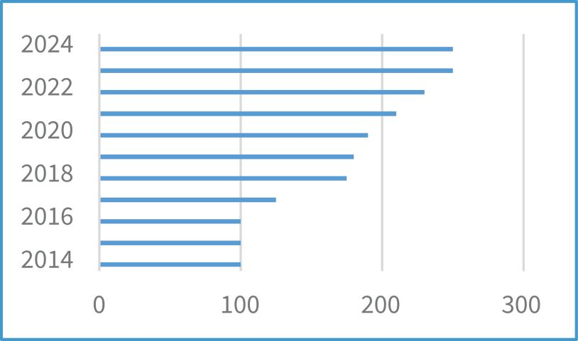
Capital Allocation Strategy
Our capital allocation priorities include:

 | • |  | Acquisitions, which contribute to our profitability and anchor our growth strategies of product, end market and geographic diversification, and

 | • |  | Quarterly and annual variable dividends and opportunistic share repurchases, which provide direct returns to our stockholders.
In 2024, we acquired nine businesses with revenues exceeding $100 million, which expanded our geographic presence in attractive housing markets. We returned a record $230 million to stockholders, including quarterly and variable dividends of $85 million and stock repurchases of $145 million.

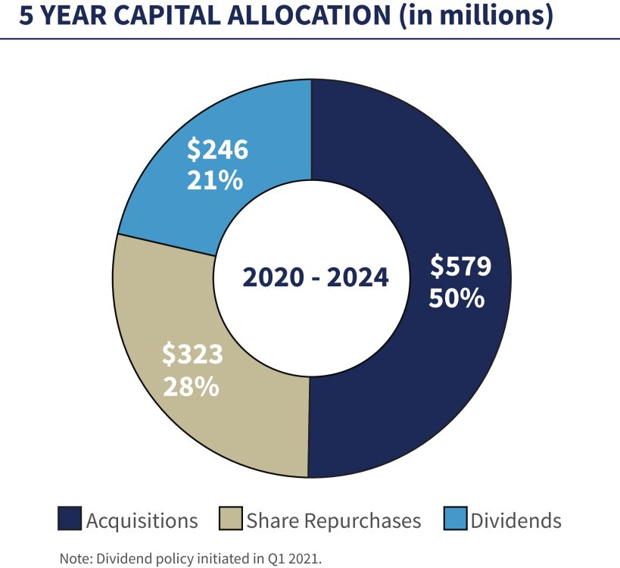

IBP 2025 Proxy Statement
Proxy Summary

4

Table of Contents
Acquisition Strategy
In the 1990s, we began our acquisition strategy with the goal of creating a national platform and have since grown, by our estimate, to become one of the nation’s largest installers of insulation in the residential new construction end market. Since 1999, we have successfully completed and integrated over 200 acquisitions, which have expanded our scale and market presence and diversified our product offerings and end market exposures. Our asset-light model generates substantial operating cash flow, which supports further acquisition growth. In 2024, we successfully acquired and integrated nine businesses representing more than $100 million in aggregate annual revenues.

∎ Keys to our acquisition approach  ✓ Target profitable markets and outstanding operators  ✓ Acquire operations with a strong reputation and customer base  ✓ Maintain existing management teams and trade names  ✓ Leverage national buying power  ✓ Leverage relationships with national homebuilders |  | 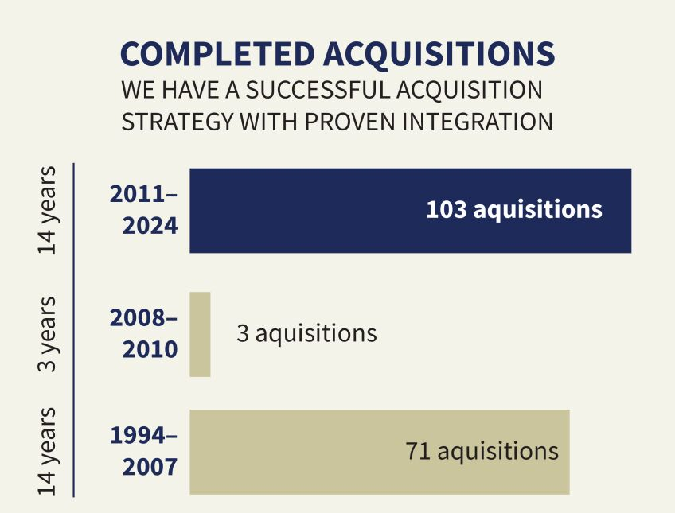
2024 Financial Highlights

Net Revenue |  | Gross Profit |  | Net Income |  | Diluted Earnings  Per Share |  | Adjusted EBITDA*
$2.9  billion |  | $994.5  million |  | $256.6  million |  | $9.10 |  | $511.4  million
5.9% increase |  | 6.9% increase |  | 5.3% increase |  | 5.7% increase |  | 5.2% increase
*See “Additional Information – Use of Non-GAAP Financial Measures” for a reconciliation of Adjusted EBITDA to the most directly comparable U.S. generally accepted accounting principles (“GAAP”) measure. Figures above reflect year over year increases.

IBP 2025 Proxy Statement
Proxy Summary

5

Table of Contents
Corporate Responsibility
We recognize the importance of our environmental and social responsibilities and their impact on our stockholders, our customers, our employees and our communities. Good corporate citizenship is important to us and we are committed to promoting a culture of doing what is right and investing in the communities where we live and work. We integrate corporate responsibility every day through making buildings energy efficient, providing for the health, safety and welfare of our employees, advocating volunteerism and committing to philanthropy.

 |  | GOING BEYOND  THE BUILDINGS |  |  |  | COMMITTING  TO OUR PEOPLE |  |  |  | ELEVATING OUR  NEIGHBORHOODS
● We released our annual Environmental, Social and Governance Report (“Sustainability Report”) in November 2024.  ● We play a direct role in creating a sustainable future by installing products that promote energy efficiency and reduce energy consumption.  ● We have transitioned a substantial portion of our electricity needs to a carbon free source.  ● We maintain a national waste management program to increase recycling at our branches nationwide to reduce landfill waste. |  |  |  | Our vision is to foster a culture that values inclusion and employee engagement. Our initiatives include:  ● Leadership training and development programs  ● Building an expanded hiring pipeline  ● Conducting employee focus groups to understand employee perceptions throughout the Company  ● Broadcasting our Positive Production Program videos to educate and encourage inclusion and employee well-being  ● Offering both English and Spanish as a Second Language classes to remove communication hurdles among our workforce |  |  |  | Installed Building Products Foundation (“Foundation”) grants since inception (dollar amounts approximate):  ● Scholarships $5.1 million (423 grants)  ● Charitable Giving Match $48,936 (137 matches)  ● Employee Financial Assistance $706,850 (850 grants)  ● Major Grants Program $4.6 million (108 grants)  Corporate giving, including multi-year commitments to The Gary Sinise Foundation’s R.I.S.E. Program, the Columbus Metropolitan Library Foundation, YWCA of Central Ohio, Junior Achievement of Central Ohio, The Columbus Promise, Besa Community, Inc. and Zora’s House.

IBP 2025 Proxy Statement
Proxy Summary

6

Table of Contents
Board of Directors Composition and Qualifications
Our Board of Directors (“Board”) is expected to represent a broad spectrum of age, gender, racial and ethnic backgrounds and experience. Our goal is to ensure that the Board is comprised of individuals whose backgrounds, skills and expertise, when taken together, provide the Board with the range of skills and expertise necessary to oversee the Company’s strategy, operations and risk management.
Board Composition

78 |  | % |  |  |  | 67 |  | % |  |  |  | 33 |  | %
78 |  | OF |  |  |  | 67 |  | OF |  |  |  | 33 |  | OF
BOARD MEMBERS ARE  INDEPENDENT  Seven Independent  Two Non-Independent |  |  |  |  |  | COMMITTEE CHAIRS ARE  WOMEN  Two Women  One Man |  |  |  |  |  | BOARD MEMBERS ARE  WOMEN  Three Women  Six Men
65 YEARS  AVERAGE AGE OF BOARD MEMBERS  Two 50s, Three 60s, Three 70s |  |  |  |  |  | 11 YEARS  AVERAGE BOARD TENURE  One 0-2, Two 3-10, Six 10+ |  |  |  |  |  | 33%  OF THE BOARD ARE DIVERSE  Two Black/African American  One LGBTQ+
Board Skill Matrix

Industry Knowledge |  |  |  | Experience
✓ Housing  ✓ Construction  ✓ Building Materials |  |  |  | ✓ Public Board  ✓ Audit Committee  ✓ Compensation Committee  ✓ Corporate Governance / Nominating Committee  ✓ Executive Leadership  ✓ Strategic / Operational / Industrial Distribution  ✓ Human Capital Management  ✓ IT / Technology / Cybersecurity / Digital Transformation  ✓ Environmental, Social and Governance
Financial Skills

✓ Public Company Financial Reporting
✓ Capital Structure Experience
✓ M&A Transactions
✓ Risk Management

IBP 2025 Proxy Statement
Proxy Summary

7

Table of Contents
2024 Executive Compensation at a Glance

Name |  | Base  Salary  ($)(1) |  |  |  |  | Performance-Based  Cash Award Earned  ($) |  |  |  |  | Performance-Based  Restricted Stock  Award Earned  Fair Value  ($)(2) |  |  |  |  | Earned  Compensation  Total  ($)
Jeffrey W. Edwards |  |  |  | 900,000 |  |  |  |  | 1,247,480 |  |  |  |  | 3,186,637 |  |  |  |  | 5,334,117
Michael T. Miller |  |  |  | 475,000 |  |  |  |  | 455,810 |  |  |  |  | 995,814 |  |  |  |  | 1,926,624
Brad A. Wheeler |  |  |  | 485,000 |  |  |  |  | 431,820 |  |  |  |  | 796,618 |  |  |  |  | 1,713,438
W. Jeffrey Hire |  |  |  | 450,000 |  |  |  |  | 215,910 |  |  |  |  | 219,049 |  |  |  |  | 884,959
Jason R. Niswonger |  |  |  | 465,000 |  |  |  |  | 278,284 |  |  |  |  | 398,227 |  |  |  |  | 1,141,511

 | (1) | Effective April 1, 2024.
 | (2) | The earned fair value was determined by multiplying the closing price of the Company’s common stock on February 25, 2025 ($170.99) (the date of certification of the achievement of the performance metric) by the number of shares awarded. The restricted stock vests in equal installments over two years (subject to continued employment).
Key Compensation Practices for Executives

What We Do |  | What We Don’t Do
Pay for Performance where a substantial percentage of compensation is based on achievement of objective pre-established performance metrics  Balanced Compensation Mix of salary and performance-based cash bonuses and restricted stock awards  Multi-year Vesting of Equity Awards over a two-year period after the performance target is met  Limited Perquisites that are not available to other salaried employees  Competitive Pay targeted near the median of our peer group  Clawback Policies for recovery of incentive compensation under specified circumstances  Meaningful Stock Ownership Requirements in multiples of base salary  Annual Say-on-Pay Vote on executive compensation |  | No Tax Gross-Ups for perquisites or excise taxes  No Pension Plans or retirement benefits that are not available to other salaried employees  No Hedging or other monetization transactions involving Company securities (the Board has made an exception for our CEO, see Footnote 2 in the “Stock Ownership Table” beginning on page 79)  No Short Sales or other speculative transactions involving Company securities  No Option Repricing of underwater stock options without stockholder approval  No Single Trigger accelerated vesting of incentive awards upon a change in control without a qualifying loss of employment  No Pledging of Company securities as collateral or holding Company securities as collateral in a margin account (the Board has made an exception for our CEO, see Footnote 2 in the “Stock Ownership Table” beginning on page 79)  No Employment Agreements for our executives other than our Chief Executive Officer

IBP 2025 Proxy Statement
Proxy Summary

8

Table of Contents
PROPOSAL 1 – ELECTION OF DIRECTORS

Upon the recommendation of the Nominating and Corporate Governance Committee (“NCG Committee”), the Board has nominated and is submitting to a vote of our stockholders a proposal to elect Jeffrey W. Edwards, Lawrence A. Hilsheimer and Janet E. Jackson as Class III directors to serve for three-year terms. Each nominee’s term runs until the 2028 Annual Meeting of Stockholders.
The NCG Committee and the Board evaluated the background, experience, qualifications, attributes and skills of each nominee, as well as the years of experience they have had working together on the Board and the knowledge of the Company’s business, operations, strategy and risks they have developed as a result of such service. The NCG Committee and the Board also considered Board refreshment and each nominee’s contributions to the Board and role in the operation of the Board as a whole. See “Director Qualifications,” “Board Composition” and “Director Skills, Experience and Background” below.
Director nominees are expected to demonstrate leadership and to possess the highest professional and personal integrity, values and judgment. The NCG Committee and the Board have determined that each of our nominees possesses the skills, experience and perspectives, collectively with other directors, to comprise a well-rounded, highly effective Board of Directors, and have determined that the nominees add to the overall strength of the Board by bringing insights and practical wisdom based on their experience and expertise.
All of the director nominees currently serve on the Board. Each nominee has accepted the nomination and has agreed to serve if elected. If a nominee is unable to serve as a director, the Board may reduce the number of directors constituting the full Board or may choose a substitute nominee.
Overview of the Board
Our directors are divided into three classes, as nearly equal in number as possible and designated Class I, Class II and Class III, with one class of directors elected annually for a three-year term and the other classes of directors continuing to serve for the remainder of their respective terms. Each director holds office until his or her successor is duly elected and qualified or until his or her earlier death, resignation, retirement, disqualification or removal.

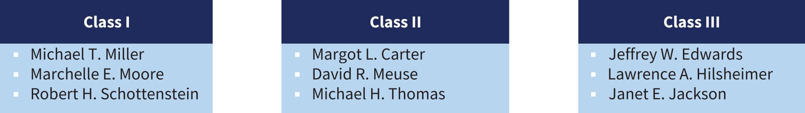
The number of directors constituting the Board is fixed from time to time by a majority vote of the directors then in office. Our Board of Directors has currently fixed the number of directors at nine. No decrease in the authorized number of directors will result in the removal of an incumbent director until that director’s term expires. Vacancies may be filled by the Board. The NCG Committee and the Board periodically evaluate Board structure.
Director Qualifications
Our NCG Committee is responsible for annually reviewing the qualifications for Board membership and identifying and assessing the appropriate skills of our directors and director candidates with a view toward ensuring that the Board is comprised of individuals whose backgrounds, skills, experience and expertise, when taken together, provide the Board with the ability to provide effective oversight of the Company and its operations, strategy and risk management.

IBP 2025 Proxy Statement
Proposal 1 – Election of Directors

9

Table of Contents
In evaluating the suitability of director candidates, the NCG Committee considers evolving needs within the Board and evaluates the entirety of each director candidate’s credentials. The NCG Committee considers numerous factors, including those set forth in the matrix below, in seeking to maintain a balance of experience and expertise. The NCG Committee reviews the matrix annually to determine if it is appropriate to add additional skill sets to the Board to meet evolving needs or if it is more appropriate to maintain those skills at the management level. The matrix assists the NCG Committee in determining whether a director candidate or a Board member possesses skills that may be valuable in light of current and anticipated strategic plans, operational requirements and risk challenges and in the long term interest of our stockholders. Each of our director nominees and continuing directors possess valuable skills and experience that are not reflected in the matrix.
Board Skill Matrix

 |  |  |  |  |  |  |  |  |  |  |  |  |  |  |  |  |  |  |  | 
 |  | Industry Knowledge
 |  | Housing |  | ● |  | ● |  | ● |  |  |  |  |  | ● |  |  |  | ● |  | ●
 |  | Construction |  | ● |  | ● |  |  |  |  |  |  |  | ● |  |  |  | ● |  | ●
 |  | Building Materials |  | ● |  | ● |  |  |  |  |  |  |  | ● |  |  |  | ● |  | ●
 |  | Financial Skills
 |  | Public Company Financial Reporting |  | ● |  |  |  | ● |  |  |  | ● |  | ● |  |  |  | ● |  | ●
 |  | Capital Structure Experience |  | ● |  | ● |  | ● |  |  |  | ● |  | ● |  |  |  | ● |  | ●
 |  | M&A Transactions |  | ● |  | ● |  | ● |  |  |  | ● |  | ● |  | ● |  |  |  | ●
 |  | Risk Management |  | ● |  |  |  | ● |  |  |  | ● |  | ● |  | ● |  |  |  | ●
 |  | Experience
 |  | Public Board |  | ● |  | ● |  | ● |  | ● |  | ● |  | ● |  | ● |  | ● |  | ●
 |  | Audit Committee |  | ● |  |  |  | ● |  |  |  | ● |  | ● |  |  |  | ● |  | ●
 |  | Compensation Committee |  | ● |  |  |  | ● |  | ● |  | ● |  |  |  | ● |  | ● |  | ●
 |  | Corporate Governance / Nominating Committee |  | ● |  |  |  | ● |  | ● |  | ● |  |  |  | ● |  | ● |  | ●
 |  | Executive Leadership |  | ● |  | ● |  | ● |  | ● |  | ● |  | ● |  | ● |  | ● |  | ●
 |  | Strategic / Operational / Industrial Distribution |  | ● |  | ● |  | ● |  |  |  | ● |  | ● |  | ● |  | ● |  | ●
 |  | Human Capital Management |  | ● |  | ● |  | ● |  | ● |  |  |  | ● |  | ● |  | ● |  | ●
 |  | IT / Technology / Cybersecurity / Digital Transformation |  | ● |  |  |  | ● |  |  |  |  |  | ● |  |  |  |  |  | ●
 |  | Environmental, Social, Governance |  | ● |  |  |  | ● |  |  |  |  |  | ● |  | ● |  |  |  | ●
The NCG Committee also considers whether a director candidate meets applicable criteria for independence and whether the individual will enhance the diversity of views and experiences available to the Board in its deliberations. If the nominee is a current director, the NCG Committee takes into account the director’s individual contributions to the Board, the director’s ability to work collaboratively and the effectiveness of the Board as a whole. No specific weight is assigned to any particular factor and, depending on the current and anticipated needs of the Board, some factors may weigh more or less heavily.

IBP 2025 Proxy Statement
Proposal 1 – Election of Directors

10

Table of Contents
Board Composition
In addition to the skills and expertise described above, the NCG Committee also seeks a broad spectrum of age, gender and race and ethnicity among members of the Board. The Board is expected to represent a range of backgrounds and experience. The NCG Committee and the Board believe that these considerations are consistent with creating a Board that best serves the Company, our stockholders, our employees and our communities. The NCG Committee believes that our director nominees and continuing directors exhibit commitment to long-term value creation for our stockholders, outstanding personal and professional ethics, sound business judgment, strategic vision, leadership experience and an appreciation of different perspectives.

78 |  | % |  |  |  | 67 |  | % |  |  |  | 33 |  | %
78 |  | OF |  |  |  | 67 |  | OF |  |  |  | 33 |  | OF
BOARD MEMBERS ARE  INDEPENDENT  Seven Independent  Two Non-Independent |  |  |  |  |  | COMMITTEE CHAIRS ARE  WOMEN  Two Women  One Man |  |  |  |  |  | BOARD MEMBERS ARE  WOMEN  Three Women  Six Men
65 YEARS  AVERAGE AGE OF BOARD MEMBERS  Two 50s, Three 60s, Three 70s |  |  |  |  |  | 11 YEARS  AVERAGE BOARD TENURE  One 0-2, Two 3-10, Six 10+ |  |  |  |  |  | 33%  OF THE BOARD ARE DIVERSE  Two Black/African American  One LGBTQ+
Director Skills, Experience and Background
The following biographical information regarding each director nominee and director continuing in office is as of April 8, 2025. In addition to age and tenure as a director, it includes information about each individual’s principal occupation, professional experience, educational background and certain other experience, attributes, qualifications and skills that make the director a valuable member of the Board.

IBP 2025 Proxy Statement
Proposal 1 – Election of Directors

11

Table of Contents

 |  | Jeffrey W. Edwards  Director Nominee
Age  61  Chairman since 1999  Independent  No  Director since  1999  Class III Director  Term Expires in 2025  Board Committees  None |  | Occupation  Installed Building Products, Inc.,  President (2011-present), Chief Executive Officer (2004-present) and Chairman (1999-present)  Education  Miami University, B.S. in Marketing  Experience  ◾ Officer and strategist for several family-owned companies across a variety of industries, including multi-family and student housing development and management, industrial tool distribution, wholesale building supply, homebuilding, restaurants, real estate development and real estate brokerage  ◾ Commercial and mixed real estate development throughout the U.S.  Other Board Service  ◾ Battelle, a leading independent research and development organization, serving governmental and commercial clients in the national security, energy, health and environmental sectors, non-voting member (November 2023-January 2024), voting member (January 2024-present), HR, Compensation and Governance committee  ◾ Director of the Company’s predecessor (2004-2011)  ◾ Columbus Museum of Art  ◾ The Salvation Army, Emeritus Board Member  ◾ The Policy Advisory Board of Harvard University’s Joint Center for Housing Studies  ◾ The Columbus Foundation, a non-profit community foundation, governing committee  ◾ The Columbus Partnership  ◾ The Columbus Downtown Development Corporation  Qualifications and Skills  As an industry leader with over 30 years of experience in the building products industry and in his roles as our CEO and Chairman, Mr. Edwards brings to the Board significant senior leadership, housing and construction industry knowledge, and strategic, operational and mergers and acquisitions experience. As founder of the Company, Mr. Edwards has unique knowledge and experience in the Company’s culture, business development, strategy and operations.

IBP 2025 Proxy Statement
Proposal 1 – Election of Directors

12

Table of Contents
 |  | Lawrence A. Hilsheimer  Director Nominee
Age  67  Independent  Yes  Director since  2014  Class III Director  Term Expires in 2025  Board Committees  ● Audit (Chair)  ● Nominating and Corporate Governance |  | Occupation  Greif, Inc., a publicly traded global leader in industrial packing products and services  Executive Vice President and Chief Financial Officer (2014–present)  Education  The Ohio State University Fisher College of Business, B.A. in Business Administration  Capital University Law School, J.D.  Experience  ◾ The Scotts Miracle-Gro Company, a publicly traded manufacturer of branded consumer lawn and garden products, Executive Vice President and Chief Financial Officer  ◾ Nationwide Mutual Insurance Company, a provider of property and casualty insurance and financial services, Executive Vice President and Chief Financial Officer; President and Chief Operating Officer of multiple business units, including Nationwide Direct and Customer Solutions and Nationwide Retirement Plans  ◾ Deloitte & Touche USA, LLP, Vice Chairman and Regional Managing Partner  Other Board Service  ◾ Root, Inc., the publicly traded parent of Root Insurance Company (October 2021-present), chair of audit committee, lead independent director  ◾ Root Insurance Company (2017-present), chair of audit committee (2017-present)  ◾ National Veteran’s Memorial and Museum Foundation Board (November 2021- present)  ◾ Battelle for Kids (2012-present), member of finance committee  Qualifications and Skills  Mr. Hilsheimer’s broad business background and corporate finance and public accounting roles bring to the Board public company financial reporting, capital structure, public board service, executive leadership and technology experience. Mr. Hilsheimer’s CERT Certificate in Cybersecurity Oversight from the National Association of Corporate Directors aids the Board’s understanding of the cybersecurity threat landscape and assists the Board in overseeing an effective risk management program.

IBP 2025 Proxy Statement
Proposal 1 – Election of Directors

13

Table of Contents
 |  | Janet E. Jackson  Director Nominee
Age  72  Independent  Yes  Director since  2014  Class III Director  Term Expires in 2025  Board Committees  ● Compensation and Human Capital (Chair)  ● Nominating and Corporate Governance |  | Occupation  United Way of Central Ohio, a nonprofit organization and one of the largest United Way affiliates in the U.S.  Retired President and Chief Executive Officer (2003-2017)  Education  Wittenberg University, B.A. in History  National Law Center at The George Washington University, J.D.  Experience  ◾ City Attorney, Columbus, Ohio  ◾ Municipal Court Judge, Franklin County, Ohio  ◾ First woman and first African American to hold her position at United Way and to be elected as Columbus City Attorney, and the first African American female judge in Franklin County, Ohio  Other Board Service  ◾ Wittenberg University (2016- May 2024), governance and board affairs committee (2018- May 2024), advancement and alumni relations committee (2017- May 2024), enrollment management committee (2016-2018), academic and student life committee (2016-2019) and finance and investments committee (2020-May 2024)  ◾ City of Columbus Civilian Police Review Board, chair (April 2021-April 2023)  Qualifications and Skills  Ms. Jackson’s significant leadership experience and extensive background in public service bring to the Board executive leadership, strategic and operational and human capital skills. The Board also benefits from Ms. Jackson’s legal background, judgment and input on community investment and engagement and inclusion and belonging.

IBP 2025 Proxy Statement
Proposal 1 – Election of Directors

14

Table of Contents
 |  | Michael T. Miller  Continuing Director
Age  60  Independent  No  Director since  2014  Class I Director  Term Expires in 2026  Board Committees  None |  | Occupation  Installed Building Products, Inc.,  Executive Vice President – Finance (2000-present) and Chief Financial Officer (2013-present)  Education  Wake Forest University, B.A. in Economics and German  Experience  ◾ Huntington Capital Corp., a subsidiary of Huntington Bancshares, Inc., a regional bank holding company, Corporate Investment Banking, Senior Vice President/Managing Director  ◾ Various positions with Deutsche Bank and Canadian Imperial Bank of Commerce in New York and First Union National Bank, Charlotte, North Carolina  Other Board Service  ◾ BMC Stock Holdings, Inc. (2014-January 2021), a publicly traded leader in diversified building products, audit committee  Qualifications and Skills  As our Chief Financial Officer and Executive Vice President of Finance for more than 20 years, Mr. Miller brings to the Board executive leadership and extensive housing and construction, strategic and operational, capital structure, risk management and mergers and acquisitions experience. His knowledge of financial markets and financing, in addition to his past service on the board and audit committee of a publicly-traded diversified building products company, contribute to the Board knowledge of public company financial reporting, internal controls and public board service.

IBP 2025 Proxy Statement
Proposal 1 – Election of Directors

15

Table of Contents
 |  | Marchelle E. Moore  Continuing Director
Age  52  Independent  Yes  Director since  2023  Class I Director  Term Expires in 2026  Board Committees  ● Compensation and Human Capital  ● Nominating and Corporate Governance |  | Occupation  Encova Mutual Insurance Group, Inc., a mutual insurance holding company providing a comprehensive range of insurance products  Senior Vice President, External Affairs and Chief Inclusion and Belonging Officer (December 2022-present)  Encova Foundation of Ohio, its affiliated philanthropic foundation President (December 2022-present)  Education  The Ohio State University, B.A. in English  The Ohio State University Moritz College of Law, J.D.  Experience  ◾ Encova Mutual Insurance Group, Inc., a mutual insurance holding company providing a comprehensive range of insurance products, Senior Vice President, Chief Legal Officer & Corporate Secretary (October 2017-December 2022)  ◾ Motorists Insurance Group (now Encova Mutual Insurance Group, Inc.), Senior Vice President, Chief Legal Officer & General Counsel  ◾ Central Ohio Transit Authority, Vice President of Legal and Government Affairs and General Counsel  ◾ Central Ohio Transit Authority, Interim Vice President of Human Resources and Labor Relations  Other Board Service  ◾ The Columbus Foundation/Community Foundations, Inc., a non-profit community foundation (January 2021-present)  ◾ Encova Foundation of Ohio (formerly The Motorists Insurance Companies Foundation), a non-profit corporate foundation, (April 2018-present), president (December 2022-present)  ◾ CampusParc Management, Inc./OSU Management GP, Inc., corporation created to manage the OSU parking system (2017-July 2021)  ◾ Iowa American Insurance Company (May 2018-June 2020), MICO Insurance Company (April 2018-June 2020) and IMARC, LLC (May 2018-May 2020), each a for profit affiliate of Encova Mutual Insurance Group, Inc.  Qualifications and Skills  Ms. Moore’s executive leadership and general counsel experience in the insurance and public transportation industries bring to the Board mergers and acquisitions, corporate governance, risk management and strategic and operational skills. Ms. Moore’s roles as Chief Diversity Officer and Interim Vice President of Human Resources and her service on charitable boards provide valuable insight on community engagement, charitable giving, human capital management and inclusion and belonging.

IBP 2025 Proxy Statement
Proposal 1 – Election of Directors

16

Table of Contents
 |  | Robert H. Schottenstein  Continuing Director
Age  72  Independent  Yes  Director since  2022  Class I Director  Term Expires in 2026  Board Committees  None |  | Occupation  M/I Homes, Inc., one of the largest publicly traded home builders in the U.S. Chairman (2004-present), Chief Executive Officer (2004-present) and President (1996-present)  Education  Indiana University, B.A.  Capital University Law School, J.D.  Experience  ◾ Private practice of law specializing in commercial real estate, corporate and banking transactions (1977-1990)  Other Board Service  ◾ Served as a director of our Company (April 2014–March 2020)  ◾ L Brands, a publicly traded leading specialty retailer focused on women’s apparel, personal care, beauty and home fragrance categories, audit committee (August 2017–May 2022)  ◾ The Ohio State University Wexner Medical Center  ◾ The Ohio State University Foundation  ◾ The Policy Advisory Board of Harvard University’s Joint Center for Housing Studies, Chair  ◾ Pelotonia, Chair  ◾ The Columbus Partnership  Qualifications and Skills  Mr. Schottenstein’s more than 30 years of experience in the homebuilding industry brings to the Board expertise and valuable insight into the housing, construction and building materials industries. Mr. Schottenstein’s executive leadership, capital structure experience and service on public company boards are advantageous to the Board in exercising its strategic, operational, risk and human capital management oversight responsibilities.

IBP 2025 Proxy Statement
Proposal 1 – Election of Directors

17

Table of Contents
 |  | Margot L. Carter  Continuing Director
Age  57  Presiding Independent  Director since 2015  Independent  Yes  Director Since  2014  Class II Director  Term Expires in 2027  Board Committees  ● Audit  ● Nominating and Corporate Governance (Chair) |  | Occupation  Living Mountain Capital L.L.C., a business advisory consulting firm  President and Founder (1998–present)  Education  Binghamton University, B.A. in Economics and History  Fordham University School of Law, J.D.  MIT Sloan School of Management, Executive Certificate - Artificial Intelligence  Southern Methodist University Cox Business School, Certificate - Finance  Experience  ◾ RealPage, Inc., a leading global software and data analytics company for the real estate industry, Executive Vice President, Chief Legal Officer and Secretary  ◾ The Princeton Review, Inc., a global education technology company, Executive Vice President and General Counsel  ◾ Soundview Technology Group, Inc., a global technology financial services firm, Executive Vice President, General Counsel and Executive Managing Director  ◾ Cantor Fitzgerald and eSpeed, Inc., a global capital markets, financial services and technology company, Assistant General Counsel  Other Board Service  ◾ Eagle Materials, Inc., a publicly traded leading provider of building materials (2017-present), compensation and corporate governance and nominating committees (2017-present), audit committee (2017-2019)  ◾ Tyler Technologies, Inc., a publicly traded leading provider of integrated software and technology services for the public sector (May 2024-present), nominating and governance committee  ◾ Interior Logic Group, a technology enabled building materials business (2017-2021)  ◾ North Texas Chapter of National Association of Corporate Directors (2016–present), Chair (July 2022-July 2023), Chair Emeritus (July 2023–present); NACD Director Certified  Qualifications and Skills  Ms. Carter’s executive and leadership experience as a C-suite executive and director of public companies in the technology, real estate and building materials industries provide insight into the dynamics of a corporate board, strategic planning, technology, cybersecurity, mergers and acquisitions, risk oversight, human capital management and environmental, social and governance issues.

IBP 2025 Proxy Statement
Proposal 1 – Election of Directors

18

Table of Contents
 |  | David R. Meuse  Continuing Director
Age  79  Independent  Yes  Director since  2020  Class II Director  Term Expires in 2027  Board Committees  ● Compensation and Human Capital |  | Occupation  Stonehenge Partners, Inc., a privately held mezzanine and equity investment firm and provider of financial and advisory services  Senior Advisor (2018–present)  Education  John Carroll University, B.A. in Political Science and Philosophy  Cleveland Marshall College of Law  Wharton School of Business, Securities Industry Institute  Experience  ◾ Banc One Capital Holdings Corporation, holding company for the investment banking, merchant banking, securities brokerage, investment advisory and insurance activities of Bank One Corporation, Chairman and Chief Executive Officer  ◾ Meuse, Rinker, Chapman, Endres & Brooks, a regional investment banking firm, Chairman and Chief Executive Officer  ◾ Diamond Hill Investment Group, Inc., a publicly traded company providing investment advisory and fund administration services, Chairman  ◾ State Auto Financial Corporation, a publicly traded casualty insurance holding company engaged in writing personal and business insurance, lead director (May 2015-February 2022), audit, independent and investment and finance committees (2006-February 2022)  Other Board Service  ◾ Service on non-profit boards, including REV Ventures and The Columbus Foundation, a nonprofit community foundation  Qualifications and Skills  Mr. Meuse’s more than 40 years of experience in the investment banking, merchant banking, securities brokerage and private equity industries bring to the board expertise in financial markets, capital structure and mergers and acquisitions. Mr. Meuse’s executive leadership roles throughout his career and his public company board experience also provide the board with risk management, strategic and operational and governance skillsets.

IBP 2025 Proxy Statement
Proposal 1 – Election of Directors

19

Table of Contents
 |  | Michael H. Thomas  Continuing Director
Age  75  Independent  Yes  Director since  2014  Class II Director  Term Expires in 2027  Board Committees  ● Audit |  | Occupation  Stonehenge Partners, Inc., privately held mezzanine and equity investment firm and provider of financial and advisory services  Retired partner, provided counsel in investment origination, portfolio asset management and disposition of investments (1999-2014)  Education  University of Notre Dame, B.A. in Business Administration  Experience  ◾ JMAC, Inc., privately held investment company, directing investments in the financial services, publishing, health care, real estate and manufacturing sectors and responsible for the owners’ financial, estate and income tax planning, Executive Vice President and Treasurer  ◾ Ernst & Young LLP Columbus, Ohio tax practice, Manager  Other Board Service  ◾ Served as a director of the Company’s predecessor (2004-2011)  Qualifications and Skills  Mr. Thomas’ significant business and investment experience brings to the Board executive leadership, capital structure, mergers and acquisitions, risk management and human capital skills. His longstanding service as a board member of the Company and its predecessor gives him a broad perspective of the housing industry and the Company’s culture and business strategy and risk oversight.

IBP 2025 Proxy Statement
Proposal 1 – Election of Directors

20

Table of Contents
Director Compensation
The Board of Directors annually reviews and determines the compensation of our non-employee directors, taking into account the recommendations of the Compensation and Human Capital Committee (“CHC Committee”). Our executive officers have no role in determining the amount or form of non-employee director compensation.
The Board and the CHC Committee consider current business and industry conditions and the director compensation paid within our peer group, which is the same peer group used in reviewing the compensation of our executives. The Board believes that non-employee director compensation should be competitive to ensure that we attract and retain qualified non-employee directors, and that compensation should include an equity component to align the long-term interests of our non-employee directors with those of our stockholders. The Board does not have a pre-established policy or target for allocation between cash and equity and determines the mix of compensation based on what it believes is most appropriate under the circumstances. In 2023, the CHC Committee engaged Meridian Compensation Partners, LLC, an independent executive compensation consulting firm (“Meridian”), to review our non-employee director compensation program and to conduct market comparisons similar to those performed for our executive officer compensation program. See Compensation Discussion and Analysis –“Section 2 – How We Determine Pay – Our Executive Compensation Process – Role of Compensation Consultants and Competitive Positioning.” The CHC Committee intends to engage Meridian or a similar firm to review our director compensation program approximately every two years, unless the committee determines to have a more frequent review.

Board service |  | $85,000
Audit Committee Chair |  | $20,000
CHC Committee Chair |  | $17,500
NCG Committee Chair |  | $15,000
Audit Committee (non-chair) |  | $10,000
CHC Committee (non-chair) |  | $10,000
NCG Committee (non-chair) |  | $7,500
Presiding Independent Director |  | $25,000
Grant of restricted stock (fair market value on grant date) |  | $125,000
Annual equity awards are awarded on the date of the Annual Meeting of Stockholders, based on the closing market price of our common stock on that date. Directors appointed to the Board at other times during the year receive a pro rata equity award. Our 2023 Omnibus Incentive Plan provides that total cash and equity compensation to any individual non-employee director may not exceed $400,000 in any fiscal year.
Non-employee directors are entitled to reimbursement for their reasonable expenses to attend Board and committee meetings, but do not receive fees for meeting attendance. Directors who are employees of the Company receive no compensation for their service as directors. We maintain directors’ and officers’ liability insurance and have entered into indemnification agreements with each of our directors. We do not provide incentive awards or retirement plans for our non-employee directors.
Director Compensation Table
The following table presents the total compensation paid in 2024 to each non-employee director. Directors’ fees are paid quarterly in arrears.

Name |  | Fees Earned or Paid  In Cash  ($)(1) |  |  |  |  | Stock Awards  ($)(2)(3) |  |  |  |  | All Other  Compensation  ($) |  |  |  |  | Total  ($)
Margot L. Carter |  |  |  | 123,342 |  |  |  |  | 125,000 |  |  |  |  | - |  |  |  |  | 248,342
Lawrence A. Hilsheimer |  |  |  | 110,842 |  |  |  |  | 125,000 |  |  |  |  | - |  |  |  |  | 235,842
Janet E. Jackson |  |  |  | 108,342 |  |  |  |  | 125,000 |  |  |  |  | - |  |  |  |  | 233,342
David R. Meuse |  |  |  | 93,342 |  |  |  |  | 125,000 |  |  |  |  | - |  |  |  |  | 218,342
Marchelle E. Moore |  |  |  | 100,842 |  |  |  |  | 125,000 |  |  |  |  | - |  |  |  |  | 225,842
Robert H. Schottenstein |  |  |  | 83,342 |  |  |  |  | 125,000 |  |  |  |  | - |  |  |  |  | 208,342
Michael H. Thomas |  |  |  | 89,042 |  |  |  |  | 125,000 |  |  |  |  | - |  |  |  |  | 214,042

IBP 2025 Proxy Statement
Proposal 1 – Election of Directors

21

Table of Contents
 | (1) | The amounts in this column represent all earned retainers. Ms. Carter and Mr. Thomas agreed in advance to waive $10,000 and $4,300, respectively, in order to assist the Company in funding awards under our Foundation.

 | (2) | Represents an annual grant of restricted stock having a fair value of $125,000 on the grant date (May 23, 2024), computed in accordance with Financial Accounting Standards Board Accounting Standards Codification Topic 718, Compensation-Stock Compensation (“FASB ASC Topic 718”), based on the closing price of our common stock ($209.01) on the grant date. The restricted stock awards vest on the earlier to occur of (i) the one year anniversary of the grant date, (ii) immediately prior to the annual meeting of the Company’s stockholders occurring after the grant date, or (iii) the director’s death, subject in the cases of (i) and (ii) to the director’s continued service through the vesting date.

 | (3) | No director held stock options as of December 31, 2024.
Director Stock Ownership Policy
Pursuant to our Stock Ownership Policy for Directors established by the Board and the CHC Committee to align each director’s interests with the long-term interests of our stockholders, each non-employee director (and any employee director who is not otherwise subject to the Company’s stock ownership policy for executive officers) is required to beneficially own our common stock having a fair market value equal to the greater of $425,000 or five times the annual non-employee director cash retainer (excluding committee and Presiding Independent Director retainers). If a director chooses to meet this requirement by holding vested or unvested shares of common stock granted in connection with our director compensation program, the shares are valued at the greater of the closing price on the grant date or on the date on which ownership is measured. If a director fails to meet the ownership requirement on a measurement date, the director is prohibited from selling any Company stock and 50% of any annual cash retainer (or, for an employee director, an equivalent amount from any annual cash bonus) will be paid in the form of stock in lieu of cash. Our directors who are executive officers are subject to our stock ownership policy for executive officers. See Compensation Discussion and Analysis – “Section 5 – Other Compensation and Policies – Stock Ownership Policy.”
To meet the requirements of the Stock Ownership Policy for Directors, a director has five years from the date of his or her appointment or election, or if later, the date of an increase in the amount of stock required to be held. All of our non-employee directors meet the stock ownership requirement except for Ms. Moore, who is on target to meet the requirement.
Required Vote and Recommendation of the Board
The affirmative vote of a majority of the total votes cast at the Annual Meeting is required to approve the election of each nominee as a director, which means that the number of shares voted “FOR” a nominee must exceed the number of shares voted “AGAINST” the nominee. “ABSTAIN” votes and broker non-votes will not be counted as votes cast either “FOR” or “AGAINST.”
Our Amended and Restated Bylaws provide that any incumbent director who fails to receive a majority of votes cast in an uncontested election is required to promptly tender his or her resignation to the Board, which will become effective only upon its acceptance by the Board. The NCG Committee will recommend to the Board whether to accept or reject the resignation, and the Board will act upon such resignation and publicly disclose its decision within 90 days from the date of the certification of the election results.
Unless otherwise instructed, the persons named as proxies will vote “FOR” each nominee.

 |  |  |  | THE BOARD OF DIRECTORS UNANIMOUSLY RECOMMENDS THAT YOU VOTE “FOR” THE ELECTION OF JEFFREY W. EDWARDS, LAWRENCE A. HILSHEIMER AND JANET E. JACKSON AS DIRECTORS.  THE BOARD BELIEVES THAT EACH NOMINEE POSSESSES QUALIFICATIONS AND ATTRIBUTES THAT ARE CRITICAL FOR THE EFFECTIVE RISK OVERSIGHT OF THE COMPANY AND ARE RELEVANT TO THE OVERSIGHT OF OUR BUSINESS, STRATEGY AND OPERATIONS.

IBP 2025 Proxy Statement
Proposal 1 – Election of Directors

22

Table of Contents
CORPORATE GOVERNANCE

Corporate Governance Highlights

Independent Board and Committees |  | 78% of our directors are independent. Board committees consist of independent directors operating under written charters approved by the Board.
Majority vote for Directors |  | Election of directors is by majority of the total votes cast, with a resignation policy if a director does not receive a majority of votes cast in an uncontested election.
Effective Board oversight |  | Our Board and committees exercise continuing oversight of our business strategy, operations, financial reporting, enterprise and cybersecurity risk management, corporate governance and corporate responsibility programs.
Presiding Independent Director |  | We have an active Presiding Independent Director with duties including leading executive sessions of the Board after every regular Board meeting.
Annual Board and  committee self-assessment |  | The Board and its committees conduct an annual self-assessment to assess the functioning and effectiveness of the Board, the committees and the directors.
Stockholder engagement |  | We engage with our stockholders throughout the year to obtain their feedback and to better understand their perspectives.
Code of Business Conduct  and Ethics |  | Our Code of Business Conduct and Ethics, applicable to our directors, officers and employees, reinforces our culture of ethical conduct and accountability.
Compensation clawback  policies |  | Our clawback policies, applicable to our executive officers, provide for mandatory recoupment of incentive compensation in the event of a financial restatement and discretionary recoupment in cases of grossly negligent or intentional misconduct.
Robust equity ownership  requirements |  | Executive officers are required to hold Company stock in a multiple of salary, and non-employee directors are required to hold Company stock equal to the greater of $425,000 or five times annual cash retainer (excluding committee and presiding independent director retainers).
Prohibition on hedging and  pledging |  | Our officers, directors and designated employees are prohibited from entering into hedging and pledging transactions involving Company stock (the Board has made an exception for our CEO, see Footnote 2 in the “Stock Ownership Table” beginning on page 79).
Succession Planning |  | The Board and NCG Committee annually review senior management succession and leadership development plans.
Board Structure and Responsibilities
Our business strategy, operations and risk management are overseen by our Board of Directors. Management is responsible for the day-to-day management of the Company’s operations and risk exposure, with the Board providing oversight and independent business judgment on issues most important to the Company. The Board’s responsibilities include oversight of:

 | ◾ |  | Business strategy and strategic planning;
 | ◾ |  | Mergers and acquisitions strategy;
 | ◾ |  | Strategic opportunities and risks;
 | ◾ |  | Strategic, operational and financial performance;
 | ◾ |  | Capital management;
 | ◾ |  | Compliance with legal and regulatory requirements;
 | ◾ |  | Integrity of financial statements and internal controls;
 | ◾ |  | Practices for identifying, managing and mitigating key enterprise risks, including cybersecurity risk;
 | ◾ |  | Management’s performance and succession planning for key executives;
 | ◾ |  | Executive and non-employee director compensation;

IBP 2025 Proxy Statement
Corporate Governance

23

Table of Contents
 | ◾ |  | Human capital management, including employee development, retention, safety and welfare; and
 | ◾ |  | Corporate governance and sustainability matters, including our Environmental, Social and Governance (“ESG”) programs and initiatives discussed below in “Corporate Responsibility”.
The Board and management regularly confer on emerging industry and macroeconomic trends, the Company’s long-term strategic plans, key strategic initiatives and significant risks relating to our business. Elements of our strategy are discussed at every regular Board meeting, as well as Board committee meetings. The Board also annually discusses and approves our budget and capital allocation plans, which are linked to our strategic plans and priorities.
Board Leadership Structure
Mr. Edwards serves as our President, Chief Executive Officer (“CEO”) and Chairman. The Board has concluded that the Company and its stockholders are best served by not having a formal policy regarding whether the same individual should serve as both Chairman and Chief Executive Officer. This approach allows the Board flexibility to exercise its business judgment in determining the optimal leadership structure depending on the Company’s particular needs and in light of prevailing circumstances. We have historically combined the positions of Chairman and Chief Executive Officer.
The NCG Committee annually assesses the Company’s corporate governance practices, which includes a review of our Board leadership structure and whether combining or separating the roles of Chairman and CEO is in the best interests of our stockholders. The NCG Committee currently is of the view that it is in our stockholders’ best interests for Mr. Edwards to serve in a combined role. The Board believes that having Mr. Edwards serve as CEO and Chairman fosters an important unity of leadership between the Board and management that is subject to effective oversight by the Presiding Independent Director and other independent Board members. The Board believes that it benefits from the unique knowledge, insight and perspective that Mr. Edwards has gained during his more than 30 years in the industry, and that Mr. Edwards’ in-depth knowledge of the Company and his extensive industry expertise makes him particularly qualified to lead Board discussions. The Board has also considered that Mr. Edwards has demonstrated exceptional leadership and vision necessary to lead the Board and the Company in challenging industry and economic environments, has demonstrated a commitment to advancing a culture of corporate responsibility and employee well-being, and, the Board believes, is viewed by our customers, stockholders, suppliers and business partners as a leader in our industry.
Based on the demonstrated success of our structure, both in terms of the functioning of the Board and the growth and performance of the Company, as well as the continued benefit of retaining Mr. Edwards’ strategic perspective in the position of Chairman, the Board believes that having a combined position is the appropriate leadership structure for the Company at this time, and allows the Board to conduct its business in the most effective manner.
To support our leadership structure, the Board has established a Presiding Independent Director position to ensure independent oversight of management and flow of information and interactions among the Board, management and other Company personnel. Our Presiding Independent Director is elected annually by the independent directors. Ms. Carter, a director since 2014, currently serves as our Presiding Independent Director. Ms. Carter works with management to determine information to be provided to the Board, provides input on agenda items for Board and committee meetings, chairs regular executive sessions of the independent directors and serves as a liaison between management and the Board, as well as among independent directors. She regularly attends the meetings of all Board committees. The Board further exercises independent oversight through executive sessions of the independent directors after every regular Board meeting without the presence of management.
The Board believes that having a combined Chief Executive Officer and Chairman position, together with a Presiding Independent Director and a Board comprised of 78% independent directors supported by strong corporate governance practices, provides the best leadership structure for our Company at the present time. The Board recognizes that no leadership model is appropriate for all companies at all times and will continue to evaluate our leadership structure to choose the appropriate structure that it believes is in the best interest of our stockholders.
Corporate Governance Guidelines
Our Corporate Governance Guidelines govern the structure of our Board and the conduct of our directors. The Corporate Governance Guidelines cover topics such as the role and responsibility of the Board, Board composition and structure (including size, independence, qualifications, conflicts of interest and leadership structure), conduct of board meetings, board committees, expectation of directors, ethical conduct, board evaluations and limitations on outside directorships.
We regularly review and update our Corporate Governance Guidelines in response to changing regulatory requirements and best practices. The experience of our directors on other public company boards provides valuable insight into emerging corporate governance practices.

IBP 2025 Proxy Statement
Corporate Governance

24

Table of Contents
Succession Planning
The retention and development of highly qualified leadership talent is critical to our continued success. The Board and the NCG Committee oversee CEO and senior management succession planning and leadership development at least annually. During its annual review, the Board and our Chief Executive Officer and Chief Financial Officer discuss recommendations of potential successors for our CEO and other senior management positions and the development of potential leadership talent within the Company. The Board reviews management succession planning for both long-term ordinary course scenarios as well as short-term contingency planning scenarios in the event of an emergency or other unanticipated event. Planning includes development of talent within the organization as well as planning to hire from outside the organization if circumstances warrant.
Role of the Board in Risk Oversight

Board of Directors
• The Board is responsible for oversight of the identification, assessment, prioritization and monitoring of enterprise risks and the development of a framework of comprehensive policies and procedures to manage material risks

• The Board fulfills its responsibility both directly and through its standing committees

• The Board ensures that actions are being taken to promote a strong culture of compliance and risk-adjusted decision making in our overall business strategy and day-to-day business operations

• The Board is responsible for leadership succession planning for our most senior executives, including the Chief Executive Officer, and reviews short-term and long-term succession plans on an annual basis

Audit Committee |  |  |  | CHC Committee |  |  |  | NCG Committee
• Oversees the quality and integrity of our financial statements  • Oversees our accounting, financial reporting and internal controls processes  • Oversees the Company’s enterprise risk, financial risk and cybersecurity risk exposures  • Oversees whistleblower procedures |  |  |  | • Oversees our human capital management practices  • Oversees the design and administration of our compensation programs  • Oversees our clawback policies  • Oversees potential risks associated with our compensation programs, policies and practices |  |  |  | • Oversees our corporate governance practices and Board structure and functioning, including associated risks  • Oversees succession planning for our executive team  • Oversees our environmental and sustainability practices and risks

Management
• Responsible for identifying material risks facing the Company, evaluating and prioritizing those risks, and developing plans, processes and controls to monitor, manage and mitigate the risks

• Regularly assesses all enterprise risks and mitigation plans, processes and controls, including through regular meetings of the Sarbanes Oxley steering committee, information security committee and enterprise risk committee

• Develops robust risk assessment practices, including auditing procedures, internal controls over financial reporting, whistleblower program and other compliance policies and programs

• Reviews enterprise risks with the Board and its committees and advises the Board concerning major risk exposure and the steps taken to monitor, mitigate or eliminate material risks

IBP 2025 Proxy Statement
Corporate Governance

25

Table of Contents
Cybersecurity Oversight
The Board considers cybersecurity risk to be a critical part of its risk oversight function and has delegated to the Audit Committee direct oversight of cybersecurity and information technology risks, including oversight of our cybersecurity risk management and business continuity programs. The Audit Committee reports to the Board at each regular meeting on matters within its oversight. We maintain a comprehensive cybersecurity program designed to (i) protect against threats to the security, confidentiality, integrity and availability of our information and information technology systems, (ii) protect against unauthorized access or use of our systems that could result in substantial harm to us, our employees or our customers, and (iii) identify, detect, contain, respond and recover from cybersecurity incidents.
Our Vice President of Internal Audit and our Chief Information Officer report to the Audit Committee at each quarterly meeting. Quarterly presentations include the rapidly evolving cybersecurity threat landscape, management’s efforts to monitor, detect and prevent cybersecurity threats, reports of cybersecurity incidents including those with little or no impact, our cybersecurity incident response protocols, and the effectiveness of our cybersecurity program. If a cybersecurity incident is deemed to have the potential for material impact on the Company, our Incident Response, Reporting and Management Policy has procedures for escalation to the Audit Committee outside of regularly scheduled meetings and to the full Board, if and as appropriate.
Our cybersecurity risk management program includes:

 | ◾ |  | Risk assessments designed to identify material cybersecurity risks to our information technology systems

 | ◾ |  | A security team responsible for managing our cybersecurity processes, procedures, controls and incident response

 | ◾ |  | The use of external service providers where appropriate to assess, test or assist with our security controls

 | ◾ |  | Security tools for protection against and monitoring for suspicious activity

 | ◾ |  | Cybersecurity awareness training for employees

 | ◾ |  | An incident response plan for responding to cybersecurity incidents

 | ◾ |  | Third-party risk management procedures for service providers, suppliers and vendors
For more detailed information on our cybersecurity program, please refer to our Annual Report on Form 10-K for the year ended December 31, 2024.
Mr. Hilsheimer, chair of our Audit Committee, has earned a CERT Certificate in Cybersecurity Oversight from the National Association of Corporate Directors, which aids the Audit Committee’s understanding of the cybersecurity threat landscape and assists the Audit Committee in overseeing an effective cybersecurity risk management program.

IBP 2025 Proxy Statement
Corporate Governance

26

Table of Contents
Corporate Responsibility Oversight
Company ESG programs and initiatives are overseen both broadly by the Board and on a more granular level by Board committees. Pursuant to its charter, the NCG Committee is responsible for the oversight of our ESG programs, except to the extent reserved to the full Board or another committee. As described in more detail in “Board Committee Oversight” below, each Board committee receives quarterly reports on the areas within its oversight function and reports on each of these areas to the Board at each quarterly Board meeting. The Board also directly receives periodic sustainability, cybersecurity, and Installed Building Products Foundation reports from Company team leaders at its regular meetings. See also “Corporate Responsibility” below.

Full Board |  | ◾ ESG strategy and risks, through oversight of enterprise risk management
Audit Committee |  | ◾ Ethics and compliance  ◾ Whistleblower policy  ◾ Data privacy and cybersecurity
Compensation and  Human Capital  Committee |  | ◾ Human capital management  ◾ Employee recruitment, development and retention  ◾ Employee talent and leadership development  ◾ Workplace inclusion initiatives  ◾ Employee culture and engagement  ◾ Employee wellness programs  ◾ Foundation and corporate giving
Nominating and  Corporate  Governance  Committee |  | ◾ Governance structures and processes, taking into account legal standards, best practices and investor views  ◾ Board organization, independence, structure and effectiveness  ◾ Environmental and sustainability practices
Board Committee Oversight
The Board currently has three standing committees: Audit, Compensation and Human Capital, and Nominating and Corporate Governance. Each committee is chaired by an independent director, who determines the agenda, frequency and length of meetings and who has unlimited access to management and Company employees. Each committee operates under a written charter approved by the Board that sets forth its responsibilities, and each committee periodically assesses the adequacy of its charter in light of developing best practices and recommends changes to the Board if necessary.
The Board has delegated certain risk management oversight to its committees in their areas of responsibility. The Board is kept informed of each committee’s risk oversight activities through reports to the Board presented at every regular Board meeting. The oversight functions of the Board committees described below do not represent a complete list of all enterprise risks and Company practices that are considered and addressed from time to time by the Board committees.

IBP 2025 Proxy Statement
Corporate Governance

27

Table of Contents
Audit Committee

Chair:  Lawrence A. Hilsheimer  Other Members:  Margot L. Carter  Michael H. Thomas  Meetings in 2024: 5  All members are independent under the Securities and Exchange Commission (“SEC”) and New York Stock Exchange (“NYSE”) rules and are “financially literate” under NYSE rules  Mr. Hilsheimer is an “audit committee financial expert” under SEC rules  Mr. Hilsheimer has earned a CERT Certificate in Cybersecurity Oversight from the National Association of Corporate Directors |  | Purpose: The Audit Committee provides independent, objective oversight of the quality and integrity of our financial statements and financial reporting processes and procedures, the performance of our accounting and financial controls, our internal audit function, the annual independent audit of our financial statements and our policies for financial and cybersecurity risk assessment and management.
Responsibilities:

∎ Selecting and engaging our independent registered public accounting firm, approving the auditor’s audit and non-audit services and fees, evaluating the auditor’s qualifications, independence and performance and directly overseeing the work of the auditors.

∎ Discussing with the auditors the scope of the annual audit and the audited financial statements and reviewing with the auditor any audit problems and management’s response.

∎ Reviewing the responsibilities, budget and staffing of the Company’s internal audit department and the selection, evaluation, compensation and removal of the director of internal audit.

∎ Reviewing with the internal audit department the status, results and remedial actions of ongoing audit projects.

∎ Overseeing the Company’s internal controls, including disclosure controls and internal controls over financial reporting (including any material weaknesses, significant deficiencies, significant changes to internal controls and fraud), which includes reporting by internal and external auditors at every regular meeting.

∎ Overseeing compliance with applicable laws and regulations and the Company’s Code of Business Conduct and Ethics (“Ethics Code”).

∎ Overseeing procedures and policies governing the process by which management assesses and manages the Company’s exposure to risk and overseeing the Company’s major financial risk exposures and the steps management has taken to monitor and control such exposures.

∎ Discussing with general counsel any significant legal, compliance or regulatory matters that may have a material effect on the financial statements, including material notices to or inquiries received from governmental agencies and evidence of breaches of fiduciary duty or other violations of the Company’s Ethics Code.

∎ Overseeing complaints regarding accounting, internal accounting controls and auditing matters.

∎ Overseeing the Company’s ethics, investment, derivatives, whistleblower and related party transaction policies.

∎ Overseeing cybersecurity and information technology risks, controls and procedures, including privacy and network security and risks affecting adequacy of internal controls, which includes reporting on cybersecurity at every meeting.

IBP 2025 Proxy Statement
Corporate Governance

28

Table of Contents
Compensation and Human Capital Committee

Chair:  Janet E. Jackson  Other Members:  David R. Meuse  Marchelle E. Moore  Meetings in 2021: 5  All members are independent under NYSE rules; “non-employee directors” under SEC rules; and “outside directors” under the Internal Revenue Code |  | Purpose: The CHC Committee oversees our human capital management practices; the design, administration and risk management of our compensation and benefit plans, policies and programs; and determines the compensation of our executive officers.
Responsibilities:

◾ Determining annually the compensation and benefits of our executive officers, including salary, bonus, cash and equity incentive compensation, perquisites, severance and other forms of executive compensation.

◾ Approving annual incentive metrics and incentive compensation targets of our executive officers and evaluating achievement of the targets and the performance of our executive officers in light of the established objectives and targets.

◾ Overseeing the administration of our 2023 Omnibus Incentive Plan.

◾ Reviewing our executive compensation programs to determine whether they are effective in achieving their intended purposes.

◾ Developing and monitoring policies regarding equity holding requirements, clawback of executive compensation, equity granting, hedging and pledging policies, say-on-pay and other matters as the Committee deems appropriate.

◾ Annual review of compliance by executive officers and non-employee directors with stock ownership policies established by the Board.

◾ Overseeing potential risks related to the design and administration of our compensation plans in order to promote appropriate incentives that do not encourage executive officers to take unnecessary or excessive risk and ensuring that our compensation practices for executives and other employees are not likely to have a material adverse effect on the Company.

◾ Reviewing and approving any employment agreements, severance arrangements, change in control agreements and supplemental compensation and benefits for executive officers.

◾ Evaluating and recommending non-employee director compensation.

◾ Overseeing human capital management, including programs for the health, safety and welfare of our employees, talent development initiatives, employee recruitment and retention and employee compensation practices.

◾ Overseeing the activities of the Company’s Foundation and other corporate giving programs.

CHC Committee Interlocks and Insider Participation
During 2024 no officer, former officer or employee of the Company served as a member of our CHC Committee, and none of our executive officers served as a member of the board of directors or the compensation committee of any entity whose executive officers served on our Board or CHC Committee.

IBP 2025 Proxy Statement
Corporate Governance

29

Table of Contents
Nominating and Corporate Governance Committee

Chair:  Margot L. Carter  Other Members:  Lawrence A. Hilsheimer  Janet E. Jackson  Marchelle E. Moore  Meetings in 2021: 4  All members are independent under NYSE rules |  | Purpose: The NCG Committee oversees our corporate governance practices and processes, including any risks that may arise in connection with our governance practices, and provides oversight of our environmental and sustainability initiatives.
Responsibilities:

∎ Establishing criteria for the selection of directors to serve on the Board.

∎ Identifying and recommending to the Board qualified director candidates, including whether directors should stand for re-election, evaluating candidates recommended by stockholders on a substantially similar basis as it considers other nominees, and conducting appropriate inquiries into the backgrounds and qualifications of director candidates.

∎ Considering independence and possible conflicts of interest of directors, and whether a director or director candidate has special relationships, interests or a specific agenda that would impair his or her ability to effectively represent the interests of all stockholders.

∎ Reviewing and recommending to the Board the composition and size of the Board in order to ensure the Board has the requisite expertise and consists of persons with sufficiently diverse backgrounds.

∎ Overseeing an annual self-evaluation of the Board and its committees.

∎ Recommending directors to serve on the committees of the Board, and where appropriate, recommending the removal of any member of any committee.

∎ Monitoring the structure and operations of Board committees.

∎ Reviewing the adequacy of the Company’s certificate of incorporation, bylaws, corporate governance guidelines, Ethics Code and committee charters and recommending amendments to the Board.

∎ Reviewing the Board’s leadership structure to assess whether it is appropriate in light of current circumstances.

∎ Overseeing annual review by the Board of succession planning for senior executives.

∎ In coordination with other Board committees, reviewing and overseeing the Company’s ESG initiatives, opportunities and reporting, including advising the Board on current and emerging ESG trends that may affect the business, operations, performance, risk and external relations of the Company, as well as overseeing the Company’s sustainability practices and initiatives and climate change impacts.

IBP 2025 Proxy Statement
Corporate Governance

30

Table of Contents
Director Independence
Based upon information provided by each director concerning his or her employment and other affiliations, our NCG Committee and Board of Directors have determined that Mmes. Carter, Jackson and Moore and Messrs. Hilsheimer, Meuse, Schottenstein and Thomas have no material relationship with the Company or its subsidiaries, either directly or indirectly, that would interfere with the exercise of their independent judgment, and that each qualifies as an “independent director” as defined by SEC and NYSE rules.
When determining whether a director qualifies as independent, the Board broadly considers all relevant facts and circumstances to determine whether the director has any material relationship with the Company, either directly or indirectly, that would interfere with the exercise of independent judgment. In the course of determining the independence of Mr. Meuse, the Board considered that Mr. Meuse’s son is an employee of Blackrock, Inc., which holds more than 10% of our common stock. Based on the fact that Mr. Meuse’s son is not an executive officer, director or control person of Blackrock, Inc., the Board does not believe that this relationship impairs the independence of Mr. Meuse. In the course of determining the independence of Mr. Schottenstein, the Board considered that Mr. Schottenstein is the Chief Executive Officer of M/I Homes, Inc., a national single-family homebuilding company with which we conduct transactions in the ordinary course of our business. Based on the aggregate annual value of these transactions (less than 1% of the annual revenues of each of the Company and M/I Homes, Inc. in 2024) and the nature of the transactions (which is the sale and installation of building products in new residential homes in the ordinary course of business of both companies), the Board does not believe that this relationship impairs the independence of Mr. Schottenstein or that Mr. Schottenstein has any material interest in any transaction between the Company and M/I Homes, Inc. Upon careful consideration, the Board of Directors has determined that seven of our nine directors are independent, and that each Board committee is comprised entirely of independent directors. There are no family relationships among our executive officers and our directors.
In making its independence recommendations, the NCG Committee evaluates the commercial, charitable and employment relationships that exist between the Company and the directors and entities with which they or members of their immediate families are affiliated (including charitable institutions to which we have given donations if the director is affiliated with such institutions). The NCG Committee also considers other relevant facts and circumstances regarding the nature of these transactions and relationships to determine whether other factors, regardless of the independence standards, might compromise a director’s independence.
Annual Board and Committee Self-Assessments
Pursuant to NYSE requirements, our Corporate Governance Guidelines and the charters of each of our Board committees, the Board and each of its committees conduct an annual self-assessment. The self-assessment is intended to determine whether the Board and the committees are functioning effectively and to provide them with an opportunity to improve. The self-assessment enables directors to provide confidential feedback on topics including the effectiveness of Board oversight of management, business strategy and enterprise risk; Board and committee composition, structure, skills and function; Board and management culture; Board resources and processes; and the effectiveness of individual directors. A summary of the results is presented to the NCG Committee, which is responsible for oversight of the process. The NCG Committee reports the results of the self-assessments to the Board, which considers ways in which Board and committee effectiveness may be improved. This process helps identify opportunities to consider implementing new practices and procedures as appropriate. While the formal self-evaluation is conducted on an annual basis, the directors share perspectives, feedback and suggestions throughout the year.
Meetings of the Board and Director Attendance
The Board of Directors held six meetings during 2024. Each director attended, in person or by telephone, at least 75% of the total number of meetings of both the Board and the committees on which he or she served during the year. Board members frequently attend meetings of committees on which they are not members to gain a better perspective of issues outside the purview of their committees. Board agendas are set in advance by management with the assistance of the Presiding Independent Director and the committee chairs to ensure that appropriate subjects are covered. Any member of the Board may request that an item be included on the agenda and often make such requests. Directors are provided with materials in advance of meetings and are expected to review these materials before each meeting to ensure that time in Board and committee meetings is focused on active discussions versus lengthy presentations. Although we do not have a formal policy requiring Board members to attend annual meetings of our stockholders, our directors are expected to make every effort to attend. All of our directors attended the Annual Meeting of Stockholders in 2024 except for Messrs. Meuse and Schottenstein.

IBP 2025 Proxy Statement
Corporate Governance

31

Table of Contents
Executive Sessions of the Board
The Board holds regularly scheduled executive sessions in which the independent directors meet without the presence of management. These meetings allow the independent directors to discuss the business and affairs of the Company, the Company’s operating and financial performance and stockholder return, as well as matters concerning the performance of senior management, without any member of management present. Ms. Carter, as the Presiding Independent Director, chairs the meetings and acts as liaison among the independent directors and the other Board members and management. As part of the executive sessions, the independent directors may meet with our Chief Executive Officer, our management team members and representatives of our independent registered public accounting firm as they deem necessary or appropriate. The independent directors held four meetings in executive session during 2024.
Code of Business Conduct and Ethics
The Board has adopted an Ethics Code to promote honest and ethical conduct by our directors, officers and employees. Each director, officer and employee must observe the highest ethical standards of business conduct in dealings with our customers, suppliers, partners, service providers, competitors and employees. Directors, officers and employees may not give or receive any gift unless it meets certain requirements, including that the gift is not cash or a cash equivalent, comports with customary local business practices and is not excessive in value.
The Ethics Code governs conflicts of interest, including financial involvement with, or ownership of, an entity that has business relationships with the Company. A director may serve as a board member of a customer or supplier of the Company only if such service would not affect his or her status as an independent director. The Ethics Code prohibits loans by the Company to, or guarantees by the Company of obligations of, any director or officer or their family members. Directors and executive officers must seek prior review and approval of potential conflicts of interest from the Audit Committee.
All directors, officers and employees are prohibited under the Ethics Code from using Company assets, information or position for personal gain. Unauthorized use or distribution of the Company’s proprietary information such as trade secrets, patents, trademarks and copyrights, as well as business and marketing plans, business processes, designs, databases, proprietary software, customer information, records and any non-public financial data or reports is prohibited.
Suspected violations of the Ethics Code involving directors or executive officers must be reported to the Audit Committee, or the General Counsel for other employees. Upon investigation and a determination that there has been a violation of the Ethics Code, the Board or General Counsel will take such preventative or disciplinary action deemed appropriate, including reassignment, demotion, dismissal and, in the event of criminal conduct or other serious violations of law, notice to appropriate governmental authorities. We do not tolerate acts of retaliation against any anyone who makes a good faith report of known or suspected acts of misconduct or other violations of the Ethics Code.

IBP 2025 Proxy Statement
Corporate Governance

32

Table of Contents

Insider Trading Policy and Hedging and Pledging Prohibition

Our insider trading policy prohibits all directors, officers, employees and their family members from directly or indirectly purchasing or selling any security, whether the issuer of that security is our Company or another company, while aware of material
non-public
information relating to the issuer. The policy also prohibits providing any such material
non-public
information to any other person who may trade in the securities while aware of such information.
Our insider trading policy prohibits all directors, officers and employees from engaging in the following transactions in Company stock:

Speculating |  | Speculating in securities of the Company, including buying with the intention of quickly reselling the securities, or selling Company securities with the intention of quickly buying the securities.
Short Sales |  | Directly or indirectly selling any equity security of the Company if the person does not own the security, including a “sale against the box” (a sale with delayed delivery).
Hedging |  | Engaging in, directly or through family members or other persons or entities, any hedging or monetization transactions involving Company securities, including through the use of financial instruments such as puts, calls, publicly-traded options, swaps, forwards, warrants and any other derivative or similar instruments. The Board has made an exception for our CEO in connection with financing arrangements made by a family-owned investment vehicle. For additional details, see Footnote 2 in the “  Stock Ownership Table” b  eginning on page 79.
The policy also prohibits our directors, officers and certain other designated employees from engaging in the following transactions in Company stock:

Pledges and  Margin  Accounts |  | Pledging Company securities as collateral for a loan or holding Company securities as collateral in a margin account. Any person who engages in a hedging transaction involving Company securities, pledges Company securities as collateral for a loan or holds Company securities as collateral in a margin account is not eligible for election or  re-election  as a director. The Board has made an exception for our CEO in connection with financing arrangements made by a family-owned investment vehicle. For additional details, see Footnote 2 in the “  Stock Ownership Table” b  eginning on page 79.
Our Insider Trading Policy has procedures that require transactions in our stock by executive officers, directors and other designated employees, and each of their family members and members of their households, only be made during open trading windows after satisfying mandatory
pre-clearance
requirements.
In addition to the foregoing policy provisions applicable to our executive officers, directors and other designated employees, our Insider Trading Policy governs the processes by which the Company repurchases its securities. We believe that our insider trading policies and repurchase procedures are reasonably designed to promote compliance with insider trading laws, rules and regulations and NYSE listing standards. The foregoing summary of our Insider Trading Policy is not complete and is qualified by reference to the full text of our Insider Trading policy, a copy of which is included as Exhibit 19 to our Annual Report on Form
10-K
for the 2024 fiscal year.

IBP 2025 Proxy Statement
Corporate Governance

33

Table of Contents
Stockholder Engagement
Developing and fostering long term relationships with our stockholders is a key priority. We actively engage with our stockholders regarding our business strategy, operations, industry trends and conditions, growth opportunities, financial performance, climate and environment issues, workplace culture and other issues. Throughout the year, members of our Investor Relations team and management seek input and feedback through telephone and video calls and in-person meetings with our stockholders to stay informed on their perspectives and to increase their understanding of our business and industry. In 2024, we engaged with over 350 investment professionals representing approximately 200 investment firms, with more than one engagement throughout the year with many of those individuals. Feedback received from our stockholder engagement activities informs our decision-making on our business strategy, capital allocation, corporate responsibility, executive compensation, and ESG initiatives. Recent stockholder engagement topics have included residential end market demand; core business operations, including material availability, material cost and installed service pricing trends; economic policy changes including U.S. fiscal, monetary, trade and immigration policies; and supporting our employees and our communities through our Foundation and charitable giving.
During 2024, senior executives participated in 11 conferences and two non-deal roadshows. We engaged with approximately 65% of institutional stockholders who held at least 1% of our shares, including 60% of our top 10 institutional stockholders based on percentage of ownership of our common stock.
Communication with Directors
Stockholders and other interested parties wishing to communicate with the Board of Directors or to any particular director, including the Presiding Independent Director, may do so by writing to the following address: c/o Corporate Secretary, Installed Building Products, Inc., 495 South High Street, Suite 50, Columbus, Ohio 43215. The Board has directed the Corporate Secretary’s office to forward to the appropriate director(s) all correspondence, except for items unrelated to the functions of the Board, business solicitations and advertisements.
Stockholder Nominations of Director Candidates
In identifying potential candidates for Board membership, the NCG Committee may rely on recommendations from directors, stockholders, management and others. The NCG Committee reviews all candidates in the same manner, regardless of the source of the recommendation. Stockholders who wish to recommend or nominate a director candidate must comply with certain procedures. If you desire to nominate a director candidate for the 2026 Annual Meeting of Stockholders, you must comply with the procedures for nomination set forth in “Stockholder Proposals for the 2026 Annual Meeting.” Stockholders may recommend a director candidate for consideration at any time by giving written notice to our Corporate Secretary at Installed Building Products, Inc., 495 South High Street, Suite 50, Columbus, Ohio 43215. The recommendation must include the candidate’s name, age, business address, residence address and principal occupation or employment, as well as a description of the candidate’s qualifications, attributes and other skills. The NCG Committee may require additional information before considering the candidate. These procedural requirements are intended to ensure that the NCG Committee has sufficient time and a basis upon which to assess potential director candidates and are not intended to discourage or interfere with stockholder nominations.

IBP 2025 Proxy Statement
Corporate Governance

34

Table of Contents
Corporate Governance Materials
The following corporate governance materials are published on our website at
http://investors.installedbuildingproducts.com/corporate-governance:

 | ◾ |  | Audit Committee Charter
 | ◾ |  | Amended and Restated Bylaws
 | ◾ |  | Amended and Restated Certificate of Incorporation
 | ◾ |  | Code of Business Conduct and Ethics
 | ◾ |  | CHC Committee Charter
 | ◾ |  | Corporate Governance Guidelines
 | ◾ |  | Disclosure Committee Charter
 | ◾ |  | Insider Trading Policy – All Employees
 | ◾ |  | Insider Trading Policy – Covered Persons
 | ◾ |  | Mandatory Recoupment Policy
 | ◾ |  | NCG Committee Charter
 | ◾ |  | Reg FD Policy
 | ◾ |  | Related Party Transactions Policy
 | ◾ |  | Whistleblower Policy

IBP 2025 Proxy Statement
Corporate Governance

35

Table of Contents
CORPORATE RESPONSIBILITY

We recognize the importance of environmental and social issues and their impact on our stockholders, our customers, our employees and our communities. Good corporate citizenship is important to us and we are committed to investing in the communities where we live and work. We integrate corporate responsibility every day through making buildings energy efficient, providing for the health, safety and welfare of our employees, advocating volunteerism and committing to philanthropy.
In 2022, we named Jason R. Niswonger, one of our executive officers, as our Chief Administrative and Sustainability Officer. Mr. Niswonger is responsible for leading and coordinating our ESG initiatives. We released our annual Sustainability Report in November 2024, which can be found on our website at https://installedbuildingproducts.com/sustainability/.
The NCG Committee is responsible for the oversight of our ESG programs, except to the extent reserved to the full Board or another Board committee and directly oversees our sustainability programs. The CHC Committee oversees our human capital management policies and practices, including inclusion and belonging, talent development initiatives, employee recruitment and retention and employee compensation practices, and oversees our Foundation and corporate giving activities. The Board and its committees receive periodic reports on sustainability, employee programs and initiatives and Foundation and corporate giving initiatives from Company team leaders at regular meetings.
We strive to make a positive impact on our environment, our people and our communities. Our efforts are focused on three pillars:

Going Beyond the Buildings |  |  |  | Committing to Our People |  |  |  | Elevating our Neighborhoods
Recognizing the importance of environmental preservation and the direct connection between our business and the health of our planet and the well-being of our communities. |  |  |  | Striving to uplift and empower our employees to help them thrive both professionally and personally. |  |  |  | Giving back and contributing to the strength and vitality of the communities where our employees live and work.
Going Beyond the Buildings
We play a direct role in creating a sustainable future through our day-to-day business operations by installing products that promote energy efficiency. According to the Office of Energy Efficiency & Renewable Energy, over $400 billion is spent each year to power homes and commercial buildings that consume 75% of all electricity used in the U.S. and 40% of the nations’ total energy. Insulation and air sealing play a critical role in reducing energy consumption. Insulated homes and commercial buildings reduce both energy consumption and greenhouse gas emissions. In addition to the wide range of insulation materials we offer, we also install a variety of advanced caulk and sealant products that control air infiltration to enhance energy efficiency, improve comfort and meet increasingly stringent energy codes.
In addition to the contribution that our insulation and air barrier installations make to energy conservation throughout the United States, we are searching for ways to reduce our own carbon footprint. We have transitioned a substantial portion of our electricity needs to a carbon free source and maintain a national waste management program to increase recycling at our branches. More information about insulation and energy efficiency and our environmental targets may be found in our Sustainability Report.

IBP 2025 Proxy Statement
Corporate Responsibility

36

Table of Contents
Fiberglass Insulation Installation Services. The most common type of insulation we install, over 80% of our insulation sales, fiberglass, which is comprised of 50-80% recycled material. Our insulation and air barrier installation services provide the critical link between manufacturer inventory and builders and homeowners who desire to promote energy efficiency or meet increasingly stringent building codes. Our installation professionals receive extensive training, including thermal performance, moisture prevention, air infiltration and ventilation, so that we can employ the latest techniques and technologies to improve energy efficiencies. |  | 
Loosefill Insulation Installation Services. Another type of fiberglass insulation we install is loosefill, or blown-in, insulation. We have a production facility in Shelbyville, Indiana that retrieves manufacturers’ waste fiberglass material that would otherwise be sent to a landfill and produces loosefill insulation suitable for blowing into attics. In 2024, we reclaimed 3.37 million pounds of scrap material that would otherwise have been placed in a landfill and insulated over 5.06 million square feet of space (to an R value of R30) using this recycled material. |  | 
Cellulose Insulation Manufacturing. Another product we install is cellulose insulation, which is installed in the walls, ceilings and attics of new homes. In 2024, our manufacturing plant located in Bucyrus, Ohio produced 51,776 tons of cellulose products consisting of a minimum of 85% post-consumer recycled waste paper and cardboard. We processed approximately 48,669 tons of recycled wastepaper to make our finished cellulose products which might have otherwise decomposed in a landfill, releasing methane and carbon dioxide gases. The manufacturing process does not directly emit atmospheric gases or use water. In 2021, the Bucyrus plant transitioned its electricity supply, which comprised approximately 30% of our total electricity consumption, to a carbon-free source. In 2024, the Bucyrus plant began recycling polypropylene supply packaging and scrap bag film, which we estimate will reduce the amount of waste we send to the landfill by at least 38,000 pounds annually. |  |   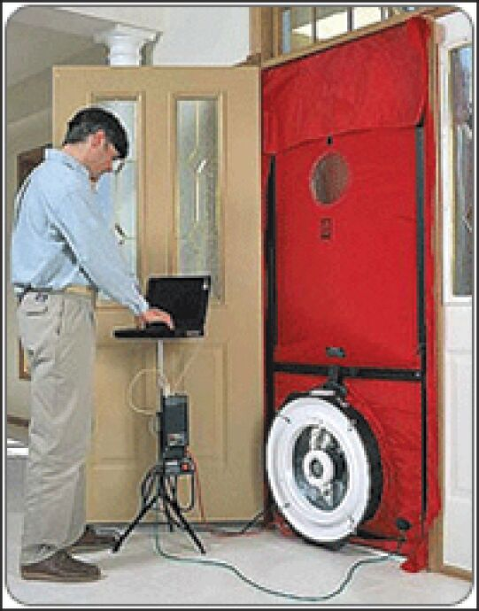
HERS Raters. The Home Energy Raters System (“HERS”) is the industry standard for measuring a home’s energy efficiency. We employ several accredited HERS raters and have affiliations with others. HERS raters are the primary means by which homes are qualified for the U.S. Environmental Protection Agency’s Energy Star for Homes Program, as well as for federal energy tax credits. HERS raters review insulation levels, window efficiency, HVAC system efficiency and water heating systems. They also do performance testing such as blower door tests to examine air and duct leakage.

IBP 2025 Proxy Statement
Corporate Responsibility

37

Table of Contents
Committing to Our People

We believe that our success and our future are directly attributable to the recruitment, development and retention of exceptional employees. Our people are our most valuable assets, making workforce safety, mental health and financial wellness paramount. We believe that employees who are engaged and committed for the long term are critical to our long-term strategy. The CHC Committee oversees our human capital management practices and receives regular updates on our employee welfare initiatives and employee engagement. The experience of the CHC Committee members in support of social initiatives and in human capital management strengthens the Board’s oversight and assures that our business strategy and long-term value creation are achieved within a responsible business model. Our culture of family unifies our workforce of approximately 10,833 employees in over 250 locations across the United States. |  |   
Below is key demographic data of our workforce as of December 31, 2024.

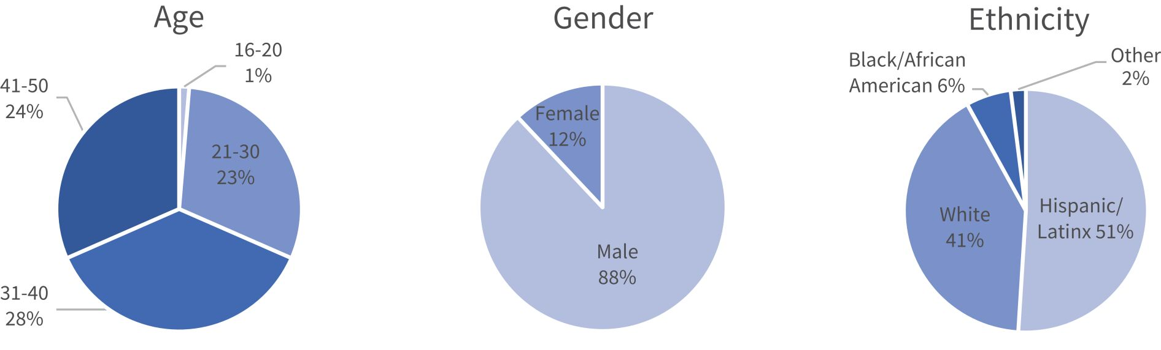

We strive to create an inclusive work culture for people of all backgrounds. We have developed a number of initiatives to help attract, develop and retain our workforce, which reduces turnover and training costs, increases productivity, builds a culture of belonging, enhances employee engagement, promotes a safer work environment, encourages customer loyalty and promotes community engagement. We believe that our retention efforts have reduced turnover levels across our installer base below the industry average, based on statistics reported by the U.S. Bureau of Labor Statistics. For example, in 2024, we experienced an average monthly turnover in our installer base of 2.8%, compared to 3.9% in the U.S. construction industry, according to the Bureau of Labor Statistics.

IBP 2025 Proxy Statement
Corporate Responsibility

38

Table of Contents
Our vision is to build an empathetic organization and to foster a culture that values inclusion and employee engagement and to create an environment where all employees feel as though they belong. Our employee initiatives are overseen by the CHC Committee, and include:

 | ◾ |  | Leadership training and development programs;
 | ◾ |  | Building an expanded hiring pipeline;
 | ◾ |  | Conducting employee focus groups to understand employee perceptions;
 | ◾ |  | Broadcasting our Positive Production Program videos to educate and encourage inclusion and employee well-being; and
 | ◾ |  | Offering both English and Spanish as a Second Language classes to remove communication hurdles among our workforce.
Benefits
Offering competitive pay and benefits helps us attract and retain talented employees. We offer a full range of benefits to qualifying employees, including medical, dental and vision insurance, prescription drug coverage, flexible spending accounts, 401(k) retirement programs with matching contributions, paid vacations and holidays, short- and long-term disability insurance, life insurance and group accident and critical illness insurance.
Safety
Employee safety is a core business objective. Our installers engage in physically strenuous, and, at times, hazardous work. We have detailed safety policies and each year significant staffing, funding and resources are allocated to safety and risk management. We have strong workplace safety measures that we call Lead with Safety, a continuing education program focused on creating a safer working environment for our employees and other jobsite personnel through year-round education and training. We have regional safety managers who are OSHA 500 certified outreach trainers who conduct intensive courses on OSHA safety training.
We track all incidents that occur on our job sites that could result in injury, including minor incidents that may not require first aid or medical treatment. We use this information to mitigate the potential for severe accidents and to refine our safety training programs. We believe our safety programs are having a positive impact. Our OSHA-defined incident rate per 100 employees was 5.10 for 2024, which was a decrease of 9% from 2023, and below our five year average of 5.86. Severe incidents increased from seven in 2023 to 11 in 2024. We have had no fatalities in the past three years.
Our safety programs include more than 35 training videos and a comprehensive list of policies and procedures for common construction industry hazards, including confined space, fall protection, hazardous chemicals communication, respiratory protection, hand and portable power tools, and drywall storage safety. Drivers take part in our fleet safety program. Each installer receives initial safety training upon hire and may receive tailored training depending upon duties. Safety training continues with weekly toolbox talks, quarterly safety initiatives, annual refresher training and safety excellence awards, keeping safety at the forefront for every employee.
Financial Wellness Program
We offer a multifaceted financial wellness education program to our employees to increase education and encourage responsible personal financial decision-making. The program educates participants on key personal financial topics, including budgeting, credit scores, debt reduction, saving and giving back to the community. One of the key components of this program is encouraging employees to establish personal savings accounts, which the Company matches dollar for dollar up to $1,000. Since inception of the program, we have matched over $6 million in employee personal savings. We believe this valuable program not only helps address employee retention, but helps educate our employees to prepare for their financial security.
Longevity Awards
Our longevity award program rewards employees who do not otherwise receive awards under another Company stock program for their long-time dedicated service to the Company. Eligible employees are awarded grants of restricted stock units for each ten years of continuous service to the Company, including service for companies that we acquire. Provided the Company meets a revenue target established in advance by the CHC Committee, employees are awarded restricted stock units based on a percentage of wages that convert one year later into shares of our common stock (for 2024 awards, the target was approximately $2.8 billion trailing 12-month revenue from July 1, 2023 to June 30, 2024). Through December 31, 2024, we have awarded approximately 165,000 restricted stock units under the program to approximately 1,980 employees with tenures ranging from 10 to 48 years. We believe the program rewards employees for valued service, assists in retention of our highly valued long-term employees and results in a highly motivated and engaged workforce.

IBP 2025 Proxy Statement
Corporate Responsibility

39

Table of Contents
Positive Production Program
The Positive Production Program is a well-being program developed for our employees to foster positive mental attitudes and to provide personal development learning opportunities. The goals of the program are:

 | ◾ |  | To provide opportunities to build strong relationships among employees and connect with one another
 | ◾ |  | To build strong teams and work environments with engaged employees
 | ◾ |  | To provide opportunities for employees to learn and grow
 | ◾ |  | To improve employee well-being by building awareness and sharing best practices
The elements of the Positive Production Program include in-house produced videos on topics such as growth mindset, emotional intelligence and gratitude, which are emailed or texted to all employees on a bi-weekly basis and streamed on screens at each branch location. The program focuses on essential workplace skills such as building trust, accountability, habit formation and goal setting, with the objective of enhancing collaboration, productivity and personal development.
Elevating our Neighborhoods
Volunteerism
Our branches serve communities nationwide and we are committed to investing in the communities where our employees live and work. We have numerous community engagement programs and encourage our employees to volunteer at nonprofit organizations in their local communities. Our employees contribute their time, passion and contributions to a wide variety of philanthropic organizations and we are proud to partner with them in their efforts.

 |  |  |  | 
In 2024, employees helped Star House organize and sort donations for the drop-in center. Star House operates Central Ohio’s only 24/7/365 drop-in center where homeless youth are provided access to food, clothing, hygiene items, laundry facilities, showers, and a safe place. IBP also supports Star House financially in its efforts to support teens and young adults as they exit homelessness and gain stability. |  |  |  | Our employees carved pumpkins for the annual Pumpkins A Glow exhibit at the Franklin Park Conservatory and Botanical Gardens. Pumpkins A Glow raises funds to help the conservatory offer horticulture, art and nature-based exhibitions and educational programs. The pumpkins carved by our team were among thousands on display during the 2024 event.

IBP 2025 Proxy Statement
Corporate Responsibility

40

Table of Contents
Installed Building Products Foundation
In 2019, we established the Installed Building Products Foundation (“Foundation”). The Foundation Advisory Board consists of non-executive employees representing all of our geographic regions in a wide range of job categories and is overseen by the CHC Committee. The Foundation sponsors programs focusing on education, community initiatives, employee financial assistance and housing-related needs. Dollar amounts in the table below are approximate and from Foundation inception.

 |  | Scholarship Program |  | The Building for Tomorrow Scholarship Program awards renewable scholarships of up to $5,000 to employees and their dependents attending accredited vocational or trade schools and universities or colleges. Selection criteria include academic performance, financial need and character reference letters. Preference is given to construction-related fields of study. We have awarded scholarships for associate’s degrees, certification and vocational programs, bachelor’s degrees, master’s degrees and other post-graduate programs. |  | $5.1 million  awarded
423
grants
 |  | Charitable Giving Match |  | Our Foundation matches cash gifts by employees of up to $500 per year or volunteer time of up to 25 hours ($20 per hour). Eligible organizations include tax-exempt public charities, nonprofit colleges, universities, hospitals and medical facilities and community service programs. |  | $48,936  Matched
137
cash gifts

 |  | Employee Financial Assistance |  | Our Employee Financial Assistance Program is designed to provide emergency financial assistance to our employees in times of crisis. The program provides for awards of up to $2,000 for food, shelter and other basic needs for employees who experience a qualifying event, such as a natural disaster or other acts of nature, house fire, accident, domestic abuse, crime, short term illness, death of a spouse, partner or dependent or military deployment. |  | $706,850  awarded
850
grants
 |  | Major Grants Program |  | Our Foundation’s Major Grants Program provides grants to 501(c)(3) organizations involved in building or renovating homes or providing shelter for those in need. |  | $4.6 million  awarded
108
grants

Corporate Giving
As we continue to grow, so does our commitment to being a positive force in the communities where our employees live and work. In addition to the Foundation, we have a robust corporate giving program that includes both national and local charities to which we have collectively contributed $4.6 million. We have entered into multi-year commitments with the Gary Sinise Foundation’s R.I.S.E. Program, YWCA of Central Ohio, The Columbus Metropolitan Library Foundation, Junior Achievement of Central Ohio, The Columbus Promise, Besa Community, Inc. and Zora’s House. Through our Foundation and corporate giving programs, we are committed to contribute 1% of EBITDA annually to nonprofit organizations to support initiatives focused on education, housing and strengthening our communities.

IBP 2025 Proxy Statement
Corporate Responsibility

41

Table of Contents
 |  |  |  | 
We believe in the power of education to change lives, and during its three-year pilot phase the Columbus Promise did just that. We were among the first donors to the program that provides Columbus City Schools graduating seniors the opportunity to attend Columbus State Community College tuition-free. 58% of those Promise scholars were the first in their family to attend college. |  |  |  | In the third year of our partnership with the Gary Sinise Foundation’s R.I.S.E. (Restoring Independence. Supporting Empowerment) program, our support went beyond a financial contribution. Our branches in Ohio, Florida, Virginia and Tennessee worked directly on specially adapted smart homes for wounded veterans and first responders.
Corporate Responsibility Materials
The following corporate responsibility materials are published on our website at
https://investors.installedbuildingproducts.com/corporate-governance:

 | ◾ |  | Conflict Minerals Policy
 | ◾ |  | Environmental Policy
 | ◾ |  | Human Rights Policy Statement
 | ◾ |  | Safety Policy
 | ◾ |  | Supplier Code of Conduct

IBP 2025 Proxy Statement
Corporate Responsibility

42

Table of Contents
PROPOSAL 2 – RATIFICATION OF THE
APPOINTMENT OF OUR INDEPENDENT
REGISTERED PUBLIC ACCOUNTING FIRM

Overview
Our Audit Committee is responsible for the appointment, compensation, retention and oversight of our independent registered public accounting firm. The Audit Committee has appointed, and the Board has ratified the appointment of, Deloitte & Touche LLP (“Deloitte”) to serve as our independent registered public accounting firm for the fiscal year ending December 31, 2025. Deloitte has served as our independent registered public accounting firm since 2013.
The Audit Committee annually reviews Deloitte’s performance and independence in deciding whether to retain Deloitte or to engage a different independent registered public accounting firm. In evaluating Deloitte’s performance, the Audit Committee considers a number of factors, among other things:

 | ◾ |  | the quality of the historical and recent performance of the firm;

 | ◾ |  | audit quality and efficiency, including the performance of the audit partner and audit team and their audit approach;

 | ◾ |  | the quality and candor of the firm’s communications with the Audit Committee;

 | ◾ |  | the independence, objectivity and integrity of the firm;

 | ◾ |  | known significant legal or regulatory proceedings against the firm;

 | ◾ |  | the firm’s internal quality control procedures;

 | ◾ |  | the appropriateness of the firm’s fees; and

 | ◾ |  | the benefits of having a long-tenured auditor and potential impact of selecting a new auditing firm.
Based upon its assessment of Deloitte’s performance, the Audit Committee believes that the retention of Deloitte as our independent registered public accounting firm is in the best interests of the Company and our stockholders. The Audit Committee believes that Deloitte’s tenure as our independent registered public accounting firm confers distinct benefits, including enhanced audit quality and efficiency due to Deloitte’s significant institutional knowledge of the Company and its operations, accounting practices and internal controls framework.
We are asking our stockholders to ratify the selection of Deloitte as our independent registered public accounting firm for 2025. Although stockholder ratification is not required, we value our stockholders’ views on our independent registered public accounting firm. If our stockholders fail to ratify the appointment of Deloitte, the Audit Committee will reconsider whether or not to retain Deloitte and may retain that firm or another firm without resubmitting the matter to our stockholders. Even if the selection of Deloitte is ratified, the Audit Committee may, in its discretion, select a different firm at any time during the year if it determines that such a change would be in the best interests of the Company and its stockholders.
A representative of Deloitte is expected to be present at the Annual Meeting, will be given an opportunity to make a statement and will be available to respond to appropriate questions.

IBP 2025 Proxy Statement
Proposal 2 – Ratification of the Appointment of our Independent Registered Public Accounting Firm

43

Table of Contents
Fees Paid to Deloitte
Deloitte audited our consolidated financial statements and effectiveness of internal controls over financial reporting during the years ended December 31, 2024 and 2023. During these periods, Deloitte provided both audit and non-audit services. The following table sets forth the aggregate fees we paid to Deloitte in 2024 and 2023, respectively.

 |  | 2024 |  |  |  | 2023
Audit Fees |  |  | $2,569,235 |  |  | $ | 2,339,666
Audit Related Fees |  |  | $33,442 |  |  |  | –
Tax Related Fees |  |  | – |  |  |  | –
All Other Fees |  |  | 2,037 |  |  |  | 2,037
Total |  |  | $2,604,714 |  |  | $ | 2,341,703
Audit Fees include fees for professional services rendered in connection with the audit of our annual consolidated financial statements and internal control over financial reporting, review of our quarterly consolidated financial statements and services that are normally provided in connection with statutory and regulatory filings or engagements.
Audit Related Fees were fees for permissible advisory services in connection with enterprise risk management services.
Tax Related Fees were fees for professional services rendered in connection with tax consultation services.
All Other Fees were fees for permissible work performed by Deloitte that does not fit within the above categories. The fees under this category are related to technical subscriptions.
Pre-Approval of Services
The Audit Committee has established a policy requiring pre-approval of all audit and non-audit services provided by our independent registered public accounting firm. On an ongoing basis, management submits to the Audit Committee specific projects and services to be performed by Deloitte for which it seeks advance approval. The Audit Committee reviews these requests and determines whether to approve the requested engagement. Periodically management reports to the Audit Committee the actual spending for such projects and services compared to the approved amounts. All services provided by Deloitte in 2024 were pre-approved by the Audit Committee in accordance with this policy.

IBP 2025 Proxy Statement
Proposal 2 – Ratification of the Appointment of our Independent Registered Public Accounting Firm

44

Table of Contents
Report of the Audit Committee

Management is responsible for the preparation and presentation of the Company’s financial statements and for developing and maintaining internal controls over financial reporting and procedures that are reasonably designed to assure compliance with accounting standards and applicable law. The Company’s independent registered public accounting firm, Deloitte & Touche LLP (“Deloitte”), is responsible for performing an independent audit of the Company’s consolidated financial statements in accordance with the standards of the Public Company Accounting Oversight Board (United States) (“PCAOB”).

The Audit Committee’s responsibility is to provide independent and objective oversight of the Company’s financial reporting and internal controls processes and the audit work of Deloitte. In fulfilling its oversight responsibilities, the Audit Committee has reviewed and discussed with management and Deloitte the Company’s audited consolidated financial statements for the fiscal year ended December 31, 2024, the fair and complete presentation of the Company’s results and the assessment of the Company’s internal controls over financial reporting. The Audit Committee discussed significant accounting policies applied in the Company’s financial statements, and, when applicable, alternative accounting treatments. Management represented to the Audit Committee that the financial statements were prepared in accordance with accounting principles generally accepted in the United States. The Audit Committee has also discussed with Deloitte the matters required by the applicable requirements of the PCAOB and the Securities and Exchange Commission.

In addition, the Audit Committee reviewed and discussed with Deloitte its independence from the Company and management. As part of that review, the Audit Committee received the written disclosures from Deloitte required by the PCAOB, and the Audit Committee considered and discussed Deloitte’s independence, including whether the firm’s provision of non-audit services to the Company is compatible with its independence. The Audit Committee concluded that Deloitte is independent from the Company and its management.

The Audit Committee discussed with the Company’s Internal Audit department and Deloitte the overall scope of and plans for their respective audits. The Audit Committee meets with the Vice President of Internal Audit and representatives of Deloitte, in regular and executive sessions, to discuss the results of their examinations, the evaluations of the Company’s internal controls and the overall quality of the Company’s financial reporting and compliance programs.

Based on these reviews and discussions, the Audit Committee has recommended to the Board that the audited consolidated financial statements for 2024 be included in the Company’s Annual Report on Form 10-K for the fiscal year ended December 31, 2024. The Audit Committee has selected, and the Board of Directors has ratified the selection of, Deloitte as the Company’s independent registered public accounting firm for 2025.

Audit Committee

Lawrence A. Hilsheimer (Chair)
Margot L. Carter
Michael H. Thomas

Required Vote and Recommendation of the Board
The affirmative vote of a majority of the shares present or represented by proxy at the Annual Meeting and entitled to vote is required to ratify the appointment of Deloitte as our independent registered public accounting firm for 2025. Brokers have discretion to vote on this proposal in the absence of voting instructions. Abstentions will have the same effect as votes “AGAINST” this proposal. Broker non-votes will have no effect on the outcome of this proposal. Unless otherwise instructed, the persons named as proxies will vote “FOR” this proposal.

THE BOARD OF DIRECTORS UNANIMOUSLY RECOMMENDS THAT YOU VOTE “FOR” THE RATIFICATION OF THE APPOINTMENT OF DELOITTE & TOUCHE LLP AS OUR INDEPENDENT REGISTERED PUBLIC ACCOUNTING FIRM FOR 2025.

THE BOARD BELIEVES THAT IT IS IN THE BEST INTERESTS OF THE COMPANY AND ITS STOCKHOLDERS TO RETAIN DELOITTE AS OUR PUBLIC ACCOUNTING FIRM.

IBP 2025 Proxy Statement
Proposal 2 – Ratification of the Appointment of our Independent Registered Public Accounting Firm

45

Table of Contents
PROPOSAL 3 – NON-BINDING ADVISORY VOTE ON EXECUTIVE COMPENSATION

As required by Section 14A of the Securities Exchange Act of 1934 (the “Exchange Act”) and as a matter of good corporate governance, we are seeking stockholder approval of our executive compensation program. This vote is not intended to address any specific item of compensation, but rather the overall compensation of our named executive officers (“NEOs”) and the executive compensation program and practices described in this Proxy Statement.
Stockholders are being asked to vote on the following advisory resolution:
“RESOLVED, that the Company’s stockholders approve, on an advisory basis, the compensation of the Company’s named executive officers for 2024, as disclosed pursuant to the compensation disclosure rules of the Securities and Exchange Commission, including the Compensation Discussion and Analysis and accompanying compensation tables and related narrative disclosures in the Company’s Proxy Statement.”
We have a pay for performance philosophy that forms the foundation of our decisions regarding payment of executive compensation. We believe that this philosophy and the compensation structure established by the CHC Committee are central to our ability to attract, retain and motivate individuals who can achieve superior financial results in the best interests of the Company and our stockholders. We link pay to performance by weighting a significant portion of the target compensation of our NEOs in variable, or “at risk,” compensation elements. We also align our NEOs’ financial interests with those of our stockholders by awarding a substantial portion of total compensation in the form of equity that is coupled with stock ownership requirements.
We urge you to read “Executive Compensation – Compensation Discussion and Analysis” below, which describes in detail how our executive compensation program operates and is designed to achieve our compensation objectives, as well as the accompanying compensation tables and narratives that provide detailed information on the compensation of our NEOs.
This advisory vote, commonly referred to as a “say-on-pay” advisory vote, is non-binding. However, the outcome of the vote will provide valuable information to the CHC Committee regarding stockholder sentiment about our compensation program, which the CHC Committee will consider when making future decisions regarding the compensation of our NEOs. Our executive compensation program was strongly supported by our stockholders in 2024, with approximately 96% of the votes cast at the 2024 Annual Meeting of Stockholders voting in favor. We have held a similar stockholder vote every year since 2017 and expect to hold a similar vote at the 2026 Annual Meeting of Stockholders.
Required Vote and Recommendation of the Board
The affirmative vote of a majority of the shares present or represented by proxy at the Annual Meeting and entitled to vote is required for approval of this advisory resolution. Abstentions will have the same effect as votes “AGAINST” this proposal. Broker non-votes will have no effect on the outcome of the proposal. Unless otherwise instructed, the persons named as proxies will vote “FOR” this proposal.

THE BOARD UNANIMOUSLY RECOMMENDS THAT YOU VOTE “FOR” THE NON-BINDING ADVISORY RESOLUTION APPROVING THE COMPENSATION OF OUR NAMED EXECUTIVE OFFICERS.

THE BOARD BELIEVES THAT OUR COMPENSATION PROGRAM SUPPORTS OUR BUSINESS MODEL AND THE OBJECTIVES AND VALUES DESCRIBED IN THE “COMPENSATION DISCUSSION AND ANALYSIS” IN THIS PROXY STATEMENT.

IBP 2025 Proxy Statement
Proposal 3 – Non-Binding Advisory Vote on Executive Compensation

46

Table of Contents
EXECUTIVE OFFICERS AND CERTAIN SIGNIFICANT EMPLOYEES

The following biographical information regarding our executive officers and certain significant employees is as of April 8, 2025:
Executive Officers

Jeffrey W. Edwards  Age 61  President, Chief Executive Officer and Chairman |  | Mr. Edwards is our President, Chief Executive Officer and Chairman and has held these positions since 2011, 2004 and 1999, respectively. Mr. Edwards’ position allows him to advise the Board on management’s perspective over a full range of issues affecting the Company. Prior to joining us, Mr. Edwards acted as an officer and strategist for several companies that he and his family started, acquired or invested in over more than 40 years across a variety of industries, including multi-family and student housing development and management, industrial tool distribution, wholesale building supply, homebuilding, restaurants and real estate development and real estate brokerage. Since 1988, Mr. Edwards has been involved in the launch of many business ventures as well as commercial real estate developments in central Ohio and elsewhere. He holds a B.S. in Marketing from Miami University.
Todd R. Fry  Age 59  Chief Accounting  Officer |  | Mr. Fry has been our Chief Accounting Officer since April 2014 and our Treasurer since March 2015. He was Chief Financial Officer of Champion Industries, Inc., a commercial printer, business form manufacturer and supplier of office products and office furniture, from 1999 to April 2014, where his responsibilities included SEC reporting, Sarbanes-Oxley compliance, mergers & acquisitions, corporate governance, risk management and debt negotiation. From 1997 to 1999, Mr. Fry served as Chief Financial Officer of Broughton Foods Company, where he led both the initial public offering and subsequent sale of the company. Mr. Fry served in various positions at Coopers & Lybrand L.L.P. from 1991 to 1997. Mr. Fry holds a B.S. from The Ohio State University. Mr. Fry has served as a director of Summit State Bank since 2000.
W. Jeffrey Hire  Age 73  President of External  Affairs |  | Mr. Hire joined the Company in 2008 and was named President of External Affairs in 2013. His responsibilities include working with our national homebuilder customers, our major insulation suppliers and industry associations. Prior to joining us, from 1978 to 2008, Mr. Hire held numerous management positions at Owens Corning. From 2006 to 2008, he served as Director of Products and Programs for the Insulating Systems Business, developing product innovations and value-added customer programs. For 11 years prior to that, Mr. Hire was General Manager of the Insulation Contractor Segment of the Residential Insulation Division. He earned a B.S. in Philosophy from University of Mount Union in Alliance, Ohio and an M.B.A. specializing in General Management from The University of St. Thomas Opus College of Business in St. Paul, Minnesota. He serves on the Board of the Insulation Contractors Association of America and has served twice as its President. Mr. Hire has served as a Committee Chairman for the North American Insulation Manufacturers Association. Mr. Hire received the Insulation Contractors Association of America’s “Key Man” award for his leadership and dedication to the industry.
Michael T. Miller  Age 60  Executive Vice President, Chief Financial Officer and  Director |  | Mr. Miller has served as our most senior financial officer since he joined us in 2000 as our Executive Vice President – Finance. He has been our Chief Financial Officer since 2013 and as a director for us and our predecessor since 2004. Prior to joining the Company, Mr. Miller held the position of Senior Vice President/Managing Director responsible for Corporate Investment Banking at Huntington Capital Corp., a subsidiary of Huntington Bancshares, Inc., a regional bank holding company. Before joining Huntington in 1991, Mr. Miller held various positions with Deutsche Bank and Canadian Imperial Bank of Commerce in New York. Mr. Miller began his career at First Union National Bank in Charlotte, North Carolina. He holds a B.A. from Wake Forest University. Mr. Miller served on the Board of BMC Stock Holdings, Inc. from 2014 to January 2021.

IBP 2025 Proxy Statement
Executive Officers and Certain Significant Employees

47

Table of Contents
Jason R. Niswonger  Age 52  Chief Administrative  and Sustainability Officer |  | Mr. Niswonger has been our Chief Administrative and Sustainability Officer since March 2022. Previously Mr. Niswonger served as our Senior Vice President, Finance and Investor Relations from March 2015 to February 2022 and our Director of Investor Relations from January 2014 until March 2015. Prior to joining the Company, he served from 2011 to 2013 as the Director, Financial Reporting for Edwards Industries, a national property development and management company. From 2006 to 2011, Mr. Niswonger held multiple positions, including the Director, Finance for the Seating Systems Division of Commercial Vehicle Group, Inc., a supplier of integrated system solutions for the global commercial vehicle market. From 2004 to 2006, he was the Director, Financial Reporting for Installed Building Products, LLC. Prior to joining Installed Building Products, LLC, Mr. Niswonger served as the Director of Global Accounting and Financial Reporting at Sterling Commerce, Inc., a global provider of EDI services, B2B integration software solutions and consulting, where he worked from 2000 to 2004. Prior to joining Sterling, he held positions in financial reporting at Express, a division of The Limited, and Exel Logistics. Mr. Niswonger earned an M.B.A. from Otterbein College and a B.A. from Ohio University.
Brad A. Wheeler  Age 50  Chief Operating Officer |  | Mr. Wheeler was named our Chief Operating Officer effective January 1, 2024. Prior to becoming Chief Operating Officer, Mr. Wheeler served as a Regional President from January 2015 through December 2024. He joined the Company in 2010 as a Regional Manager and has been responsible for the management of our operations in several states, including Colorado, Texas, Florida and Georgia. In June 2022, Mr. Wheeler assumed additional responsibility for Alpha’s heavy commercial business and was named President of the Alpha family of companies. He attended Radford University and has been an active member of Vistage International CEO Organization since 2011.
Certain Key Employees

Randall A. Hall  Age 63  President, Aster  Contractors Holdings, LLC |  | Mr. Hall has been President of Aster Contractors Holdings, LLC, one of our subsidiaries, since October 2020. Mr. Hall joined the Company in 1995 and has held a number of positions, including regional manager (January 2017-October 2020), regional operations performance manager (2016-2017), manager of our Cornerstone Energy Conservation Service operations and manager of our Edwards/Mooney & Moses branch operations. Prior to joining the Company, Mr. Hall served as the Vice President of Operations and Vice President of Finance at Pipeliner Systems, Inc., and as an accountant at Bolon, Hart & Buehler, Inc. He received a B.S. in Accounting from Franklin University in Columbus, Ohio.
R. Scott Jenkins  Age 69  Regional President |  | Mr. Jenkins has been a Regional President since 2006 when we acquired OJ Insulation, Inc., which he co-founded in 1984. Since joining us, Mr. Jenkins has been responsible for the management of operations in several states, including Minnesota, Idaho, Washington and California. During his 22-year tenure at OJ Insulation as owner and chief executive officer, Mr. Jenkins was responsible for numerous strategic acquisitions and significant company growth. He received a B.A. in Social Science from the University of California at Irvine and was an active member of Vistage International CEO Organization for over 15 years.
William W. Jenkins  Age 68  Division President, Purchasing and Distribution |  | Mr. Jenkins has been our Division President, Purchasing and Distribution, since October 2024. He served as our Senior Vice President, Purchasing and Supply Chain from March 2015 until October 2024, and our Director of Internal Audit from September 2013 until March 2015. He held other senior management positions from 1998 to 2013. Mr. Jenkins began his career with Ernst & Young LLP, where he progressed to become a Senior Manager. He graduated from The Ohio State University with a B.S. and was licensed as a CPA in the State of Ohio.

IBP 2025 Proxy Statement
Executive Officers and Certain Significant Employees

48

Table of Contents
Martin J. Luffy  Age 65  Chief Information Officer |  | Mr. Luffy has been our Chief Information Officer since joining the company in 2002. Prior to joining Installed Building Products, he served in a number of roles for an international data center hosting provider, including Regional Director and Vice President of Data Center Operations and Services. Mr. Luffy began his career with Arthur Andersen and Peat Marwick and has held successive senior management positions with a number of technology and professional services entities. He received a B.S. degree from Purdue University and a M.B.A. from the University of Dayton. Mr. Luffy has served on multiple nonprofit boards including his current role on the board of a foundation that provides financial aid assistance for cancer patients.
Shelley A. McBride  Age 68  General Counsel and Secretary |  | Ms. McBride joined the Company in 2005 as General Counsel and Secretary. Prior to joining the Company, she worked as an attorney at the law firm of Calfee, Halter & Griswold, representing corporate and institutional clients in the areas of mergers and acquisitions, secured credit transactions, subordinated debt financings, common and preferred equity investments, organizational restructuring and general corporate matters. Before joining Calfee, Halter & Griswold in 2001, Ms. McBride served as legal counsel for Nationwide Mutual Insurance Company in the Nationwide Enterprise Office of Investments and also served as legal counsel for various investment funds at Banc One Capital. Her experience includes representing corporate and institutional clients at the law firms of Squire Patton Boggs and Kegler, Brown, Hill & Ritter. From 1983 to 1989, Ms. McBride served as a law clerk to the Honorable John D. Holschuh and the Honorable Mark R. Abel in the United States District Court for the Southern District of Ohio. Ms. McBride earned a J.D. and a B.A. from The Ohio State University.
Warren W. Pearce  Age 66  Regional President |  | Mr. Pearce has been a Regional President since 2011. Since joining the Company, Mr. Pearce has been responsible for the management of operations in several states, including Ohio, North Carolina, Virginia and Maryland. From 2004 to 2011, he was Vice President of Operations for Masco Corporation, a manufacturer of home products, distributor of building products and installer of building products, where he held various other positions beginning in 1984. Mr. Pearce began his career at Carroll Insulation and later served as branch manager at American Aluminum Insulation. He received from Kent Votech his Electrical Apprenticeship certification.
Kelly Clifford Riehl  Age 48  Vice President of Communications and Community Relations |  | Ms. Clifford Riehl has been our Vice President of Communications and Community Relations since May 2023 and the President of our Foundation since March 2019. She served as our Director of Communications and Community Relations from 2014 to 2023 and our Marketing Manager from 2009 to 2014. Prior to joining us, Ms. Clifford Riehl led a meeting and event company, The Meeting Partners Group, and served in communications, management and marketing roles at Nationwide Arena, the Greater Columbus Convention Center and the Radiological Society of North America. Ms. Clifford Riehl has a Bachelor of Science degree in Organizations Communications from Ohio University and serves on numerous nonprofit boards.
Randall S. Williamson  Age 63  Regional President |  | Mr. Williamson has been a Regional President since 2001. Since joining us, Mr. Williamson has been responsible for the management of operations in several states, including Massachusetts, New Jersey, New York and Michigan. He began his career in 1981 at Monroe Insulation and Gutter Company Incorporated, or Monroe, where he progressed to become Vice President in 1992. In 1996, Mr. Williamson purchased Monroe and merged it with other companies to form American Building Systems, Inc., where he served as President until 2001. American Building Systems, Inc. merged with us in 2001. Mr. Williamson attended Colorado State University and serves on the board of governors for U.S. Grown Foods.

IBP 2025 Proxy Statement
Executive Officers and Certain Significant Employees

49

Table of Contents
COMPENSATION DISCUSSION AND ANALYSIS

CHC Committee Report

The CHC Committee has reviewed the Compensation Discussion and Analysis (“CD&A”) included in this Proxy Statement and has discussed the CD&A with members of the management team involved in the compensation process. Based on such review and discussions, the CHC Committee recommended to the Board of Directors that the CD&A be included in this Proxy Statement and incorporated in the Company’s Annual Report on Form 10-K for the year ended December 31, 2024.

CHC Committee

Janet E. Jackson (Chair)
David R. Meuse
Marchelle E. Moore

CD&A Table of Contents

Section 1 – Executive Summary |  | Page |  | Section 3 – Elements of our Compensation Program |  | Page
◾ Our Growth Strategy |  | 51 |  | ◾ Compensation Components |  | 59
◾ Our Capital Allocation Strategy |  | 52 |  | ◾ Base Salary |  | 60
◾ Our Acquisition Strategy |  | 53 |  | ◾ Performance-Based Cash Incentives |  | 60
◾ 2024 Financial Highlights |  | 53 |  | ◾ Performance-Based Equity Incentives |  | 61
◾ Pay for Performance |  | 53 |  | Section 4 – What we Paid in 2024
◾ 2024 Say-on-Pay Voting Results |  | 54 |  | ◾ 2024 Base Salary |  | 61
◾ 2024 Named Executive Officers |  | 54 |  | ◾ 2024 Performance-Based Incentive Cash Awards |  | 62
◾ 2024 Executive Compensation at a Glance |  | 54 |  | ◾ 2024 Performance-Based Incentive Equity Awards |  | 62
◾ 2024 Target Compensation Mix |  | 54 |  | ◾ Compensation Changes after December 31, 2024 |  | 63
◾ Key Compensation Practices for Executives |  | 55 |  | Section 5 – Other Compensation and Policies
Section 2 – How We Determine Pay |  |  |  | ◾ Perquisites |  | 65
◾ Our Philosophy |  | 55 |  | ◾ Post-Termination Compensation |  | 65
◾ Our Goals |  | 55 |  | ◾ Retirement Benefits |  | 65
◾ Our Guiding Principles |  | 56 |  | ◾ Equity Grant Practices |  | 66
◾ Our Process |  | 56 |  | ◾ Taxes |  | 66
◾ Competitive Positioning |  | 57 |  | ◾ Stock Ownership Policy |  | 66
◾ Advisory Stock Vote |  | 58 |  | ◾ Clawback Policies |  | 67
◾ Risk Management |  | 58

IBP 2025 Proxy Statement
Compensation Discussion and Analysis

50

Table of Contents
Section 1 – Executive Summary
Our Growth Strategy
We are focused on diversifying our products and services, broadening our mix of end market exposure and expanding our geographic footprint. Our growth strategy includes acquisition of residential and commercial installers in new markets, acquisitions of businesses offering complementary products, introduction of new product offerings in existing markets, pursuit of new product categories in commercial markets, and expanding our multi-family sales in existing branches.
In February 2024, we celebrated ten years as a publicly traded company. At the time of our public offering in 2014, we had approximately 3,200 employees, and we estimate that we had a national residential insulation market share of approximately 16%. We currently have approximately 10,800 employees and we estimate that we service approximately 30% of the residential insulation market. During our ten year history as a public company, we have a demonstrated record of success for each of our growth strategies:

 | ◾ |  | Product diversification - Revenue from insulation installation services represented approximately 76% of our total revenues in 2014 compared to 60% in 2024.

 | ◾ |  | End market diversification - We have decreased our single family residential new construction end market exposure from 73% in 2014 to 57% in 2024.

 | ◾ |  | Geographic expansion - We have added approximately 150 branch locations since 2014.

 |  |  |  | 2014 |  |  |  | 2024
Revenue
by
Product
Revenue
by
End-
Market

IBP 2025 Proxy Statement
Compensation Discussion and Analysis

51

Table of Contents

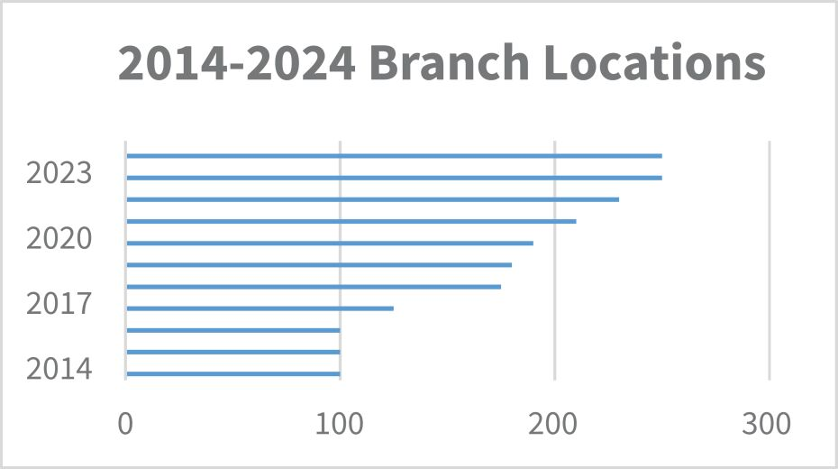
Our Capital Allocation Strategy
Our capital allocation priorities include:

 | • |  | Acquisitions, which contribute to our profitability and anchor our growth strategies of product, end market and geographic diversification, and
 | • |  | Quarterly and annual variable dividends and opportunistic share repurchases, which provide direct returns to our stockholders.
In 2024, we acquired nine businesses with revenues exceeding $100 million, which expanded our geographic presence in attractive housing markets. We returned a record $230 million to stockholders, including quarterly and variable dividends of $85 million and stock repurchases of $145 million.

IBP 2025 Proxy Statement
Compensation Discussion and Analysis

52

Table of Contents
Our Acquisition Strategy
In the 1990s, we began our acquisition strategy with the goal of creating a national platform and have since grown, by our estimate, to become one of the nation’s largest installers of insulation in the residential new construction end market. Since 1999, we have successfully completed and integrated over 200 acquisitions, which have expanded our scale and market presence and diversified our product offerings and end market exposures. Our asset-light model generates substantial operating cash flow, which supports further acquisition growth. In 2024, we successfully acquired and integrated nine businesses representing more than $100 million in aggregate annual revenues.

◾ Keys to our acquisition approach

✓ Target profitable markets and outstanding operators

✓ Acquire operations with a strong reputation and customer base

✓ Maintain existing management teams and trade names

✓ Leverage national buying power

✓ Leverage relationships with national homebuilders
2024 Financial Highlights

Net Revenue |  | Gross Profit |  | Net Income |  | Diluted Earnings  Per Share |  | Adjusted EBITDA*
$2.9  billion  5.9% increase |  | $994.5  million  6.9% increase |  | $256.6  million  5.3% increase |  | $9.10  5.7% increase |  | $511.4  million  5.2% increase
*See “Additional Information – Use of Non-GAAP Financial Measures” for a reconciliation of Adjusted EBITDA to the most directly comparable U.S. generally accepted accounting principles (“GAAP”) measure. Figures above reflect year over year increases.
Pay for Performance
Our executive compensation philosophy is to provide a competitive compensation package weighted toward Company performance and aligned with our stockholders’ long-term interests. The CHC Committee believes that our executive compensation program drives performance and increases stockholder value. The CHC Committee believes that total compensation for the Company’s named executive officers should align with the Company’s financial and strategic objectives and sustained growth, as well as individual performance, level of responsibility and experience. Consistent with that philosophy, in 2024 approximately 85.5% of our Chief Executive Officer’s and an average of 70.0% of our other named executive officers’ total target compensation reflected our continued emphasis on at-risk compensation linked with the Company’s operational and financial performance. Any incentive compensation earned by our NEOs depends upon the Company’s achieved Adjusted EBITDA during the performance period as compared against the target set in advance by the CHC Committee. Performance-based restricted stock is awarded as a number of shares rather than a fixed dollar amount, so the value of the restricted stock award fluctuates with our stock price during the performance period and the additional two year vesting period, strongly aligning the interests of our NEOs with the interests of our stockholders.

IBP 2025 Proxy Statement
Compensation Discussion and Analysis

53

Table of Contents
2024 Say-on-Pay Voting Results
Our executive compensation program received strong support from our stockholders in 2024, with more than 96% the votes cast at the 2024 Annual Meeting of Stockholders voting in favor. The CHC Committee believes that this level of support is indicative of our stockholders’ strong support of our compensation practices and pay for performance alignment and influenced its decision to retain the core elements of our executive compensation program.
2024 Named Executive Officers

 |  |  |  |  |  |  |  | 
Jeffrey W. Edwards |  | Michael T. Miller |  | Brad A. Wheeler |  | W. Jeffrey Hire |  | Jason R. Niswonger
President, Chief Executive  Officer and Chairman |  | Executive Vice President and  Chief Financial Officer |  | Chief Operating Officer |  | President, External Affairs |  | Chief Administrative and  Sustainability Officer
2024 Executive Compensation at a Glance

Name |  | Base  Salary  ($)(1) |  |  |  |  | Performance-Based  Cash Award Earned  ($) |  |  |  |  | Performance-Based  Restricted Stock  Award Earned  Fair Value  ($)(2) |  |  |  |  | Earned  Compensation  Total  ($)
Jeffrey W. Edwards |  |  |  | 900,000 |  |  |  |  | 1,247,480 |  |  |  |  | 3,186,637 |  |  |  |  | 5,334,117
Michael T. Miller |  |  |  | 475,000 |  |  |  |  | 455,810 |  |  |  |  | 995,814 |  |  |  |  | 1,926,624
Brad A. Wheeler |  |  |  | 485,000 |  |  |  |  | 431,820 |  |  |  |  | 796,618 |  |  |  |  | 1,713,438
W. Jeffrey Hire |  |  |  | 450,000 |  |  |  |  | 215,910 |  |  |  |  | 219,049 |  |  |  |  | 884,959
Jason R. Niswonger |  |  |  | 465,000 |  |  |  |  | 278,284 |  |  |  |  | 398,227 |  |  |  |  | 1,141,511

 | (1) | Effective April 1, 2024.
 | (2) | The earned fair value was determined by multiplying the closing price of the Company’s common stock on February 25, 2025 ($170.99) (the date of certification of the achievement of the performance metric) by the number of shares awarded. The restricted stock vests in equal installments over two years (subject to continued employment).
2024 Target Compensation Mix
Our executive compensation program for 2024 consisted of three components: base salary, performance-based cash awards and performance-based restricted stock awards. The CHC Committee believes that a significant portion of each NEO’s target compensation should be at risk and based on Company performance. The graphics below reflect the mix of target executive compensation for 2024 and highlights the at-risk portion of total target compensation:

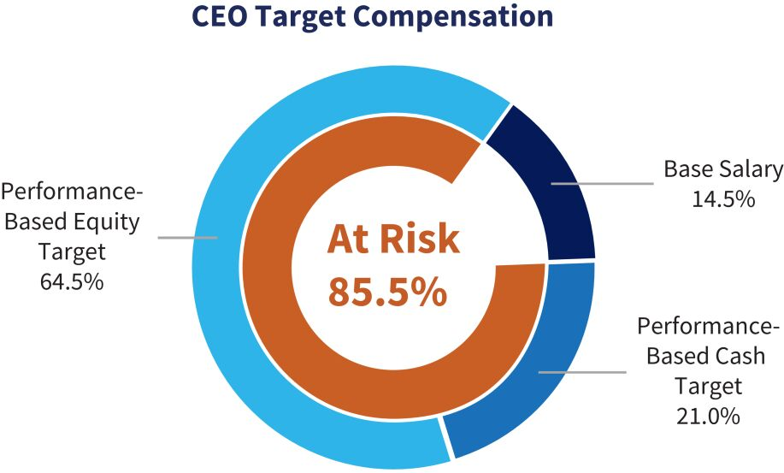 |  | 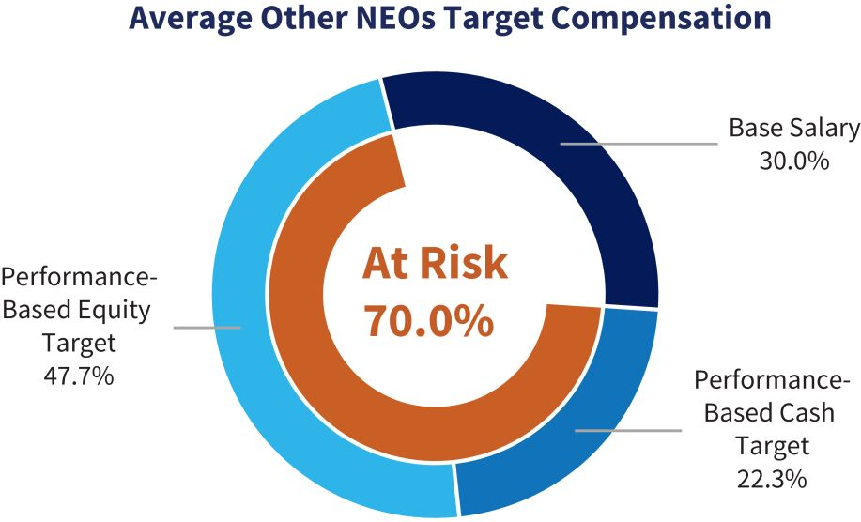

IBP 2025 Proxy Statement
Compensation Discussion and Analysis

54

Table of Contents
Key Compensation Practices for Executives

What We Do |  |  |  | What We Don’t Do
✓ Pay for Performance where a substantial percentage of compensation is based on achievement of objective pre-established performance metrics  ✓ Balanced Compensation Mix of salary and performance-based cash bonuses and restricted stock awards  ✓ Multi-year Vesting of Equity Awards over a two-year period after the performance target is met  ✓ Limited Perquisites that are not available to other salaried employees  ✓ Competitive Pay targeted near the median of our peer group  ✓ Clawback Policies for recovery of incentive compensation under specified circumstances  ✓ Meaningful Equity Ownership Requirements as a multiple of base salary  ✓ Annual Say-on-Pay Vote on executive compensation |  |  |  | ✗ No Tax Gross-Ups for perquisites or excise taxes  ✗ No Pension Plans or retirement benefits that are not available to other salaried employees  ✗ No Hedging or other monetization transactions involving Company securities (the Board has made an exception for our CEO, see Footnote 2 in the “Stock Ownership Table” beginning on page 79)  ✗ No Short Sales or other speculative transactions involving Company securities  ✗ No Option Repricing of underwater stock options without stockholder approval  ✗ No Single Trigger accelerated vesting of incentive awards upon a change in control without a qualifying loss of employment  ✗ No Pledging of Company securities as collateral or holding Company securities as collateral in a margin account (the Board has made an exception for our CEO, see Footnote 2 in the “Stock Ownership Table” beginning on page 79)  ✗ No Employment Agreements for our executives other than  our Chief Executive Officer
Section 2 – How We Determine Pay
Our Philosophy
Our executive compensation philosophy is to provide a competitive compensation package weighted toward Company performance and aligned with our stockholders’ long-term interests. Our executive compensation program is both reflective of the strategic value of the individual’s position and designed to ensure long-term retention and motivation. Our objective is to offer compensation opportunities competitive with our peer companies with respect to overall compensation (cash and equity), allowing for differences in the Company’s size, scale and scope and the individual’s job responsibilities.
Our Goals

 | ∎ |  | To attract, motivate and retain exceptional executives who are critical to successful execution of the Company’s growth strategy, long-term Company performance and the creation of stockholder value.
 | ∎ |  | To align the interests of our executives with those of our stockholders by tying a significant amount of executive compensation to the achievement of performance metrics related to our business strategy and financial performance and to the price of our stock.
 | ∎ |  | To motivate our executives to perform at the highest level, to achieve our financial, operational and strategic goals and to reinforce our commitment to high-quality service, which is primarily responsible for the strength of our long-standing relationships with our customers and suppliers.

IBP 2025 Proxy Statement
Compensation Discussion and Analysis

55

Table of Contents
Our Guiding Principles

 | ∎ |  | Pay for Performance. We reward our executives’ achievements by linking a significant portion of their compensation to the Company’s financial and operational performance. Our incentive compensation program has a pre-established objective performance metric that reflects strategic and operational objectives. Incentive compensation varies based on the extent to which the objective is met - if the target is not achieved at a level of at least 50%, then no incentive compensation is payable, while if the target is exceeded, executives have an opportunity to earn above-target incentive compensation, up to a maximum of 200% of target.

 | ∎ |  | Competitive Pay. Our compensation program is designed to attract, retain, motivate and reward top talent through pay elements that are flexible and competitive with our peers.

 | ∎ |  | Internal Pay Equity. We believe that internal pay equity ensures fairness and encourages a collaborative environment among our executive team. The CHC Committee reviews each NEO’s pay components and levels relative to other NEOs, considering experience, leadership role, seniority and level of responsibility.

 | ∎ |  | Aligned with Stockholders. A significant portion of our executives’ compensation is in the form of at-risk performance-based equity awards that, if earned, vest over an additional two years after the end of the performance period. We award restricted stock based on a number of shares, rather than a dollar value, so the value of an executive’s equity-based award fluctuates with the price of our common stock during the performance period and the two-year vesting period, which aligns the long-term interests of our executives with those of our stockholders. In furtherance of this principle, our NEOs are required to maintain levels of ownership of our common stock based upon a multiple of their salaries.
The CHC Committee considers the overall mix of cash and equity compensation, annual and long-term incentives and fixed and variable pay in determining our executive compensation program. The CHC Committee does not follow any pre-established policies, guidelines or formulas for allocating compensation mix, instead retaining flexibility by determining annually what it believes is the appropriate mix of compensation elements.
Our Process
Role of the CHC Committee. Our CHC Committee, comprised solely of independent directors, is responsible for the establishment, implementation, administration and oversight of our executive compensation program. During its regular first quarter meeting, the CHC Committee, in consultation with our Chief Executive Officer and Chief Financial Officer, determines incentive compensation earned by our NEOs based on the prior year’s performance and finalizes base salary, performance metrics and target incentive compensation levels for the current year. Later in the year, the committee reviews materials relating to peer group composition and other information that forms the basis for future decisions. The CHC Committee sets compensation consistent with our compensation philosophy and competitive with our peers, considering a balance of information including the experience, leadership, level of responsibility and performance of the executive team. While the CHC Committee consults with management and its independent compensation consultant in determining our compensation program, final authority rests solely with the committee. For more information regarding the CHC Committee, see Corporate Governance – “Board Committee Oversight – CHC Committee.”
Role of Executives. In the course of determining executive compensation, the CHC Committee solicits input from management. The committee believes this input is valuable because of the Chief Executive Officer’s and Chief Financial Officer’s comprehensive knowledge of our business and financial and strategic goals. Our Chief Executive Officer and Chief Financial Officer (i) provide data, analysis and recommendations to the CHC Committee regarding the Company’s compensation programs, (ii) annually evaluate the performance of our NEOs (other than themselves) based on each individual’s performance, length of service, experience, level of responsibility and achievement of Company strategic goals, and (iii) propose to the committee the performance metrics for target incentive awards. The CHC Committee from time to time delegates certain administrative duties to management and the human resources department.
Role of Compensation Consultants. The CHC Committee engages Meridian Compensation Partners, LLC, (“Meridian”), as an independent consultant to assist the committee with its duties. Meridian reports directly to the committee. In July and November 2023, the CHC Committee engaged Meridian to perform a review of our executive compensation program and non-employee director compensation and to conduct market comparisons with our peer group. The committee considered Meridian’s advice in structuring our compensation program. The CHC Committee intends to engage Meridian or a similar firm to review our executive

IBP 2025 Proxy Statement
Compensation Discussion and Analysis

56

Table of Contents
compensation and non-employee director compensation programs approximately every two years, unless the committee determines to have a more frequent review. In connection with the engagement of Meridian, the committee considered and assessed all relevant factors, including those set forth in applicable SEC and NYSE rules, that could give rise to a potential conflict of interest. Based upon this review, the CHC Committee determined that engaging Meridian did not raise any conflict of interest.
Competitive Positioning
Meridian, in consultation with our management and CHC Committee, compiles reports of compensation data for executive officers and non-employee directors in our peer group. The data for executives includes base salary, target cash incentive compensation, long-term incentive awards, target total compensation and variable pay mix. Meridian compiles this data from the proxy disclosures of the peer group and from published surveys. Using the information provided by Meridian, the CHC Committee gauges the reasonableness and competitiveness of our executive compensation program. While the CHC Committee does not establish executive pay based solely on peer group data, it believes that our pay levels and practices should be within a range of competitiveness.
The CHC Committee reviews Meridian’s report summarizing the target total cash compensation (base salary plus target annual incentive) and target total compensation (base salary plus target annual incentive plus long-term incentive) for each of our NEOs against benchmarks at the 25th, median and 75th percentiles of the market for positions comparable to those held by each of our NEOs. For retention, motivation and competitive considerations, the CHC Committee targets each NEO’s total cash compensation and total direct compensation levels at approximately the median of the peer group.
To determine our peer group, Meridian recommended that the CHC Committee consider a number of factors for each potential peer company, including industry classification and business-specific characteristics (scope and products and services), size (revenue and market capitalization) and frequency of inclusion in the peer groups of other peers of the Company. The committee believes our selected peer group includes an appropriate representation of industry competitors and companies with which we compete for executive talent.

IBP 2025 Proxy Statement
Compensation Discussion and Analysis

57

Table of Contents
For 2024, the CHC Committee selected the following 13 companies as our peer group. Peers are periodically added or eliminated due to acquisition or size changes to maintain a balance of appropriate size, market cap, revenue, similar industry and presence as a competitor for executive talent.

Peer Group |  | Market Cap(1)  ($ in Millions) |  | Peer Group |  | LTM Revenue(2)  ($ in Millions)
TopBuild Corp. |  | $9,185 |  | Meritage Homes Corporation |  |  |  | $6,393
Eagle Materials Inc. |  | $8,277 |  | TopBuild Corp. |  |  |  | $5,330
Simpson Manufacturing Co., Inc. |  | $6,992 |  | M/I Homes, Inc. |  |  |  | $4,505
Meritage Homes Corporation |  | $5,565 |  | Tri Pointe Homes, Inc. |  |  |  | $4,493
Champion Homes Inc |  | $5,057 |  | Century Communities, Inc. |  |  |  | $4,398
Installed Building Products, Inc. |  | $4,932 |  | Installed Building Products, Inc. |  |  |  | $2,941
Cavco Industries, Inc. |  | $3,617 |  | Griffon Corporation |  |  |  | $2,613
M/I Homes, Inc. |  | $3,617 |  | Champion Homes Inc |  |  |  | $2,426
Griffon Corporation |  | $3,408 |  | Eagle Materials Inc. |  |  |  | $2,267
Tri Pointe Homes, Inc. |  | $3,394 |  | Simpson Manufacturing Co., Inc. |  |  |  | $2,232
Century Communities, Inc. |  | $2,299 |  | LGI Homes, Inc. |  |  |  | $2,203
LGI Homes, Inc. |  | $2,102 |  | Cavco Industries, Inc. |  |  |  | $1,927
Gibraltar Industries, Inc. |  | $1,787 |  | Apogee Enterprises, Inc. |  |  |  | $1,377
Apogee Enterprises, Inc. |  | $1,567 |  | Gibraltar Industries, Inc. |  |  |  | $1,309
Peer Group Median |  | $3,617 |  | Peer Group Median |  |  |  | $2,519
Peer Group 75th Percentile |  | $5,438 |  | Peer Group 75th Percentile |  |  |  | $4,469

 | (1) | According to Bloomberg, as of December 31, 2024

 | (2) | According to Bloomberg, as of December 31, 2024 or the most recently reported period as of March 2025.
Advisory Stockholder Vote
Our executive compensation program received substantial stockholder support at the 2024 Annual Meeting of Stockholders, with more than 96% of the votes cast by our stockholders voting in favor. The CHC Committee believes that this level of support is indicative of our stockholders’ strong support of our executive compensation philosophy and goals. Say-on-pay votes provide valuable information regarding stockholder sentiment about our compensation program, which the CHC Committee considers when making future decisions. In accordance with the preference expressed by our stockholders in our most recent say-on-frequency vote in 2023 and as a matter of good corporate governance, our Board has committed to having an annual say-on-pay vote.
Risk Management
The CHC Committee regularly undertakes a risk assessment of our compensation programs with the aid of a risk analysis performed by Meridian, to determine whether our programs are appropriately designed to mitigate incentive for short-term risk-taking by executives that could be detrimental to the long-term best interests of the Company and its stockholders. The CHC Committee believes that any risks arising from our compensation programs are not reasonably likely to have a material adverse effect on the Company. The CHC Committee believes that the following features of our executive compensation program appropriately mitigate potential risks:

 | ◾ |  | Performance Metrics. The CHC Committee sets pre-established performance metrics designed to reward success without encouraging excessive risk taking by executives.

 | ◾ |  | Equity Vesting. Our executives are awarded performance-based restricted stock that, if earned, vests over two years of continued service, rewarding stability and sustained performance.

IBP 2025 Proxy Statement
Compensation Discussion and Analysis

58

Table of Contents
 | ◾ |  | Equity Retention. Our stock ownership policy requires our executives to own prescribed levels of Company common stock, linking their interests with those of our stockholders.

 | ◾ |  | No Hedging or Pledging. Our executives are prohibited from engaging in hedging or other monetization transactions involving Company securities, pledging Company securities as collateral and holding Company securities as collateral in a margin account (the Board has made an exception for our CEO in connection with financing arrangements made by a family owned investment vehicle, see Footnote 2 in the “Stock Ownership Table” beginning on page 79).

 | ◾ |  | Clawback Policies. The CHC Committee will recoup excess incentive compensation paid to an executive in the event of a restatement of our financial statements, and may recoup such compensation if an executive has engaged in grossly negligent or intentional misconduct that is a significant contributing factor to an accounting restatement, a significant increase in the value of such executive’s incentive compensation or substantial financial or reputational harm to the Company.

 | ◾ |  | Other Factors. Other mitigating factors include benchmarking practices, oversight by a committee of independent directors and a mix of fixed and variable incentive compensation.
Section 3 – Elements of our Compensation Program
Compensation Components
Our executive compensation program is designed to be simple, competitive and link pay to performance. We design our executive compensation program to reward financial and operational performance and to promote effective strategic leadership. Our approach to executive compensation for the 2024 fiscal year was substantially the same as the approach approved by our stockholders at the 2024 Annual Meeting of Stockholders.
Our executive compensation program includes the following three key elements:

 |  | Element |  | Design |  | Purpose
 |  | Base Salary |  | ∎ Fixed cash compensation.  ∎ Reviewed annually and adjusted as appropriate, based on level of responsibility, performance, internal pay equity and competitiveness. |  | ∎ Provides a fixed source of income to attract and retain executives with proven skills and leadership abilities.  ∎ Rewards scope of responsibility, experience and individual performance.
 |  | Performance-Based Cash Incentives |  | ∎ At-risk cash compensation based on achievement of objective pre-established corporate financial performance goals.  ∎ Earned only if at least 50% of target goal is achieved; capped at 200% of target.  ∎ Performance metric is Adjusted EBITDA. |  | ∎ To motivate and reward executives to achieve short term performance objectives that are key to our annual financial and strategic goals, without creating an incentive to take excessive risk.
 |  | Performance-Based Equity Incentives |  | ∎ At-risk equity compensation based on achievement of objective, pre-established corporate financial performance goals.  ∎ Granted as shares of restricted stock.  ∎ Earned only if at least 50% of target goal is achieved; capped at 200% of target.  ∎ Performance metric is Adjusted EBITDA.  ∎ Vests over two years of continued service after satisfaction of performance goals. |  | ∎ To motivate and reward executives for focusing on sustained long-term growth and financial success, aligned with stockholder value.  ∎ Enhances retention of key talent.  ∎ Aligns compensation with stockholder value.
Our executive compensation program includes both fixed components (base salary and benefits) and variable components (short- and long-term incentive awards) that are directly tied to our financial and operational performance. The CHC Committee annually considers the mix of compensation and may make adjustments after giving consideration to evolving circumstances, the individuals involved and their responsibilities and performance. The CHC Committee believes this mix of components is

IBP 2025 Proxy Statement
Compensation Discussion and Analysis

59

Table of Contents
appropriate because it incentivizes our NEOs to focus on both short- and long-term success, aligns their interests with those of our stockholders and is consistent with peer group practices. The CHC Committee strives to achieve an appropriate balance among the elements of our compensation program but does not apply any set formula in allocating the components. We do not provide perquisites or other special benefits to our executive officers that are not generally available to our salaried employees, other than auto leases or allowances (including insurance) and cell phones. We provide no pension plans or other retirement benefits to our executive officers other than our 401(k) plan, which is available to all of our eligible employees, and our non-qualified deferred compensation plan, which allows our executive officers and other highly compensated employees to defer a portion of their eligible compensation above 401(k) plan limits.
Base Salary
We provide base salaries to our NEOs to compensate them for performing day-to-day responsibilities and to provide competitive fixed pay to balance at-risk compensation. Base salary is intended to provide a fundamental level of compensation so that our executives do not feel pressured to take unnecessary or excessive risks or to focus on the price of our common stock. The CHC Committee reviews base salaries annually, in the first quarter of each year, and takes into consideration comparative peer group data, the scope of the executive’s responsibilities, skills, tenure, experience, individual contribution, retention objectives, internal pay equity and overall mix and amount of compensation elements. Salary adjustments, if any, typically become effective on April 1 of each year. Our Chief Executive Officer’s employment agreement provides for a minimum annual base salary of $600,000 but does not provide for guaranteed salary increases. See “Employment Agreement with Jeffrey W. Edwards” below for more information.
Performance-Based Cash Incentives
We provide our NEOs with annual performance-based cash incentive opportunities, which are designed to reward achievement of short-term performance goals. Incentive award opportunities are tied to the achievement of an objective pre-determined performance metric that is directly related to our financial performance for the year. In February of each year, the CHC Committee, after considering the recommendations of management, sets an annual financial performance target for the year based primarily on the Board-approved budget for the year and establishes for each NEO a target cash bonus expressed as a fixed dollar amount. The cash bonus earned may be above or below target, based on the degree to which the performance metric is met. If the performance metric is achieved at a minimum of 50%, at least some portion of the cash award is earned. Awards are capped at 200% of target. The executive generally must remain employed through the end of the performance period to be eligible for any cash bonus.
In setting performance goals each year, the CHC Committee uses a one-year performance metric so that performance targets reflect current industry conditions, upon which the Company is heavily dependent. This approach takes into account that the Company operates in the residential and commercial construction industry, which is cyclical, seasonal and highly sensitive to macroeconomic and housing market factors over which our executives have no control, including interest rates; inflation; employment levels; housing demand; affordability; material prices; availability and pricing of mortgage financing; financial, political system and credit market stability; consumer confidence and other general economic conditions.
The CHC Committee currently uses Adjusted EBITDA as our performance metric because the committee believes that it serves as the best measure of the success of our growth strategies, provides an effective incentive to maximize operating profitability and aligns management awards with the financial interests of our stockholders. The CHC Committee believes Adjusted EBITDA is the most useful measure of profitability and operating performance as it measures changes in pricing decisions, cost controls and other factors that impact operating performance and removes the effect of our capital structure, asset base, items outside our control and volatility related to the timing and extent of activities such as asset impairments and non-core income and expenses. The annual performance target set by the CHC Committee is based on the budget approved by the Board and the annual and long-term business plan established at the beginning of each fiscal year and is intended to be challenging but fair. The budget and business plan are based upon certain assumptions and estimates of the housing and commercial markets, Company growth objectives and macroeconomic conditions. The performance target established by the CHC Committee in the first quarter is periodically adjusted throughout the year to account for the impact of completed acquisitions. The CHC Committee expects to continue to re-assess the performance metric selection and goal setting processes annually. See “Additional Information – Use of Non-GAAP Financial Measures” for a reconciliation of Adjusted EBITDA to the most directly comparable GAAP measure.

IBP 2025 Proxy Statement
Compensation Discussion and Analysis

60

Table of Contents
Performance-Based Equity Incentives
A substantial component of our executive compensation program consists of rewards for long-term growth and enhancement of stockholder value through the use of performance-based incentive equity awards. The award represents an opportunity, with the ultimate realized value of the award determined by our stock performance over the long term. The CHC Committee believes that long-term incentive compensation is an effective way to retain a strong executive team and provide them with incentives to focus on the Company’s long-term success.
The CHC Committee grants target incentive awards of restricted stock to our NEOs that are performance-based over a one year performance period and which, if earned, vest over two years of continued service after the performance goal is met. The CHC Committee has determined to use a one-year performance metric of Adjusted EBITDA for the reasons outlined in “Performance-Based Cash Incentives” above. In order to achieve a balance between the advisability of setting an annual performance metric and our desire to align the interests of our NEOs with the long-term interests of our stockholders, the CHC Committee added the time-vesting component to the performance-based awards. Performance-based restricted stock target awards are based on a fixed number of shares, rather than a dollar amount, so that the value of the executive’s award fluctuates with the price of our common stock during the performance period, the vesting period and thereafter. Performance-based restricted stock awards actually earned may be above or below the target award, based on the degree to which the performance metric is met. If the performance metric is achieved at a minimum of 50%, at least a portion of the restricted stock is earned and vests in equal installments over the next two years, generally subject to the NEO’s continued employment on the applicable vesting date. Awards are capped at 200% of target.
The CHC Committee believes that the additional two-year vesting period serves as a valuable retention incentive for our NEOs, whose skills and experience are sought after within the industry. The committee also believes that granting long-term restricted stock awards aligns the executive officers’ interests directly with those of our stockholders, as the executive officers will realize greater or lesser value based on our stock price during the performance and vesting period, which will parallel that of our stockholders over the same period. The CHC Committee further believes the restricted stock awards focus our NEOs on our long-term performance and discourages excessive risk-taking in the short-term.
Section 4 – What We Paid in 2024
2024 Base Salary
The table below sets forth the base salaries for our NEOs as of December 31, 2024.

 |  | 2023 Base  Salary  ($) |  |  |  |  | 2024 Base  Salary  ($) |  |  |  |  | Percentage Increase  in Base Salary  (%) |  |  |  |  | 2024 Base Salary as  Percentage of Earned  Total Compensation  (%)
Jeffrey W. Edwards |  |  |  | 840,000 |  |  |  |  | 900,000 |  |  |  |  | 7.1 |  |  |  |  | 16.9 | %
Michael T. Miller |  |  |  | 445,000 |  |  |  |  | 475,000 |  |  |  |  | 6.7 |  |  |  |  | 24.7 | %
Brad A. Wheeler |  |  |  | - |  |  |  |  | 485,000 |  |  |  |  | - |  |  |  |  | 28.3 | %
W. Jeffrey Hire |  |  |  | 420,000 |  |  |  |  | 450,000 |  |  |  |  | 7.1 |  |  |  |  | 50.8 | %
Jason R. Niswonger |  |  |  | 425,000 |  |  |  |  | 465,000 |  |  |  |  | 9.4 |  |  |  |  | 40.7 | %
The CHC Committee determined to increase the base salaries of our NEOs as a result of their increased responsibilities due to the increased size and complexity of the Company’s business, strong individual performance and peer practices.

IBP 2025 Proxy Statement
Compensation Discussion and Analysis

61

Table of Contents
2024 Performance-Based Incentive Cash Awards
In consultation with our Chief Executive Officer and Chief Financial Officer, in February 2024, the CHC Committee considered corporate goals and objectives for our named executive officers for the 2024 fiscal year. Based on management’s strategic and operational goals and considering management’s short- and long-term budgets and projections, the CHC Committee established an Adjusted EBITDA target of $525.8 million as the 2024 performance metric for our NEOs’ performance-based incentive awards, to be adjusted throughout the year for the impact of acquisitions. The committee determined that the performance goal was reasonable, but would be challenging given macroeconomic headwinds and projections for our industry.
The CHC Committee set target performance-based incentive cash awards for each NEO as set forth in the table below. The target awards were increased for 2024 to bring compensation levels into alignment with the Company’s peers, to compensate our officers based on their increasing responsibilities due to Company growth and expanding service categories and to encourage our executive team to continue to focus its efforts on further increasing Company growth and creating stockholder value. Thresholds remained unchanged. The amount of each NEO’s earned incentive cash award was equal to the NEO’s target award multiplied by the percentage of the Adjusted EBITDA target achieved. No incentive award would be earned if the Company’s actual Adjusted EBITDA during 2024 was less than 50% of the target, as adjusted for acquisitions, and awards were capped at 200% of target. Unless otherwise determined by the CHC Committee, payment of any incentive cash award is generally subject to the NEO remaining employed through the payment date. Incentive cash awards are subject to clawback under the terms of our recoupment policies.
In February 2025, the CHC Committee met to review the results of the Company’s performance against the target Adjusted EBITDA performance metric. The Company’s final Adjusted EBITDA target, as adjusted for the impact of acquisitions during the year, was $532.9 million. Actual Adjusted EBITDA was $511.4 million, or approximately 95.96% of target.
The following table reflects each NEO’s 2024 target cash incentive award, earned cash incentive award and earned cash incentive award as a percentage of total compensation.

Name |  | Target Cash  Incentive  ($) |  | Earned Cash  Incentive  ($) |  | Earned Cash Incentive as a  Percentage of Earned  Total Compensation  (%)
Jeffrey W. Edwards |  | 1,300,000 |  | 1,247,480 |  | 23.3
Michael T. Miller |  | 475,000 |  | 455,810 |  | 23.7
Brad A. Wheeler |  | 450,000 |  | 431,820 |  | 25.2
W. Jeffrey Hire |  | 225,000 |  | 215,910 |  | 24.4
Jason R. Niswonger |  | 290,000 |  | 278,284 |  | 24.4
The performance-based incentive cash awards earned by our NEOs for 2024 are included in the “Non-Equity Incentive Plan Compensation” column of the Summary Compensation Table below.
2024 Performance-Based Incentive Equity Awards
In February 2024, the CHC Committee met to consider and finalize the performance metric for our 2024 performance-based incentive equity awards. The committee determined, for the reasons outlined in “Section 3 – Elements of Our Compensation Program – Performance-Based Cash Incentives” above, to use a one-year performance metric of Adjusted EBITDA. The target chosen by the CHC Committee for the incentive equity award program was the same as that chosen for the incentive cash award program. In order to achieve a balance between setting an annual performance metric and its desire to align the interests of our NEOs with the long-term interests of our stockholders, the CHC Committee adds a time-vesting component to the performance-based equity awards. The performance-based restricted stock awards actually earned by an executive may be above or below the target award, based on the degree to which the performance metric is met. Similar to performance-based cash awards, no equity award would be earned if the Company’s actual Adjusted EBITDA during 2024 was less than 50% of the target, as adjusted for acquisitions, and awards were capped at 200% of target. Target awards are based on a number of shares rather than a dollar amount, so that the potential value of the award fluctuates with the price of our common stock during both the performance period, the vesting period and thereafter, aligning executive compensation with stockholder value.

IBP 2025 Proxy Statement
Compensation Discussion and Analysis

62

Table of Contents
In February 2025, the CHC Committee met to review the results of the Company’s financial performance against the target performance metric. Consistent with the incentive cash award program, the Company’s final Adjusted EBITDA target, as adjusted for the impact of acquisitions during the year, was $532.9 million. Actual Adjusted EBITDA was $511.4 million, or approximately 95.96% of target. Due to the decline in the price of our common stock between the grant date ($205.96) and the date upon which the award was earned ($170.99), the value of the NEOs equity awards correspondingly decreased in alignment with stockholder value.
The following table reflects each NEO’s 2024 target incentive restricted stock award, earned incentive restricted stock award and the fair value of the awards at the grant date and the date upon which the award was earned.

Name |  | 2024  Target  Restricted  Stock  (#) |  | Target Restricted Stock  Potential Payout Grant  Date Fair Value  ($)(1) |  | Earned Restricted  Stock  (#) |  | Earned Restricted  Stock  Payout Value  ($)(2)
Jeffrey W. Edwards |  | 19,421 |  | 3,999,949 |  | 18,636 |  | 3,186,637
Michael T. Miller |  | 6,069 |  | 1,249,971 |  | 5,824 |  | 995,814
Brad A. Wheeler |  | 4,855 |  | 999,936 |  | 4,659 |  | 796,618
W. Jeffrey Hire |  | 1,335 |  | 274,957 |  | 1,281 |  | 219,049
Jason R. Niswonger |  | 2,427 |  | 499,865 |  | 2,329 |  | 398,227

 | (1) | The grant date fair value was determined by multiplying the closing price of the Company’s common stock on February 20, 2024 ($205.96) by the number of target shares.

 | (2) | The earned fair value was determined by multiplying the closing price of the Company’s common stock on February 25, 2025 ($170.99) (the date of certification of the achievement of the performance metric) by the number of shares awarded. The restricted stock vests in equal installments over two years (subject to continued employment). The actual value on the vesting date will be based on the closing price of the Company’s common stock on that date.
Compensation Changes after December 31, 2024
Base Salary. For 2025, the CHC Committee determined not to adjust the base salaries of our NEOs to weight their compensation more heavily toward incentive equity compensation, with the objective of further aligning the compensation of our executives with stockholder value.

Name |  | 2024 Base Salary  ($) |  | 2025 Base Salary  ($) |  | Increase  (%)
Jeffrey W. Edwards |  | 900,000 |  | 900,000 |  | –
Michael T. Miller |  | 475,000 |  | 475,000 |  | –
Brad A. Wheeler |  | 485,000 |  | 485,000 |  | –
W. Jeffrey Hire |  | 450,000 |  | 450,000 |  | –
Jason R. Niswonger |  | 465,000 |  | 465,000 |  | –
Incentive Cash Compensation. The CHC Committee continued our performance-based incentive cash program for 2025 on substantially the same terms as the program approved by our stockholders in 2024. For all incentive-based compensation, the

IBP 2025 Proxy Statement
Compensation Discussion and Analysis

63

Table of Contents
threshold is 50% of target and the maximum is 200% of target. Similar to base salary, for 2025 CHC Committee determined not to adjust the incentive cash compensation targets of our NEOs to weight their compensation more heavily toward incentive equity compensation in an effort to further align the compensation of our executives with stockholder value.

Name |  | 2024 Target Cash  Bonus  ($) |  | 2025 Target Cash  Bonus  ($) |  | Increase  (%)
Jeffrey W. Edwards |  | 1,300,000 |  | 1,300,000 |  | –
Michael T. Miller |  | 475,000 |  | 475,000 |  | –
Brad A. Wheeler |  | 450,000 |  | 450,000 |  | –
W. Jeffrey Hire |  | 225,000 |  | 225,000 |  | –
Jason R. Niswonger |  | 290,000 |  | 290,000 |  | –
Incentive Equity Compensation. For the reasons noted above, for 2025 the CHC Committee increased the target value of annual restricted stock awards for each NEO and added a five-year performance share award plan with new performance metrics for certain executives described in “Five Year Performance Share Award Plan” below.
For the annual incentive awards, the CHC Committee determined that each NEO is eligible to receive the target number of shares of restricted stock set forth in the table below, based on the achievement of Adjusted EBITDA performance goals. The performance metric and terms of the equity awards are the same as those used for incentive cash awards. If restricted stock is earned, it will vest in two equal installments on April 20, 2027 and April 20, 2028, generally subject to the NEO’s continued employment on each vesting date. The restricted stock vests in full in the event of an NEO’s death. The CHC Committee has discretion to adjust any award, even if fully earned.

Name |  | 2024 Target  Restricted Stock  Target (#) |  | 2024 Target  Restricted Stock  Fair Market Value  on Grant Date  ($) |  | 2025 Target  Restricted Stock  Target  (#) |  | 2025 Target  Restricted Stock  Fair Market Value  on Grant Date  ($)(1)
Jeffrey W. Edwards |  | 19,421 |  | 3,999,949 |  | 25,148 |  | 4,300,000
Michael T. Miller |  | 6,069 |  | 1,249,971 |  | 7,954 |  | 1,360,000
Brad A. Wheeler |  | 4,855 |  | 999,936 |  | 6,433 |  | 1,100,000
W. Jeffrey Hire |  | 1,335 |  | 274,957 |  | 1,901 |  | 325,000
Jason R. Niswonger |  | 2,427 |  | 499,865 |  | 3,363 |  | 575,000

 | (1) | The grant date fair value was determined by multiplying the closing price of the Company’s common stock on February 25, 2025 ($170.99) by the number of target shares.
In addition to earned incentive equity awards for 2024, on February 25, 2025, the CHC Committee awarded Messrs. Wheeler and Niswonger 584 and 584 shares of restricted stock, respectively, for their strong individual performance in 2024. The restricted shares vest in their entirety on April 20, 2028.
Five Year Performance Share Award Plan. The new Five Year Performance Share Award Plan has two components.
Component 1 is a one time award of restricted stock that will be earned no later than the end of the five year performance period (2025-2029) if the five year performance metrics are met. The performance metrics for Component 1 are a revenue target and an Adjusted EBITDA target. One half of the total target share award of $500,000 per participant is assigned to each performance metric. The shares for each target will be earned if the respective target is met at least 90%, without proration. Additional shares will not be awarded if the targets are exceeded.

IBP 2025 Proxy Statement
Compensation Discussion and Analysis

64

Table of Contents
Component 2 is an annual award of restricted stock each year for five years that will be earned if the annual performance metric is met. The performance metric for Component 2 is a target adjusted general and administrative expense as a percentage of revenue, to be set by the CHC Committee each year for five years. The annual award is targeted at $150,000 per year, earned if the target does not exceed 105%, without proration. Additional shares will not be awarded if the target is exceeded. The number of shares of restricted stock earned will be determined annually, but the shares earned will not vest until April 20, 2030.
The number of earned shares will be based on the closing price of our common stock on the date of certification of the achievement of the particular performance metric. Issuance of the restricted stock is generally subject to the NEO’s continued employment on each vesting date. The restricted stock vests in full in the event of an NEO’s death. Only Messrs. Edwards, Wheeler, Miller and Niswonger will be eligible to participate in the Five Year Performance Share Plan.

Name |  | Component 1 Target  Restricted Stock  Potential Payout if  Earned  ($) |  | Component 2 2025  Target Restricted Stock  Potential Payout if  Earned each Year  ($)
Jeffrey W. Edwards |  | 500,000 |  | 150,000
Michael T. Miller |  | 500,000 |  | 150,000
Brad A. Wheeler |  | 500,000 |  | 150,000
Jason R. Niswonger |  | 500,000 |  | 150,000
Section 5 – Other Compensation and Policies
Perquisites
The Company offers no perquisites to our NEOs that are not generally available to salaried employees other than auto leases or allowances (including insurance) and cell phones, which are set forth in the “All Other Compensation” column of the Summary Compensation Table below. These perquisites do not play a significant role in our executive compensation program. From time to time, our NEOs may travel by Company-paid chartered aircraft services to facilitate travel that is directly related to the performance of their duties.
Post-Termination Compensation
We do not have severance or change-in-control arrangements with our named executive officers, except for Mr. Edwards. If an NEO’s employment is terminated due to retirement or disability, the CHC Committee may, in the exercise of its discretion, determine to accelerate vesting of restricted stock awards and to waive any limitations placed on performance-based incentive cash awards. If an NEO’s employment is terminated due to the executive’s death, all earned but unvested restricted stock awards automatically vest in full.
The Company has entered into an employment agreement with Mr. Edwards, the terms of which are more fully described below in “Employment Agreement with Jeffrey W. Edwards.” Under the terms of his employment agreement, Mr. Edwards is entitled to certain severance benefits in the event his employment is terminated by the Company without “Cause” or by Mr. Edwards for “Good Reason,” as defined in the employment agreement. These benefits include salary continuation, a lump sum cash payment and payment of earned but unpaid or unissued performance-based incentive awards. Details of the arrangement with Mr. Edwards are described in more detail in “Potential Payments Upon Termination or Change in Control” below. We have entered into non-compete agreements with each of our named executive officers, which also contain confidentiality provisions.
Retirement Benefits
The Company does not provide pension, retirement or similar benefits to its NEOs other than our 401(k) program, which is available to all of our qualifying employees, and our non-qualified deferred compensation plan, which allows our executive officers and other highly compensated employees to defer a portion of their eligible compensation above 401(k) plan limits.

IBP 2025 Proxy Statement
Compensation Discussion and Analysis

65

Table of Contents

Equity Grant Practices

The CHC Committee’s practice is to grant equity awards to our NEOs during the first quarter of each year, typically in late February when the CHC Committee has the financial information necessary to establish appropriate performance award criteria for the current year and to certify the achievement of the performance criteria for the prior fiscal year. Equity awards to other employees are granted by the CHC Committee in April of each year, except in special circumstances where awards may be made at other times during the year. We do not engage in the practice of timing grants with the release of
non-public
information nor do we time the disclosure of material
non-public
information for the purpose of affecting the value of executive compensation. In 2024, the Company did not grant stock options to any NEO during any period beginning four business days before and ending one business day after the filing of any Company periodic report on Form
10-Q
or Form
10-K,
or the filing or furnishing of any Company current report on Form
8-K
that disclosed any material nonpublic information. We did not grant stock options or other stock-based compensation other than performance-based restricted stock described herein.

Taxes

We do not provide tax
gross-ups
for perquisites provided to our NEOs or for excise tax applied pursuant to Section 280G of the Internal Revenue Code. None of our NEOs received a tax
gross-up
for any benefits in 2024.

Stock Ownership Policy

The CHC Committee has established a Stock Ownership Policy for Executive Officers for the purpose of requiring executives to hold our common stock with a value equal to a multiple of base salary to strengthen their alignment with the interests of our stockholders and to promote achievement of long-term business objectives.

Position |  | Stock Ownership Level
Chief Executive Officer |  | 5 times base salary
Chief Financial Officer |  | 3 times base salary
Chief Operating Officer |  | 3 times base salary
Chief Accounting Officer and Treasurer |  | 1 times base salary
President, External Affairs |  | 1 times base salary
Chief Administrative and Sustainability Officer |  | 1 times base salary
The following shares qualify for purposes of the ownership requirement: shares owned by the executive or held jointly with a spouse; shares held in a trust established for the benefit of the executive or his or her family; and shares of unvested restricted stock, excluding performance-based shares for which the performance metric has not been met. If an executive chooses to meet the ownership requirement using unvested shares of common stock issued under the Company’s incentive plan, the stock is valued for purposes of meeting the requirement at the greater of the closing price on the grant date or the closing price on the date on which ownership is measured (the last trading day of the year of measurement), unless the CHC Committee determines that the closing price on the measurement date is not representative. Once an executive has satisfied the ownership requirement, a decrease in share price absent a sale of shares by the executive will not result in noncompliance with the policy. An executive has five years from the date of being named as an executive officer, or if later, the date of an increase in the number of shares required to be held (e.g., due to an increase in salary), to meet this requirement. If an executive officer does not meet the ownership requirement at the measurement date, the executive is prohibited from selling any of our common stock, and fifty percent (50%) of his or her annual incentive bonus will be paid in the form of common stock in lieu of cash. All of our executive officers held shares in excess of the requirements as of December 31, 2024 except for Mr. Wheeler, who is on track to meet his requirement within the required time frame. In 2024, none of our executives had Rule
10b5-1
trading arrangements in place.

IBP 2025 Proxy Statement
Compensation Discussion and Analysis

66

Table of Contents

Clawback Policies

The Board of Directors has adopted incentive compensation recoupment policies, or “clawback” policies, the purpose of which is to deter our executives from taking actions that could potentially harm the Company and our stockholders. Our mandatory clawback policy applies to all incentive cash and equity compensation paid to any current or former executive officer. Under the policy, if we are required to restate our financial statements due to material noncompliance with financial reporting requirements under applicable securities laws, the Company will recover from each executive officer the amount of any incentive-based compensation paid during the three-year period preceding the restatement in excess of what would have been paid if calculated under the restated financial statements, without regard to taxes paid by the executive officer or the Company. The Company will not indemnify any executive officer against the loss of any incorrectly awarded or otherwise recouped incentive compensation. The Policy overrides any contrary provisions of any employment agreements, compensation plans or arrangements, or award agreements. The CHC Committee may decline to recoup incentive compensation if the committee determines that recovery is impracticable under limited exceptions. A copy of the policy is posted on our website at
https://investors.installedbuildingproducts.com/corporate-governance
.
In addition to our mandatory clawback policy, the Board has adopted a discretionary clawback policy. The discretionary policy provides that if the CHC Committee determines that an executive officer has engaged in grossly negligent or intentional misconduct that was a significant contributing factor to an accounting restatement, any significant increase in the value of such executive’s incentive compensation or any substantial financial or reputational harm to the Company, the committee may (i) recover any incentive-based compensation awards paid prior to the date of determination, (ii) cancel any incentive compensation not paid or otherwise settled prior to the date of the determination, and (iii) withhold or eliminate any incentive compensation that could be paid or awarded after the date of determination. The CHC Committee may also dismiss the executive officer, authorize legal action against the executive for breach of fiduciary duty or other violation of law, and take such other action as the committee may deem appropriate.

IBP 2025 Proxy Statement
Compensation Discussion and Analysis

67

Table of Contents
EXECUTIVE COMPENSATION

Summary Compensation Table
The following table contains information regarding the compensation paid to or earned by each of our named executive officers for the three most recently completed fiscal years except for Brad Wheeler, who was named our Chief Operating Officer effective January 1, 2024.

Name and Principal Position |  | Year |  |  |  |  | Salary ($) |  |  |  |  | Stock  Awards  ($)(1) |  |  |  |  | Non-Equity  Incentive Plan  Compensation  ($)(2) |  |  |  |  | All Other  Compensation  ($)(3) |  |  |  |  | Total  ($)
Jeffrey W. Edwards |  |  |  | 2024 |  |  |  |  | 883,846 |  |  |  |  | 3,999,949 |  |  |  |  | 1,247,480 |  |  |  |  | 42,832 |  |  |  |  | 6,174,107
President, Chief Executive Officer and Chairman |  |  |  | 2023 |  |  |  |  | 829,231 |  |  |  |  | 3,837,502 |  |  |  |  | 1,225,900 |  |  |  |  | 39,541 |  |  |  |  | 5,932,174
 |  |  |  | 2022 |  |  |  |  | 786,731 |  |  |  |  | 3,377,950 |  |  |  |  | 1,126,000 |  |  |  |  | 40,353 |  |  |  |  | 5,331,034
Michael T. Miller |  |  |  | 2024 |  |  |  |  | 466,923 |  |  |  |  | 1,249,971 |  |  |  |  | 455,810 |  |  |  |  | 21,025 |  |  |  |  | 2,193,730
Executive Vice President and Chief Financial Officer |  |  |  | 2023 |  |  |  |  | 439,615 |  |  |  |  | 1,236,500 |  |  |  |  | 458,380 |  |  |  |  | 22,940 |  |  |  |  | 2,157,435
 |  |  |  | 2022 |  |  |  |  | 411,731 |  |  |  |  | 1,086,542 |  |  |  |  | 427,880 |  |  |  |  | 23,111 |  |  |  |  | 1,949,264
Brad A. Wheeler |  |  |  | 2024 |  |  |  |  | 474,231 |  |  |  |  | 999,936 |  |  |  |  | 431,820 |  |  |  |  | 4,375 |  |  |  |  | 1,910,361
Chief Operating Officer

W. Jeffrey Hire |  |  |  | 2024 |  |  |  |  | 441,923 |  |  |  |  | 274,957 |  |  |  |  | 215,910 |  |  |  |  | 32,465 |  |  |  |  | 965,255
President, External Affairs |  |  |  | 2023 |  |  |  |  | 414,615 |  |  |  |  | 266,418 |  |  |  |  | 213,200 |  |  |  |  | 31,914 |  |  |  |  | 926,147
 |  |  |  | 2022 |  |  |  |  | 393,365 |  |  |  |  | 225,217 |  |  |  |  | 168,900 |  |  |  |  | 31,511 |  |  |  |  | 818,994
Jason R. Niswonger |  |  |  | 2024 |  |  |  |  | 454,231 |  |  |  |  | 499,865 |  |  |  |  | 278,284 |  |  |  |  | 24,767 |  |  |  |  | 1,257,147
Chief Administrative and Sustainability Officer |  |  |  | 2023 |  |  |  |  | 416,923 |  |  |  |  | 437,011 |  |  |  |  | 282,490 |  |  |  |  | 25,536 |  |  |  |  | 1,161,959
 |  |  |  | 2022 |  |  |  |  | 384,385 |  |  |  |  | 315,119 |  |  |  |  | 197,050 |  |  |  |  | 12,153 |  |  |  |  | 908,706
 | (1) | Amounts in this column for 2024 represent the aggregate grant date fair value of performance-based restricted stock awards granted February 20, 2024 based on 2024 performance metrics, computed in accordance with FASB ASC Topic 718. The grant date fair value was determined by multiplying the number of shares of common stock that would be earned based on the probable outcome of the performance conditions(i.e., target) by the closing price of $205.96 on the grant date. The amounts shown in this column do not reflect compensation actually received by the NEOs. The actual value, if any, that an NEO may realize from an award is contingent upon the satisfaction of the vesting conditions and the value of the underlying shares if and when the award vests. Thus, the value eventually realized by the NEOs is unlikely to equal amounts shown in these columns. The grant date fair value for each NEO, assuming the achievement of maximum performance levels, is as follows: Mr. Edwards, $7,999,898; Mr. Miller, $2,499,942; Mr. Wheeler, $1,919,135; Mr. Hire, $549,913; and Mr. Niswonger, $999,730. See Compensation Discussion and Analysis – “Section 4 – What We Paid in 2024 – 2024 Performance-Based Incentive Equity Awards,” and “Grants of Plan-Based Awards for 2024” and “Potential Payments Upon Termination or Change in Control” below for more information concerning the restricted stock awarded in 2024.

 | (2) | Amounts in this column represent the performance-based cash incentives earned in the applicable fiscal year.

IBP 2025 Proxy Statement
Executive Compensation

68

Table of Contents
 | (3) | The following table describes each component of the “All Other Compensation” column for 2024.

Name |  | Company  Car  ($) |  |  |  |  | Company  Paid Car  Insurance  ($) |  |  |  |  | Company  Paid  Parking  ($) |  |  |  |  | 401(K)  Match  ($) |  |  |  |  | Company  Paid  Mobile  Phone  ($) |  |  |  |  | All Other  Compensation  ($)
Jeffrey W. Edwards |  |  |  | 30,399 |  |  |  |  | 2,762 |  |  |  |  | - |  |  |  |  | 1,193 |  |  |  |  | 8,477 |  |  |  |  | 42,832
Michael T. Miller |  |  |  | 15,451 |  |  |  |  | 2,762 |  |  |  |  | - |  |  |  |  | 1,722 |  |  |  |  | 1,090 |  |  |  |  | 21,025
Brad A. Wheeler |  |  |  | - |  |  |  |  | - |  |  |  |  | - |  |  |  |  | 3,558 |  |  |  |  | 817 |  |  |  |  | 4,375
W. Jeffrey Hire |  |  |  | 21,103 |  |  |  |  | 2,762 |  |  |  |  | 1,920 |  |  |  |  | 5,750 |  |  |  |  | 930 |  |  |  |  | 32,465
Jason R. Niswonger |  |  |  | 17,176 |  |  |  |  | 2,762 |  |  |  |  | 1,920 |  |  |  |  | 2,342 |  |  |  |  | 567 |  |  |  |  | 24,767
Grants of Plan-Based Awards for 2024
The following table contains information regarding plan-based incentive awards granted to each of our NEOs for 2024 under our 2023 Omnibus Incentive Plan.

 |  |  |  |  |  | Estimated Future Payments Under  Non-Equity Incentive Plan Awards(1) |  |  |  |  |  |  |  |  |  |  |  |  |  |  |  | Estimated Future Payments  Under Equity Incentive Plan Awards(2) |  |  |  |  |  |  |  |  |  |  |  | Grant Date  Fair Value  of Stock  Awards  ($)(3)
Name |  | Grant Date |  |  |  | Threshold  ($) |  |  |  | Target  ($) |  |  |  | Maximum  ($) |  |  |  |  |  |  |  | Threshold  (#) |  |  |  | Target  (#) |  |  |  | Maximum  (#)
Jeffrey W. Edwards |  |  | — |  |  |  | 650,000 |  |  |  | 1,300,000 |  |  |  | 2,600,000
Performance-Based |  |  | 2/20/2024 |  |  |  |  |  |  |  |  |  |  |  |  |  |  |  |  |  |  |  | 9,711 |  |  |  | 19,421 |  |  |  | 38,842 |  |  |  | 3,999,949
Michael T. Miller |  |  | — |  |  |  | 237,500 |  |  |  | 475,000 |  |  |  | 950,000
Performance-Based |  |  | 2/20/2024 |  |  |  |  |  |  |  |  |  |  |  |  |  |  |  |  |  |  |  | 3,035 |  |  |  | 6,069 |  |  |  | 12,138 |  |  |  | 1,249,971
Brad A. Wheeler |  |  | — |  |  |  | 225,000 |  |  |  | 450,000 |  |  |  | 900,000
Performance-Based |  |  | 2/20/2024 |  |  |  |  |  |  |  |  |  |  |  |  |  |  |  |  |  |  |  | 2,330 |  |  |  | 4,659 |  |  |  | 9,318 |  |  |  | 999,936
W. Jeffrey Hire |  |  | — |  |  |  | 112,500 |  |  |  | 225,000 |  |  |  | 450,000
Performance-Based |  |  | 2/20/2024 |  |  |  |  |  |  |  |  |  |  |  |  |  |  |  |  |  |  |  | 668 |  |  |  | 1,335 |  |  |  | 2,670 |  |  |  | 274,957
Jason R. Niswonger |  |  | — |  |  |  | 145,000 |  |  |  | 290,000 |  |  |  | 580,000
Performance-Based |  |  | 2/20/2024 |  |  |  |  |  |  |  |  |  |  |  |  |  |  |  |  |  |  |  | 1,214 |  |  |  | 2,427 |  |  |  | 4,854 |  |  |  | 499,865

 | (1) | The amounts shown reflect the threshold, target and maximum amounts that each NEO was eligible to receive for 2024 based on achievement of the Adjusted EBITDA performance target established by the CHC Committee. Actual payouts are reported in the Summary Compensation Table under the “Non-Equity Incentive Plan Compensation” column. The material terms of the 2024 non-equity incentive awards are described above under “2024 Performance-Based Incentive Cash Award.” A reconciliation of Adjusted EBITDA to the most directly comparable GAAP measure may be found under the heading “Additional Information – Use of Non-GAAP Financial Measures.”

 | (2) | The amounts shown reflect the threshold, target and maximum amounts that each NEO was eligible to receive for 2024 performance based on achievement of the Adjusted EBITDA performance target established by the CHC Committee. Actual payouts are reported in “Section 4 – What We Paid in 2024 – 2024 Performance-Based Incentive Equity Awards” in this proxy statement. The material terms of the 2024 equity incentive awards are described above under “2024 Performance-Based Incentive Equity Awards.” A reconciliation of Adjusted EBITDA to the most directly comparable GAAP measure may be found under the heading “Additional Information – Use of Non-GAAP Financial Measures.”

IBP 2025 Proxy Statement
Executive Compensation

69

Table of Contents
 | (3) | Amounts in this column for 2024 represent the aggregate grant date fair value of performance-based restricted stock awards, computed in accordance with FASB ASC Topic 718. The grant date fair value was determined by multiplying the closing price of the Company’s common stock on February 20, 2024 ($205.96) by the number of shares that would be earned based on the probable outcome of the performance conditions (i.e., target).
Outstanding Equity Awards Table
The following table contains information regarding outstanding equity awards held by each of our NEOs as of December 31, 2024.

 |  |  |  |  |  |  |  |  |  |  |  | Stock Awards
Name |  |  |  |  |  |  | Grant Date |  |  |  |  | Number of  Shares or  Units of  Stock that  Have Not  Vested  (#) |  |  |  |  | Market  Value of  Shares or  Units of  Stock that  Have Not  Vested  ($)(1) |  |  |  |  | Equity Incentive  Plan Awards:  Number of  Unearned  Shares or Units  of Stock that  Have Not  Vested  (#) |  |  |  |  | Equity Incentive  Plan Awards:  Market or  Payout Value of  Unearned  Shares or Units  of Stock that  Have Not  Vested  (#)(1)
Jeffrey W. Edwards |  |  |  | (2 | ) |  |  |  | 2/22/2022 |  |  |  |  | 16,400 |  |  |  |  | 2,874,100
 |  |  |  | (3 | ) |  |  |  | 2/20/2023 |  |  |  |  | 34,963 |  |  |  |  | 6,127,266
 |  |  |  | (4 | ) |  |  |  | 2/20/2024 |  |  |  |  |  |  |  |  |  |  |  |  |  |  | 18,636 |  |  |  |  | 3,265,959
Michael T. Miller |  |  |  | (2 | ) |  |  |  | 2/22/2022 |  |  |  |  | 5,275 |  |  |  |  | 924,444
 |  |  |  | (3 | ) |  |  |  | 2/20/2023 |  |  |  |  | 11,265 |  |  |  |  | 1,974,191
 |  |  |  | (4 | ) |  |  |  | 2/20/2024 |  |  |  |  |  |  |  |  |  |  |  |  |  |  | 5,824 |  |  |  |  | 1,020,656
Brad A. Wheeler |  |  |  | (4 | ) |  |  |  | 2/20/2024 |  |  |  |  |  |  |  |  |  |  |  |  |  |  | 4,659 |  |  |  |  | 816,490
W. Jeffrey Hire |  |  |  | (2 | ) |  |  |  | 2/22/2022 |  |  |  |  | 1,093 |  |  |  |  | 191,548
 |  |  |  | (3 | ) |  |  |  | 2/20/2023 |  |  |  |  | 2,427 |  |  |  |  | 425,332
 |  |  |  | (5 | ) |  |  |  | 4/13/2023 |  |  |  |  | 5,375 |  |  |  |  | 941,969
 |  |  |  | (4 | ) |  |  |  | 2/20/2024 |  |  |  |  |  |  |  |  |  |  |  |  |  |  | 1,281 |  |  |  |  | 224,495
Jason R. Niswonger |  |  |  | (2 | ) |  |  |  | 2/22/2022 |  |  |  |  | 1,530 |  |  |  |  | 268,133
 |  |  |  | (3 | ) |  |  |  | 2/20/2023 |  |  |  |  | 3,982 |  |  |  |  | 697,846
 |  |  |  | (4 | ) |  |  |  | 2/20/2024 |  |  |  |  |  |  |  |  |  |  |  |  |  |  | 2,329 |  |  |  |  | 408,157

 | (1) | The market value of unvested stock was determined by multiplying the closing price of the Company’s common stock on December 31, 2024 ($175.25) by the number of shares.

 | (2) | Although the performance criteria was satisfied for the 2022 performance period, the shares remain subject to a vesting schedule. The shares vest on April 20, 2025.

 | (3) | Although the performance criteria was satisfied for the 2023 performance period, the shares remain subject to a vesting schedule. The shares vest in two equal installments (rounded to the nearest whole share) on April 20, 2025 and April 20, 2026.

 | (4) | Although the performance criteria was satisfied for the 2024 performance period and certified on February 25, 2025, the shares remain subject to a vesting schedule. The shares vest in two equal installments (rounded to the nearest whole

IBP 2025 Proxy Statement
Executive Compensation

70

Table of Contents
share) on April 20, 2026 and April 20, 2027. The number of shares shown as subject to these awards represent the number of shares certified as earned upon satisfaction of the performance criteria.

 | (5) | Shares awarded April 13, 2023, which vest April 20, 2026.
Stock Vested as of December 31, 2024
The following table contains information on equity awards held by our NEOs that vested in 2024.

 |  | Stock Awards
Name |  | Number of Shares  Acquired on Vesting  (#) |  |  |  |  | Value Realized on  Vesting  ($)(1)
Jeffrey W. Edwards |  |  |  | 27,361 |  |  |  |  | 6,056,084
Michael T. Miller |  |  |  | 9,053 |  |  |  |  | 2,003,791
Brad A. Wheeler |  |  |  | — |  |  |  |  | —
W. Jeffrey Hire |  |  |  | 1,681 |  |  |  |  | 372,073
Jason R. Niswonger |  |  |  | 2,117 |  |  |  |  | 468,577

 | (1) | The value realized on vesting was determined by multiplying the closing price of our common stock on the vesting date of April 19, 2024 ($221.34) by the number of shares vested.
Pension Benefits
We do not provide any qualified or non-qualified defined pension benefit plans for our NEOs. The CHC Committee may elect to adopt such plans in the future if it determines that doing so best serves the interests of the Company and our stockholders.
Non-Qualified Deferred Compensation
In 2020, we adopted a non-qualified deferred compensation plan to allow our executive officers and other highly compensated employees to defer a portion of their eligible compensation above the limits in our 401(k) plan. The Company adopted a “rabbi trust” to fund benefits under the plan, which is an irrevocable trust, but is subject to the claims of the Company’s creditors. Under the terms of the plan, eligible individuals, including our named executive officers, may annually elect to defer a portion of eligible compensation, primarily base salary, commission and cash bonuses. Deferral elections are irrevocable once made and remain in effect for the calendar year of the election. The Company may elect to provide a discretionary matching contribution or a discretionary non-elective contribution in any year, but to date has not done so. Participants are immediately vested in contributions and earnings from contributions. Company matches and non-elective contributions and associated earnings vest after three years of service (except in the event of a change in control or when the participant reaches age 65, in which case both Company matches and non-elective contributions vest immediately). Participants may elect among a number of distribution options, including (i) either lump sum or payments over two to ten years upon separation from service; and (ii) lump sum or payments over two to ten years of all or a portion of the amount deferred in a given year, after at least three years following the year of deferral.

IBP 2025 Proxy Statement
Executive Compensation

71

Table of Contents
The table below sets forth information concerning the amount of each NEO’s compensation that was deferred under our non-qualified deferred compensation plan in 2024.

Name |  | Executive  Contributions  in Last Fiscal Year  ($)(1) |  |  |  |  | Registrant  Contributions  in Last Fiscal Year  ($) |  |  |  |  | Aggregate Earnings  in Last Fiscal Year  ($) |  |  |  |  | Aggregate  Withdrawals/  Distributions  ($) |  |  |  |  | Aggregate Balance  at Last Fiscal Year  End  ($)
Jeffrey W. Edwards |  |  |  | – |  |  |  |  | – |  |  |  |  | – |  |  |  |  | – |  |  |  |  | –
Michael T. Miller |  |  |  | – |  |  |  |  | – |  |  |  |  | – |  |  |  |  | – |  |  |  |  | –
Brad A. Wheeler |  |  |  | 48,904 |  |  |  |  | – |  |  |  |  | 20,699 |  |  |  |  | – |  |  |  |  | 136,976
W. Jeffrey Hire |  |  |  | – |  |  |  |  | – |  |  |  |  | – |  |  |  |  | – |  |  |  |  | –
Jason R. Niswonger |  |  |  | 45,234 |  |  |  |  | – |  |  |  |  | 16,049 |  |  |  |  | – |  |  |  |  | 206,752
(1) Mr. Wheeler’s and Mr. Niswonger’s contributions of $48,904 and $45,234 respectively, are included in the “Base Salary” column of the Summary Compensation Table.
Employment Agreements, Severance and Change in Control Benefits
Employment Agreement with Jeffrey W. Edwards
In November 2013, we entered into an employment agreement with Mr. Edwards pursuant to which he agreed to serve as our Chief Executive Officer and President for an initial employment term through November 1, 2016. The agreement provides Mr. Edwards with a minimum annual base salary of $600,000, subject to adjustment by the CHC Committee, and an opportunity to participate in our annual incentive programs, as well as our employee benefit plans and programs in effect from time to time.
The agreement has been amended and restated, most recently in May 2023, to extend Mr. Edwards’ employment term to April 15, 2026 with automatic five-year renewals unless either party provides at least 90 days’ prior notice of non-renewal, to provide that Mr. Edwards must give 180 days’ prior written notice of a voluntary termination of employment without “Good Reason” (as defined in the employment agreement), to provide for a reduction in severance payments that would exceed tax laws governing parachute payments and to modify certain of Mr. Edwards’ severance payments.
Mr. Edwards is required to devote the amount of his business time necessary to conduct Company business and affairs and to use his best efforts to perform his duties as our Chief Executive Officer and President. However, to the extent such activities do not create a conflict of interest or substantially interfere with the performance of Mr. Edwards’ duties and responsibilities to the Company, he may (i) manage his personal and family financial and legal affairs, (ii) participate in charitable, civic, educational, professional, community and industry affairs (including serving on boards or committees of such entities, including the Salvation Army and the Columbus Museum of Art) and (iii) continue to engage in non-competitive operational activities for a real estate development business in which he participated prior to entering into his employment agreement.
Mr. Edwards is entitled to receive certain severance benefits in the event of termination of his employment by us without “Cause” or if Mr. Edwards terminates his employment for “Good Reason,” in each case as defined in the employment agreement. See “Potential Payments Upon Termination or Change in Control” below for a summary of these severance benefits. In the event of Mr. Edwards’ termination for any reason, we are required to pay him for his accrued and unpaid vacation as of the date of termination.
While employed and for two years after termination of his employment, Mr. Edwards is subject to non-competition, customer and employee non-solicitation as well as confidentiality restrictions that last during his employment and thereafter.
Potential Payments Upon Termination or Change in Control
None of our named executive officers other than Mr. Edwards are entitled to benefits (other than vested benefits and awards) upon a resignation, termination or a change in control, except that if an NEO’s employment is terminated due to retirement or

IBP 2025 Proxy Statement
Executive Compensation

72

Table of Contents
disability, the CHC Committee may, in the exercise of its discretion, accelerate vesting of restricted stock awards and waive any limitations placed on performance-based cash awards. If an NEO’s employment is terminated due to the executive’s death, all earned but unvested restricted stock awards automatically vest in full. Our 2023 Omnibus Incentive Plan does not provide for automatic acceleration of vesting of any incentive-based awards in the event of a change in control without another qualifying event.
In the event of a “change in control” (as defined in our 2023 Omnibus Incentive Plan), the CHC Committee may cause any unvested shares of restricted stock to be continued or assumed, to have new rights substituted therefor, to entitle the NEOs to receive the same distribution as other shares of common stock in the change in control transaction or to be cancelled in exchange for cash. The committee may also accelerate vesting in connection with a change in control. If a named executive officer engages in a “detrimental activity” (as defined in the 2023 Omnibus Incentive Plan), prior to or one year following vesting of any restricted stock, the CHC Committee may direct that all unvested restricted stock be forfeited and that the executive pay to the Company the fair market value of vested restricted stock (valued as of the vesting date).
Payments to Mr. Edwards upon Termination without Cause or Resignation for Good Reason
If we terminate Mr. Edwards without Cause or Mr. Edwards terminates his employment for Good Reason, then subject to his compliance with certain restrictive covenants and upon his signing a release of claims, we are required to pay Mr. Edwards (i) base salary continuation payments for 18 months; (ii) any earned but unpaid or unissued annual incentive cash bonus or restricted stock award with respect to the performance year prior to the year of termination; and (iii) a lump sum cash payment equal to 1.5 times the dollar value of the total target incentive cash award (“Target Cash Award”) established by the CHC Committee for the year of termination. If termination occurs within two years following a change in control (other than as a result of a sale of all of Mr. Edwards’ equity interests in the Company), then Mr. Edwards is entitled to receive the severance benefits described in the foregoing sentence, except that base salary continuation payments will be made for 24 months and the lump sum cash payment is 2.0 times the Target Cash Award.
“Cause” generally means: (i) conviction of or a plea of guilty to a felony; (ii) willful commission of an act of fraud, dishonesty or other willful misconduct in the course of Mr. Edwards’ duties having a significant adverse effect on the Company; (iii) willful failure to perform prescribed duties after the Company has delivered a written demand for performance; or (iv) any material breach by Mr. Edwards of the employment agreement that remains uncured for 30 days.
“Good Reason” generally means any of the following events with respect to Mr. Edwards occurring without his consent: (i) a material diminution in base salary; (ii) a material diminution in duties, authorities or responsibilities; (iii) a relocation of a primary work location by more than 50 miles; or (iv) any material breach by the Company of the employment agreement.
The following table shows the value of the termination payments Mr. Edwards would receive if (i) we terminated him without Cause or he terminated his employment for Good Reason, and (ii) we terminated him without Cause or he terminated his employment for Good Reason following a change in control, in each case on December 31, 2024, excluding distributions under our 401(k) plan and any additional benefits generally available to our salaried employees.

 |  | Termination Without Case or  for Good Reason  ($) |  |  |  |  | Termination Without Cause or  for Good Reason in Connection with  Change in Control  ($)
Jeffrey W. Edwards
Base Salary Continuation |  |  |  | 1,350,000 |  |  |  |  | 1,800,000
Target Cash Incentive |  |  |  | 1,950,000 |  |  |  |  | 2,600,000
Total |  |  |  | 3,300,000 |  |  |  |  | 4,400,000

IBP 2025 Proxy Statement
Executive Compensation

73

Table of Contents
Payments to NEOs upon Death, Retirement or Disability, Change in Control or Termination
The following table summarizes the value of any cash awards or unvested restricted stock that would vest in the event of an NEO’s death, retirement or disability; an NEO’s termination without cause or for good reason; or a change of control, assuming such event occurred on December 31, 2024. The value was determined by multiplying the closing price of our common stock on December 31, 2024 ($175.25) by the number of shares that would have vested on such date.

Name |  | Type of  Compensation |  |  |  | Death Retirement or  Disability ($)(1) |  |  |  | Change of Control ($)(1) |  |  |  | Termination Without Cause  or For Good Reason
Jeffrey W. Edwards |  |  | Stock |  |  |  | 9,001,541 |  |  |  | 9,001,541 |  |  |  | —
 |  |  | Cash |  |  |  | — |  |  |  | 4,400,000(2) |  |  |  | 3,300,000(2)
Michael T. Miller |  |  | Stock |  |  |  | 2,898,635 |  |  |  | 2,898,635 |  |  |  | —
 |  |  | Cash |  |  |  | — |  |  |  | — |  |  |  | —
Brad A. Wheeler |  |  | Stock |  |  |  | 850,839 |  |  |  | 850,839 |  |  |  | —
 |  |  | Cash |  |  |  | — |  |  |  | — |  |  |  | —
W. Jeffrey Hire |  |  | Stock |  |  |  | 1,558,849 |  |  |  | 1,558,849 |  |  |  | —
 |  |  | Cash |  |  |  | — |  |  |  | — |  |  |  | —
Jason R. Niswonger |  |  | Stock |  |  |  | 965,978 |  |  |  | 965,978 |  |  |  | —
 |  |  | Cash |  |  |  | — |  |  |  | — |  |  |  | —

 | (1) | If an NEO’s employment is terminated due to death, retirement or disability, the CHC Committee may also, in the exercise of its discretion, determine to waive any limitations placed on performance-based incentive cash awards. The CHC Committee also retains discretion to fully vest stock awards on a Change in Control.
 | (2) | Values are based on Mr. Edwards’ employment agreement described above.
Chief Executive Officer Pay Ratio
In accordance with SEC rules, we are providing the ratio of the annual total compensation of our Chief Executive Officer to the annual total compensation of our median employee.
For 2024:

 | ∎ |  | the annual total compensation of our median employee was $60,287;

 | ∎ |  | the annual total compensation of our CEO was $6,174,107; and

 | ∎ |  | the ratio of the annual total compensation of our CEO to the annual total compensation of our median employee was approximately 102 to 1.
The methodology and material assumptions, adjustments, and estimates that we used for these calculations were as follows.
We determined that, as of our testing date of December 31, 2024, our employee population consisted of 10,833 employees, including our CEO. After taking into consideration the adjustments permitted by SEC rules (by excluding 129 contractual employees and 115 employees, 40 of whom were hired after the final pay period in December 2024, and 67 of whom were union employees who remain active in our system but performed no work in 2024), our measurable employee population was 10,589 individuals. All of our employees are located in the United States.
With respect to the annual total compensation used to determine our “median employee,” we used a consistently applied measure, which we applied separately for salaried and hourly employees. For salaried employees, we used base salary rate. For hourly employees, we estimated annual wages based on hourly wage rate and normal weekly schedule. For piece rate employees, we used earned production wages. For salespersons, wages included commissions. We annualized the compensation of employees who were employed on our December 31, 2024 testing date, but who worked less than a full year.

IBP 2025 Proxy Statement
Executive Compensation

74

Table of Contents
Once we identified our median employee, we combined all of the elements of the employee’s compensation for 2024 in accordance with SEC rules, resulting in annual total compensation of $60,287. For the annual total compensation of our CEO, we used the amount reported in the “Total” column of the Summary Compensation Table.
The SEC rules for identifying the median employee and calculating the pay ratio allow companies to choose from a variety of methodologies, to apply certain exclusions, and to make reasonable estimates and assumptions that reflect their varied employee populations and compensation practices. The pay ratio reported by other companies may not be comparable to our reported pay ratio, as other companies have differing employee populations and compensation practices and may utilize different methodologies, exclusions, estimates and assumptions in calculating their pay ratios.
Our pay philosophy is to pay our workforce competitively. We offer competitive pay based on industry specific compensation practices across our local markets, taking into account job responsibilities and individual performance. We believe both our CEO and our employee compensation programs are structured to attract and retain valuable talent necessary to drive profitable operations and enhance stockholder value.

IBP 2025 Proxy Statement
Executive Compensation

75

Table of Contents

Pay Versus Performance

The following information has been prepared in accordance with the SEC’s pay versus performance rules under the Exchange Act. The tables and related disclosures contain information about the relationship between our executive compensation actually paid (as defined by SEC rules) and certain Company financial performance measures. The CHC Committee did not consider this information when making its executive compensation decisions in 2024 or in setting target compensation for 2025. For further information about how we align executive compensation with Company performance, see
“Compensation Discussion and Analysis.”
The amounts in the tables below are calculated in accordance with SEC rules and may not represent amounts actually earned or realized by our Principal Executive Officer (“PEO”) or
Non-PEO
Named Executive Officers.

Value of Initial Fixed $100
Investment Based On
Year |  | Summary  Compensation  Table Total for  CEO  ($)1 |  | Compensation  Actually Paid to  CEO  ($)1 |  | Average Summary  Compensation  Table Total  Compensation  for Other NEOs  ($)2,3 |  | Average  Compensation  Actually Paid to  Other NEOs  (4) |  | Cumulative  Total  Shareholder  Return  ($) |  | Peer Group  Cumulative  Total  Shareholder  Return  ($)4 |  | Net Income  ($) |  | Adjusted  EBITDA  ($)5
2024 |  | 6,174,107 |  | 6,243,012 |  | 1,581,623 |  | 1,523,695 |  | 271 |  | 225 |  | 256,600,000 |  | 511,400,000
2023 |  | 5,932,174 |  | 10,434,046 |  | 1,593,537 |  | 2,890,501 |  | 280 |  | 200 |  | 243,700,000 |  | 485,900,000
2022 |  | 5,331,034 |  | 696,971 |  | 1,399,047 |  | 84,150 |  | 129 |  | 132 |  | 223,400,000 |  | 439,300,000
2021 |  | 4,351,277 |  | 7,666,457 |  | 1,213,319 |  | 2,139,501 |  | 205 |  | 159 |  | 118,800,000 |  | 285,400,000
2020 |  | 4,097,375 |  | 5,547,911 |  | 1,149,186 |  | 2,089,937 |  | 148 |  | 127 |  | 97,200,000 |  | 245,600,000

 | (1) | Jeffrey W. Edwards, our Chief Executive Officer, served as our PEO for each of 2024, 2023, 2022, 2021 and 2020.
 | (2) | Compensation actually paid to our PEO in each of 2024, 2023, 2022, 2021 and 2020 reflects the amounts in the  Summary Compensation Table  Totals for PEO in the table above, adjusted as set forth in the table below, determined in accordance with SEC rules.

CEO |  | 2024  ($) |  |  |  | 2023  ($) |  |  |  | 2022  ($) |  |  |  | 2021  ($) |  |  |  | 2020  ($)
Summary Compensation Table (SCT) Total Compensation |  |  | 6,174,107 |  |  |  | 5,932,174 |  |  |  | 5,331,034 |  |  |  | 4,351,277 |  |  |  | 4,097,375
- Aggregate change in actuarial present value of pension benefits |  |  | - |  |  |  | - |  |  |  | - |  |  |  | - |  |  |  | -
+ Service cost of pension benefits |  |  | - |  |  |  | - |  |  |  | - |  |  |  | - |  |  |  | -
+ Prior service cost of pension benefits |  |  | - |  |  |  | - |  |  |  | - |  |  |  | - |  |  |  | -
- SCT stock award values reported in the SCT for the covered year |  |  | 3,999,949 |  |  |  | 3,837,502 |  |  |  | 3,377,950 |  |  |  | 2,703,051 |  |  |  | 2,502,713
- SCT option award values reported in the SCT for the covered year |  |  | - |  |  |  | - |  |  |  | - |  |  |  | - |  |  |  | -
+ Year end fair value for equity awards granted in the covered year that were outstanding and unvested at year end |  |  | 3,265,959 |  |  |  | 2,990,008 |  |  |  | 2,807,851 |  |  |  | 3,062,523 |  |  |  | 3,301,003
+/- Year-over-year change in fair value of equity awards granted in prior years that are outstanding and unvested as of the covered years |  |  | (388,818) |  |  |  | 4,254,444 |  |  |  | (2,062,567) |  |  |  | 2,053,206 |  |  |  | 1,850,633
-/+ Year-over-year change in fair value of equity awards granted in prior years that vested in the covered year |  |  | 1,053,946 |  |  |  | 983,445 |  |  |  | (2,093,505) |  |  |  | 892,293 |  |  |  | (1,198,387)
- Fair value as of prior-year end of equity awards granted in prior years that failed to vest in the covered year |  |  | - |  |  |  | - |  |  |  | - |  |  |  | - |  |  |  | -
+ Dollar value of dividends/earnings paid on equity awards in the covered year |  |  | 137,767 |  |  |  | 111,476 |  |  |  | 92,108 |  |  |  | 10,209 |  |  |  | -
+ Excess fair value for equity award modifications |  |  | - |  |  |  | - |  |  |  | - |  |  |  | - |  |  |  | -
Compensation Actually Paid to PEO |  |  | 6,243,012 |  |  |  | 10,434,046 |  |  |  | 696,971 |  |  |  | 7,666,457 |  |  |  | 5,547,911

 | (3) | Our  Non-PEO  Named Executive Officers were Brad Wheeler, Jeffrey Hire, Michael Miller and Jason Niswonger for 2024 and Jay Elliott, Jeffrey Hire, Michael Miller and Jason Niswonger for each of 2023, 2022, 2021 and 2020.
 | (4) | Average compensation actually paid to our non-PEO NEOs in each of 2024, 2023, 2022, 2021 and 2020 reflects the amounts in the  Summary Compensation Table  Totals for non-PEO NEO’s in the third column of the table above, adjusted as set forth in the table below, determined in accordance with SEC rules.

IBP 2025 Proxy Statement
Executive Compensation

76

Table of Contents
Average non-PEO NEOs |  | 2024  ($) |  |  |  | 2023  ($) |  |  |  | 2022  ($) |  |  |  | 2021  ($) |  |  |  | 2020  ($)
Average Summary Compensation Table (SCT) Total Compensation |  |  | 1,581,623 |  |  |  | 1,593,537 |  |  |  | 1,399,047 |  |  |  | 1,213,319 |  |  |  | 1,149,186
- Aggregate change in actuarial present value of pension benefits |  |  | - |  |  |  | - |  |  |  | - |  |  |  | - |  |  |  | -
+ Service cost of pension benefits |  |  | - |  |  |  | - |  |  |  | - |  |  |  | - |  |  |  | -
+ Prior service cost of pension benefits |  |  | - |  |  |  | - |  |  |  | - |  |  |  | - |  |  |  | -
- SCT stock award values reported in the SCT for the covered year |  |  | 756,182 |  |  |  | 804,755 |  |  |  | 688,190 |  |  |  | 556,266 |  |  |  | 522,471
- SCT option award values reported in the SCT for the covered year |  |  | - |  |  |  | - |  |  |  | - |  |  |  | - |  |  |  | -
+ Year end fair value for equity awards granted in the covered year that were outstanding and unvested at year end |  |  | 617,450 |  |  |  | 627,041 |  |  |  | 547,498 |  |  |  | 630,242 |  |  |  | 1,308,093
+/- Year-over-year change in fair value of equity awards granted in prior years that are outstanding and unvested as of the covered years |  |  | (58,567) |  |  |  | 999,592 |  |  |  | (755,678) |  |  |  | 658,604 |  |  |  | 393,249
+/- Year-over-year change in fair value of equity awards granted in prior years that vested in the covered year |  |  | 123,755 |  |  |  | 424,055 |  |  |  | (437,789) |  |  |  | 191,413 |  |  |  | (238,121)
- Fair value as of prior-year end of equity awards granted in prior years that failed to vest in the covered year |  |  | - |  |  |  | - |  |  |  | - |  |  |  | - |  |  |  | -
+ Dollar value of dividends/earnings paid on equity awards in the covered year |  |  | 15,616 |  |  |  | 51,032 |  |  |  | 19,261 |  |  |  | 2,190 |  |  |  | -
+ Excess fair value for equity award modifications |  |  | - |  |  |  | - |  |  |  | - |  |  |  | - |  |  |  | -
Average Compensation Actually Paid to non-PEO NEOs |  |  | 1,523,695 |  |  |  | 2,890,501 |  |  |  | 84,150 |  |  |  | 2,139,501 |  |  |  | 2,089,937

 | (5) | For each of the five fiscal years presented in the table, total shareholder return was calculated in accordance with Item 402(v) of Regulation S-K under the Exchange Act. For purposes of this pay versus performance disclosure, the peer group used was the S&P 600 Building Products Sub Industry GICS Level 4 Index, which we also utilize in the stock performance graph required by Item 201(e) of Regulation S-K included in our Annual Report for the year ended December 31, 2024. The comparison assumes $100 was invested for the period starting December 31, 2019, through the end of the listed year in the Company and in the S&P 600 Building Products Sub Industry GICS Level 4 Index, respectively. In 2022, our peer group consisted of two published industry indices: the Russell 2000 and the S&P 600 Building Products Sub Industry GICS Level 4 Index. TSR performance for these indexes, for the years ending December 31, 2020, 2021, 2022, 2023 and 2024, would have been: $120, $138, $110, $129 and $225, respectively.

 | (6) | Net income is rounded to the nearest hundred thousand.

 | (7) | The CHC Committee has selected Adjusted EBITDA as the most important financial performance measure used to link our executive compensation to Company performance. See “  Additional Information – Use of  Non-GAAP  Financial Measures  ” for a reconciliation of Adjusted EBITDA to the most directly comparable GAAP measure. Adjusted EBITDA is rounded to the nearest hundred thousand.

IBP 2025 Proxy Statement
Executive Compensation

77

Table of Contents
The following graphs describe the relationships between executive compensation actually paid as listed above in the pay versus performance table to Company Adjusted EBITDA, Company Net Income and Company and Peer Group Total Shareholder Return and the relationship between Company Total Shareholder Return to Peer Group Total Shareholder Return.

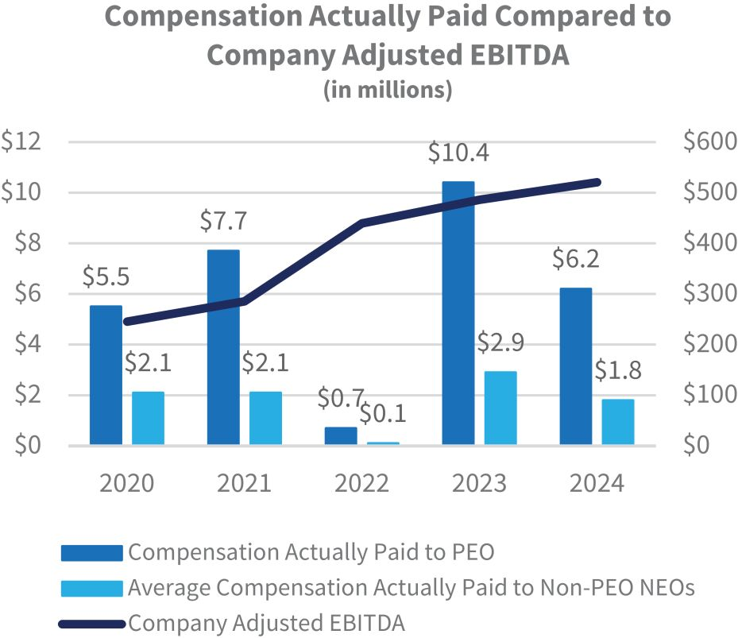 |  | 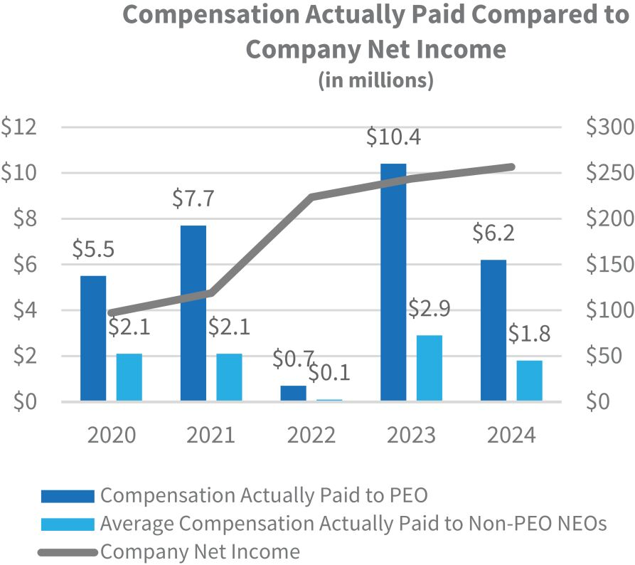
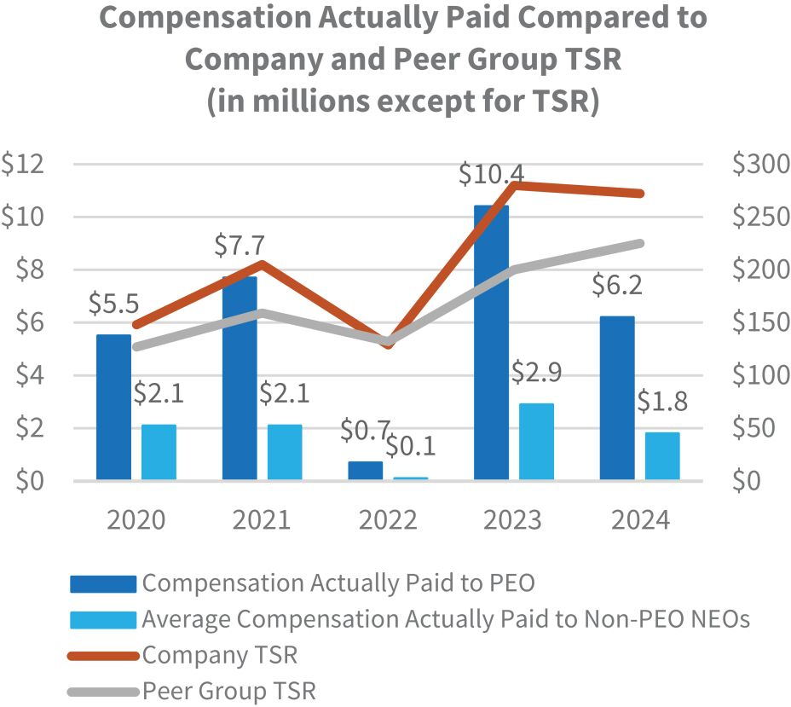 |  | 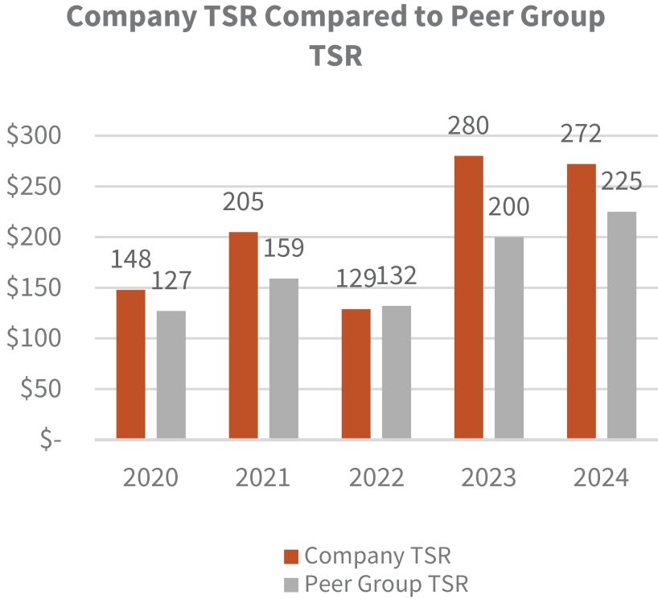
See “
Additional Information – Use of
Non-GAAP
Financial Measures
” for a reconciliation of Adjusted EBITDA to the most directly comparable GAAP measure.
The following table lists the financial performance measure that we believe represents the most important financial measure used to link compensation actually paid to our executives to Company performance.

 |  | Adjusted  EBITDA |  | •  Performance-based incentive cash awards  •  Performance-based incentive equity awards

IBP 2025 Proxy Statement
Executive Compensation

78

Table of Contents

STOCK OWNERSHIP INFORMATION

Stock Ownership Table

The following table shows the beneficial ownership of our common stock as of March 25, 2025 held by:

 | ∎ |  | each person whom we know to beneficially own more than 5% of our outstanding common stock;
 | ∎ |  | each director;
 | ∎ |  | each named executive officer; and
 | ∎ |  | all directors and executive officers as a group.
Unless otherwise indicated, the address of each director and executive officer is c/o Installed Building Products, Inc., 495 South High Street, Suite 50, Columbus, Ohio 43215.
The number of shares of common stock “beneficially owned” is determined under certain SEC rules and is not necessarily indicative of ownership for any other purpose. Under these rules, beneficial ownership includes shares as to which the stockholder has sole or shared voting power or investment power and shares as to which the stockholder has the right to acquire beneficial ownership within 60 days after March 25, 2025, including shares that could be purchased by the exercise of options or warrants. Unless otherwise indicated, to our knowledge all persons named in the table have sole voting and investment power with respect to their shares of our common stock. Each stockholder’s percentage ownership is based on 27,610,885 shares of common stock outstanding as of March 25, 2025, except to the extent indicated in the footnotes .

Shares of Common Stock
Beneficially Owned

Name of Beneficial Owner |  | Number |  |  |  |  | Percent
5% Stockholders:
BlackRock, Inc.(1) |  |  |  | 4,106,184 |  |  |  |  | 14.9
PJAM IBP Holdings, Inc.(2) |  |  |  | 2,677,819 |  |  |  |  | 9.7
The Vanguard Group, Inc.(3) |  |  |  | 2,622,555 |  |  |  |  | 9.5
Installed Building Systems, Inc.(2) |  |  |  | 1,416,194 |  |  |  |  | 5.1
Directors and Named Executive Officers:
Margot L. Carter(4) |  |  |  | 8,638 |  |  |  |  | *
Jeffrey W. Edwards(2)(5) |  |  |  | 4,281,760 |  |  |  |  | 15.5
W. Jeffrey Hire(6) |  |  |  | 45,406 |  |  |  |  | *
Lawrence A. Hilsheimer(4) |  |  |  | 27,248 |  |  |  |  | *
Janet E. Jackson(4) |  |  |  | 7,567 |  |  |  |  | *
David R. Meuse(4) |  |  |  | 4,972 |  |  |  |  | *
Michael T. Miller(7) |  |  |  | 61,175 |  |  |  |  | *
Marchelle E. Moore(4) |  |  |  | 1,532 |  |  |  |  | *
Jason R. Niswonger(8) |  |  |  | 16,072 |  |  |  |  | *
Robert H. Schottenstein(4) |  |  |  | 2,502 |  |  |  |  | *
Michael H. Thomas(4) |  |  |  | 9,599 |  |  |  |  | *
Brad A. Wheeler(9) |  |  |  | 11,922 |  |  |  |  | *
Directors and Executive Officers as a Group (13 persons) |  |  |  | 4,486,654 |  |  |  |  | 16.2

* | Less than 1%
(1) | Information reported is based on a Schedule 13G/A, as filed with the SEC on January 23, 2024, reporting beneficial ownership as of December 31, 2023, in which BlackRock, Inc. reported sole voting power over 4,025,875 shares of our common stock and sole dispositive power over 4,106,184 shares of our common stock. The address for BlackRock, Inc. is 50 Hudson Yards, New York, NY 10001.

IBP 2025 Proxy Statement
Stock Ownership Information

79

Table of Contents
(2) | Information reported is based on a Schedule 13G/A as filed with the SEC on January 31, 2024, reporting beneficial ownership as of December 31, 2023, as updated by Form 4 as filed with the SEC on March 10, 2025, in which PJAM IBP Holdings, Inc. (“PJAM”) and IBP Holding Company, the sole shareholder of PJAM, reported shared voting and dispositive power over 2,477,819 shares of our common stock, Installed Building Systems, Inc. (“IBS”) reported shared voting and dispositive power over 1,416,194 shares of our common stock and Jeffrey W. Edwards reported (i) sole voting and dispositive power over 214,339 shares of our common stock, (ii) shared voting and dispositive power over 3,894,013 shares of our common stock directly held by PJAM and IBS, and (iii) shared voting and dispositive power over 173,408 shares of our common stock held by Tremont FT, Inc. as trustee. Mr. Edwards disclaims any beneficial ownership of shares in which he does not have a pecuniary interest. The address for PJAM, IBP Holding Company, IBS and Jeffrey W. Edwards is 495 South High Street, Suite 150, Columbus, OH 43215.
The Board has made exceptions to our Insider Trading Policy for Mr. Edwards in connection with certain financing arrangements made by a family-owned investment vehicle. In each of September, November 2023 and May 2024, IBS, an investment vehicle owned by Mr. Edwards and his siblings, entered into prepaid variable forward sale contracts with an unaffiliated third party buyer. In each of the September and November transactions, IBS pledged 450,000 shares, or 900,000 shares in the aggregate, and in the May transaction, IBS pledged 250,000 shares (collectively, the “Pledged Shares”) of our common stock to secure its obligations under the contracts, but retained ownership, dividend and voting rights in the Pledged Shares. The contracts obligate IBS to deliver to the buyer, on the applicable settlement date for each of the 12 components in the September transaction, each of the 15 components in the November transaction, and each of the 12 components in the May transaction, up to one hundred percent of the number of Pledged Shares for such component or, at IBS’ option, an equivalent amount of cash.
For the September transaction, the number of shares of our common stock to be delivered to the buyer on the settlement date (or on which to base the amount of cash to be delivered to the buyer on the settlement date) is determined as follows: (a) if the closing price of our common stock on the designated valuation date for the applicable component (each, a “September Settlement Price”) is less than or equal to $120.9623 (the “September Floor Price”), IBS will deliver to the buyer all of the Pledged Shares for the applicable component; (b) if such September Settlement Price is greater than the September Floor Price but less than or equal to $152.7944 (the “September Cap Price”), IBS will deliver to the buyer the number of shares equal to one hundred percent of the Pledged Shares for the applicable component multiplied by a fraction, the numerator of which is the September Floor Price and the denominator of which is such September Settlement Price and (c) if such September Settlement Price is greater than the September Cap Price, IBS will deliver to the buyer the number of shares equal to one hundred percent of Pledged Shares for the applicable component multiplied by a fraction, the numerator of which is the September Floor Price plus the excess of such September Settlement Price over the September Cap Price, and the denominator of which is such September Settlement Price. In connection with the entry into the forward contracts, IBS was entitled to receive aggregate net cash payments (amounts receivable by it upon entry into the forward contract) of $46,869,694. Each component is exercisable on the same date as it expires, and the expiration dates for the components, occur from August 14, 2025 to August 22, 2025 under one contract and from March 9, 2026 to March 13, 2026 under the other contract.
For the November transaction, the number of shares of our common stock to be delivered to the buyer on the settlement date (or on which to base the amount of cash to be delivered to the buyer on the settlement date) is determined as follows: (a) if the volume-weighted average price of our common stock on the designated valuation date for the applicable component (each, a “November Settlement Price”) is less than or equal to $131.9962 (the “ November Floor Price”), IBS will deliver to the buyer all of the Pledged Shares for the applicable component; (b) if such November Settlement Price is greater than the November Floor Price but less than or equal to $166.7321 (the “ November Cap Price”), IBS will deliver to the buyer the number of shares equal to one hundred percent of the Pledged Shares for the applicable component multiplied by a fraction, the numerator of which is the November Floor Price and the denominator of which is such November Settlement Price and (c) if such November Settlement Price is greater than the November Cap Price, IBS will deliver to the buyer the number of shares equal to one hundred percent of Pledged Shares for the applicable component multiplied by a fraction, the numerator of which is the November Floor Price plus the excess of such November Settlement Price over the November Cap Price, and the denominator of which is such November Settlement Price. In connection with the entry into the forward contracts, IBS was entitled to receive aggregate net cash payments (amounts receivable by it upon entry into the forward contract) of $48,769,133. Each component is exercisable on the same date as it expires, and the expiration dates for the components occur from November 16, 2026 to November 23, 2026 under one contract and from May 24, 2027 to June 4, 2027 under the other.

IBP 2025 Proxy Statement
Stock Ownership Information

80

Table of Contents
For the May transaction, the number of shares of our common stock to be delivered to the buyer on the settlement date (or on which to base the amount of cash to be delivered to the buyer on the settlement date) is determined as follows: (a) if the closing price of our common stock on the designated valuation date for the applicable component (each, a “May Settlement Price”) is less than or equal to $195.2611 (the “ May Floor Price”), IBS will deliver to the buyer all of the Pledged Shares for the applicable component; (b) if such May Settlement Price is greater than the May Floor Price but less than or equal to $246.6456 (the “ May Cap Price”), IBS will deliver to the buyer the number of shares equal to one hundred percent of the Pledged Shares for the applicable component multiplied by a fraction, the numerator of which is the May Floor Price and the denominator of which is such May Settlement Price and (c) if such May Settlement Price is greater than the May Cap Price, IBS will deliver to the buyer the number of shares equal to one hundred percent of Pledged Shares for the applicable component multiplied by a fraction, the numerator of which is the May Floor Price plus the excess of such May Settlement Price over the May Cap Price, and the denominator of which is such May Settlement Price. In connection with the entry into the forward contracts, IBS was entitled to receive aggregate net cash payments (amounts receivable by it upon entry into the forward contract) of $42,777,596. Each component is exercisable on the same date as it expires, and the expiration dates for the components occur from August 14, 2025 to August 22, 2025 under one contract and from March 9, 2026 to March 13, 2026 under the other contract.

(3) | Information reported is based on a Schedule 13G/A as filed with the SEC on February 13, 2024, reporting beneficial ownership as of December 29, 2023, in which The Vanguard Group reported shared voting power over 43,733 shares of our common stock, sole dispositive power over 2,553,720 shares of our common stock and shared dispositive power over 68,835 shares of our common stock. The address for The Vanguard Group is 100 Vanguard Blvd., Malvern, PA 19355.

(4) | Includes 598 shares of restricted stock that vest on May 20, 2025.

(5) | Includes 16,401 shares of restricted stock that vest on April 20, 2025, 34,963 shares of restricted stock that vest in equal installments (rounded to the nearest whole share) on each of April 20, 2025 and 2026 and 18,636 shares of restricted stock that vest in equal installments (rounded to the nearest whole share) on each of April 2026 and 2027, generally subject to Mr. Edwards’ continued employment on the applicable vesting date. These shares of restricted stock are included in the 214,339 shares reflected in note (2) with respect to which Mr. Edwards has sole voting and dispositive power.

(6) | Includes 1,093 shares of restricted stock that vest on April 20, 2024, 2,187 shares of restricted stock that vest in equal installments (rounded to the nearest whole share) on each of April 20, 2024 and 2025, 5,375 shares of restricted stock that vest on April 20, 2026, 2,427 shares of restricted stock that vest in equal installments (rounded to the nearest whole share) on each of April 20, 2025 and 2026, generally subject to Mr. Hire’s continued employment on the applicable vesting date.

(7) | Includes 3,777 shares of restricted stock that vest on April 20, 2025, 11,265 shares of restricted stock that vest in equal installments (rounded to the nearest whole share) on each of April 20, 2025 and 2026 and 1,281 shares of restricted stock that vest in equal installments (rounded to the nearest whole share) on each of April 20, 2026 and April 20, 2027, generally subject to Mr. Miller’s continued employment on the applicable vesting date. Includes 33,320 shares of common stock held by a trust of which Mr. Miller is the sole trustee and sole beneficiary and exercises sole voting and investment power.

(8) | Includes 1,530 shares of restricted stock that vest on April 20, 2025, 3,982 shares of restricted stock that vest in equal installments (rounded to the nearest whole share) on each of April 20, 2025 and 2026, 2,329 shares of restricted stock tat vest in equal installments (rounded to the nearest whole shares) on each of April 20, 2026 and 2027 and 584 shares of restricted stock that vest on April 20, 2028, generally subject to Mr. Niswonger’s continued employment on the applicable vesting date.

(9) | Includes 4,855 shares of restricted stock that vest in equal installments (rounded to the nearest whole share) on each of April 20, 2025 and 2026, 4,659 shares of restricted stock that vest in equal installments on each of April 20, 2026 and 2027 and 584 shares of restricted stock that vest on April 20, 2028, generally subject to Mr. Wheeler’s continued employment on the applicable vesting date.

IBP 2025 Proxy Statement
Stock Ownership Information

81

Table of Contents

Securities Authorized for Issuance under Equity Compensation Plans

The following table sets forth information regarding the shares of our common stock issuable under our 2023 Omnibus Incentive Plan as of December 31, 2024. The plan authorizes the grant of stock options, stock appreciation rights, stock equivalent units, restricted stock, restricted stock units, bonus awards, performance shares, performance units and other stock-based awards.
The aggregate number of shares of our common stock initially reserved for issuance under the 2023 Omnibus Incentive Plan was 2,098,116. As of December 31, 2024, there were 194,645 shares issuable under the 2023 Omnibus Incentive Plan pursuant to outstanding restricted stock awards granted under the plan, and 7,952 shares issuable pursuant to outstanding restricted stock units granted under the plan. No other equity-based awards have been issued under the 2023 Omnibus Incentive Plan.
The line item in the table below relating to our 2014 Omnibus Incentive Plan are shares that are subject to outstanding awards. The shares subject to outstanding awards under the 2014 Omnibus Incentive Plan will become available for issuance under the 2023 Omnibus Incentive Plan if the underlying outstanding awards are forfeited.

Number of Securities Remaining
Available for Future Issuance
under Equity Compensation Plans
(#)

Equity compensation plans approved by security holders:

2014 Omnibus Incentive Plan |  |  |  | 60,856
2023 Omnibus Incentive Plan |  |  |  | 1,717,724
Equity compensation plans not approved by stockholders |  |  |  | -
Total |  |  |  | 1,778,310

IBP 2025 Proxy Statement
Stock Ownership Information

82

Table of Contents
RELATED PARTY TRANSACTIONS

Jeff Edwards, Peter Edwards Jr., Anne Edwards and Michael Edwards, and the investment entities through which they directly and indirectly beneficially own shares of our common stock, are referred to below as the Edwards Investors. Peter Edwards Jr., Anne Edwards and Michael Edwards are siblings of Jeff Edwards.
Affiliate Sales
Our operating subsidiaries install building products in the ordinary course of their businesses for certain of our directors and executive officers or their affiliated entities. These transactions are performed on terms comparable to those that could be obtained in an arm’s-length transaction with an unrelated third party. In 2024, these sales were to:

 | ◾ |  | Edwards Investors affiliates: $492,798

 | ◾ |  | Robert H. Schottenstein affiliates (including MI Homes, Inc. and affiliated entities): $24,105,558
Real Property Leases
Our headquarters building in Columbus, Ohio is subject to a master lease agreement between an unrelated third party owner and The Edwards Companies, LLC, an entity affiliated with the Edwards Investors, to which we pay rent payments. In 2024, we paid $709,999 in base rent payments to The Edwards Companies, LLC.
In 2024, we entered into a lease agreement with an affiliate of the Edwards Investors in connection with the relocation of our corporate headquarters. The relocation is planned to begin in the third quarter of 2025. No rent payments were made under the lease in 2024.
We lease two branch locations in Columbus, Ohio from Peter H. Edwards, an immediate family member of the Edwards Investors. We paid base rent payments for these facilities in 2024 of $265,769 and $265,769, respectively.
In each case under the applicable lease, we are also obligated to pay our proportionate share of certain common area maintenance charges, taxes, insurance premiums and other costs of operation, depending on the terms of the lease.
Aircraft Lease and Ownership Agreement
In 2019, we entered into an aircraft lease agreement with an affiliate of the Edwards Investors, pursuant to which we lease the use of an aircraft for business travel on a non-priority basis. The lease agreement automatically renews every 29 days unless terminated on ten days’ notice by either party and is updated for current rental rate charges each year. In 2024, we paid lease payments, including operating expenses, of $415,058.
In 2024, we purchased a 35% interest in an aircraft to be used for business travel, together with an affiliate of the Edwards Investors, who purchased a 15% interest, and an unrelated third party, who owns the remaining interest. In connection with that transaction, we entered into an aircraft co-ownership agreement to govern the respective rights and obligations of the owners. The agreement continues until the aircraft is sold or the agreement is terminated by the owners. In 2024, we paid $254,270 for our pro-rata share of ownership costs such as insurance, labor, hangar and office rent, licenses and registrations.
Share Repurchases
On each of August 14, 2024 and March 7, 2025, as part of our stock buyback program, we entered into a share repurchase agreement with PJAM IBP Holdings, Inc. (“PJAM”) for the purchase of 100,000 shares, or a total of 200,000 shares, of our common stock in a privately-negotiated transaction (the “Share Repurchases”). The aggregate purchase price for the Share Repurchase in August 2024 was approximately $20.7 million, or $206.90 per share, which was the last reported price of our common stock on August 13, 2024, less a discount of 3.0%. The aggregate purchase price for the Share Repurchase in March 2025 was approximately $16.9 million, or $168.75 per share, which was the last reported price of our common stock on March 6, 2025, less a discount of 3.0%. Jeff Edwards, our Chief Executive Officer, has beneficial ownership of the shares held by PJAM, an Edwards family entity.

IBP 2025 Proxy Statement
Related Party Transactions

83

Table of Contents
Policies and Procedures for Related Party Transactions
Our Board of Directors has adopted a Related Party Transaction Policy (“Policy”) for the review and approval or ratification of certain related party transactions. The Policy is administered by the Audit Committee with the assistance of our General Counsel, Chief Financial Officer and Chief Accounting Officer.
The Policy applies to any transaction, arrangement or relationship (or any series of similar transactions, arrangements or relationships) in which the Company or one of our subsidiaries is a participant; the amount involved exceeds $120,000; and a Related Party (as defined below) had, has or will have a direct or indirect material interest. Any transaction meeting these criteria is a “Related Party Transaction.”
Under the Policy, a “Related Party” is any person who: (i) is, or, at any time since the beginning of our last fiscal year, was, a director, executive officer or director nominee, or an immediate family member of any such person; or (ii) is known by us to be the beneficial owner of more than 5% of our common stock, or an immediate family member of such person.
Prior to entering into a potential Related Party Transaction, the Related Party (or the person whose immediate family member is the Related Party) or any member of management aware of the transaction must provide notice of the facts and circumstances of the proposed transaction to our General Counsel, Chief Financial Officer or Chief Accounting Officer, who will assess whether the proposed transaction is subject to the Policy. If it is determined that the proposed transaction is a Related Party Transaction, it is submitted to the Audit Committee for consideration at its next meeting. If it is not practicable or desirable to wait until the next Audit Committee meeting, the transaction may be submitted to the Chair of the Audit Committee for consideration (with any action taken by the Chair reported to the Audit Committee at its next regular meeting).
When considering a proposed Related Party Transaction, the Audit Committee reviews all of the relevant available facts and circumstances, including:

 | ◾ |  | the benefits of the transaction to the Company;

 | ◾ |  | any impact on a director’s independence;

 | ◾ |  | the availability of other sellers or purchasers of comparable products or services;

 | ◾ |  | the terms of the transaction;

 | ◾ |  | whether the transaction is on terms comparable to those obtainable in an arm’s-length transaction with an unrelated party; and

 | ◾ |  | the extent of the Related Party’s interest in the transaction.
The Audit Committee will approve a Related Party Transaction if it determines that the transaction is in, or is not inconsistent with, the best interests of the Company and our stockholders. No member of the Audit Committee may participate in the consideration or approval of a transaction as to which he or she or any member of his or her immediate family is the Related Party, but may participate in the discussion of the transaction at the Audit Committee meeting if requested by the Chair of the Audit Committee.
The Related Party Transaction Policy prohibits the Company from directly or indirectly extending credit to, arranging for the extension of credit for, or renewing an extension of credit, in each case in the form of a personal loan, to any director or executive officer of the Company, except in the case of a trade receivable relating to work performed by the Company for the director or executive officer or an affiliate thereof in the ordinary course of the Company’s business on terms comparable to those that could be obtained in an arm’s length transaction with an unrelated party.
If a director or a member of management becomes aware of a Related Party Transaction that has not been approved by the Audit Committee, he or she must promptly notify our General Counsel, Chief Financial Officer or Chief Accounting Officer. If the transaction is pending or ongoing, it is submitted to the Audit Committee for review, and the Audit Committee will consider the relevant facts and circumstances and evaluate all options, including ratification, amendment or termination of the transaction. If the transaction is completed, the Audit Committee will determine if rescission of the transaction and/or disciplinary action is appropriate.
All of the transactions described in this section were approved by the Audit Committee in accordance with the Policy.

IBP 2025 Proxy Statement
Related Party Transactions

84

Table of Contents
STOCKHOLDER PROPOSALS FOR THE 2026 ANNUAL MEETING

Proposals for Inclusion in our 2026 Proxy Statement
SEC Rule 14a-8 permits stockholders to submit proposals for inclusion in our proxy statement if the stockholders and the proposals meet certain requirements specified in the rule. If a stockholder wishes to present a proposal to be included in our proxy statement for our 2026 Annual Meeting of Stockholders (the “2026 Annual Meeting”), the proposal must be received in writing by our Corporate Secretary at Installed Building Products, Inc., 495 South High Street, Suite 50, Columbus, Ohio 43215 no later than December 9, 2025 . Proposals must conform to and include the information required by SEC Rule 14a-8. See also Article I, Section 1.03 of our Bylaws.
Director Nominees for Inclusion in our 2026 Proxy Statement
In order to nominate a candidate for director at our 2026 Annual Meeting, stockholders must comply with Article I, Section 1.03 of our Bylaws. Stockholders wishing to nominate a candidate for director must provide notice no earlier than the close of business on January 20, 2026 , and no later than the close of business on February 19, 2026. If the 2026 Annual Meeting is more than 30 days before, or more than 70 days after, the anniversary of this Annual Meeting, then notice must be received no earlier than the close of business 120 days prior to the 2026 Annual Meeting and no later than the close of business 90 days prior to the 2026 Annual Meeting (or 10 days following the date on which we publicly disclose the date of the 2026 Annual Meeting). Under our Bylaws, if the number of directors to be elected at an annual meeting of stockholders is increased and we do not make a public announcement naming the nominees for the additional directorship(s) at least 100 days prior to the anniversary of the previous year’s annual meeting, a stockholder nomination with respect to the additional directorship(s) will be considered timely if delivered to our Corporate Secretary no later than 10 days following the date when we publicly announce the increase in the number of directors.
All stockholder nominations must set forth the information specified in Article I, Section 1.03 of our Bylaws and must be submitted in writing to our Corporate Secretary, Installed Building Products, Inc., 495 South High Street, Suite 50, Columbus, Ohio 43215. In addition to satisfying the requirements under our Bylaws, stockholders who intend to solicit proxies in support of director nominees other than the Company’s nominees must provide notice that sets forth the information required by Rule 14a-19 under the Exchange Act no later than March 21, 2026.
A copy of our Bylaws may be obtained without charge from our Corporate Secretary at Installed Building Products, Inc., 495 South High Street, Suite 50, Columbus, Ohio 43215, or may be found on our website at www.installedbuildingproducts.com under the “Investors” section. A nomination or proposal that does not comply with our Bylaws and/or applicable SEC rules may be excluded from our proxy materials in accordance with applicable SEC rules. Please carefully review our Bylaws and applicable SEC rules prior to submitting any nominations or proposals.
Other Proposals for the 2026 Annual Meeting
Article I, Section 1.03 of our Bylaws requires that any stockholder wishing to submit a proposal that is not intended for inclusion in our 2026 proxy statement, but is instead sought to be presented directly at the 2026 Annual Meeting, must provide notice in writing to our Corporate Secretary, Installed Building Products, Inc., 495 South High Street, Suite 50, Columbus, Ohio 43215 no later than the close of business on December 9, 2025. If the 2026 Annual Meeting is more than 30 days before, or more than 70 days after, the anniversary of this Annual Meeting, then notice must be received no earlier than the close of business 120 days prior to the 2026 Annual Meeting and no later than the close of business 90 days prior to the 2026 Annual Meeting (or 10 days following the date on which we publicly disclose the date of the 2026 Annual Meeting). The notice must provide the information required by Article I, Section 1.03 of our Bylaws.

IBP 2025 Proxy Statement
Stockholder Proposals for the 2026 Annual Meeting

85

Table of Contents
ADDITIONAL INFORMATION

Householding of Proxy Materials
We have adopted a “householding” procedure, approved by the SEC, relating to the delivery of our proxy materials, which conserves natural resources and reduces our printing and mailing costs. Under this procedure, stockholders with the same last name and address will receive only one copy of our proxy materials unless we receive instructions to the contrary from any stockholder at that address. A stockholder who wishes to receive a separate copy of our proxy materials, or wishes to stop receiving separate copies of our proxy materials, may make a request by writing to Computershare Investor Services, P.O. Box 43006, Providence, Rhode Island 02940-3006 or by calling (781) 575-3100.
A number of brokerage firms have also instituted householding. If you and members of your household have multiple accounts holding shares of our common stock, you may have received a householding notification from your broker, bank or other nominee. Please contact that organization if you have questions or wish to opt in our opt out of householding.
Solicitation of Proxies
Our Board of Directors is soliciting your vote for the proposals being submitted at the Annual Meeting. Solicitation is being made by mail or internet but could also be made by our directors, officers and select other employees telephonically, electronically or by other means of communication. The Company will bear the cost of soliciting proxies. Directors, officers and employees who assist in the solicitation will not be compensated for those services, but may be reimbursed for out-of-pocket expenses. We are requesting brokers, banks and other nominees to forward our proxy materials to beneficial owners and will reimburse them for their reasonable out-of-pocket expenses.
Incorporation by Reference
The CHC Committee Report and the Audit Committee Report included in this Proxy Statement are not “soliciting material,” and are not deemed filed with the SEC. The reports shall not be deemed incorporated by reference into any of our prior or future filings made with the SEC except to the extent that we specifically incorporate such reports by reference. Any references in this Proxy Statement to website addresses are intended to provide textual references only. Information contained on our website or any other website that may be referenced herein is not incorporated into this Proxy Statement.
Forward Looking Statements
This Proxy Statement contains certain forward-looking statements, including with respect to the housing and commercial construction market, industry conditions, our operations, our ESG related initiatives and performance, our business model, expansion of our footprint and end markets, our product diversification and our pursuit of value enhancing acquisitions. By their nature, forward-looking statements involve risks and uncertainties because they relate to events and depend on circumstances that may or may not occur in the future. These statements are based on management’s current expectations, beliefs, estimates and projections. These statements include matters that are not historical facts, are not guarantees and are subject to certain uncertainties and other factors, many of which are beyond our control. Please refer to our Annual Report on Form 10-K for the year ended December 31, 2024, including the sections captioned “Risk Factors” and “Information Regarding Forward-Looking Statements and Risk Factors Summary” for a description of the risks and uncertainties related to any forward-looking statements included herein. Our actual performance, including the development of any program or initiative, may differ materially in the future. Forward-looking and other statements in this Proxy Statement regarding our ESG and sustainability plans and goals are not an indication that these statements are material to investors or required to be disclosed in our filings with the SEC. Historical, current, and forward-looking ESG and sustainability-related statements may be based on standards for measuring progress that are still developing, internal controls and processes that continue to evolve, and assumptions that are subject to change in the future.

IBP 2025 Proxy Statement
Additional Information

86

Table of Contents
Availability of SEC Filings and Corporate Governance Documents
Copies of our SEC filings on Forms 10-K, 10-Q and 8-K, and any amendments to those reports, as well as copies of our governing documents, ESG policies and reports of beneficial ownership of our common stock filed by our executive officers, directors and beneficial owners of more than 10% of our outstanding common stock are available on our website at www.installedbuildingsproducts.com under the “Investors” section. This information may also be requested at no cost by calling (614) 221-3399, by emailing InvestorRelations@installed.net or by mailing Installed Building Products, Inc., 495 South High Street, Suite 50, Columbus, Ohio 43215, Attention: Investor Relations.
Use of Non-GAAP Financial Measures
This Proxy Statement uses the financial measure of “Adjusted EBITDA,” which is not calculated in accordance with GAAP. The reasons for the use of this measure and reconciliation to the most directly comparable GAAP measure is set forth below.
Adjusted EBITDA measures performance by adjusting EBITDA for certain income or expense items that are not considered part of our core operations. We believe that this measure assists both management and the CHC Committee in analyzing and benchmarking the performance and value of our business and the performance of our executive team. We use Adjusted EBITDA-based measures in determining the achievement of awards under our executive incentive compensation programs.
We believe the Adjusted EBITDA measure is useful to investors and to us as a measure of comparative operating performance from period to period, because it measures our changes in pricing decisions, cost controls and other factors that impact operating performance, and removes the effect of our capital structure (primarily interest expense), asset base (primarily depreciation and amortization), items outside our control (primarily income taxes) and volatility related to the timing and extent of other activities such as asset impairments and non-core income and expenses. Accordingly, we believe that this measure is useful for comparing general operating performance from period to period. Other companies may define Adjusted EBITDA differently and, as a result, our measure may not be directly comparable to measures of other companies.

($ in millions) |  | 2024 |  |  |  | 2023
Adjusted EBITDA
Net income, as reported |  |  | $ 256.6 |  |  |  | $243.7
Interest expense |  |  | 36.9 |  |  |  | 37.0
Provision for income tax |  |  | 89.8 |  |  |  | 89.4
Depreciation and amortization |  |  | 101.6 |  |  |  | 96.7
EBITDA |  |  | 484.9 |  |  |  | 466.8
Acquisition related expenses |  |  | 2.2 |  |  |  | 1.9
Share based compensation expense |  |  | 19.4 |  |  |  | 15.9
Legal reserve |  |  | - |  |  |  | 1.3
Asset impairment |  |  | 4.9 |  |  |  | -
Adjusted EBITDA |  |  | $ 511.4 |  |  |  | $ 485.9

IBP 2025 Proxy Statement
Additional Information

87

Table of Contents
MEETING AND VOTING INFORMATION

Certain of the topics below refer to “stockholders of record” or “beneficial owners.” If your shares were registered directly in your name with our transfer agent on the record date, then you are a “stockholder of record” with respect to those shares. If your shares were held in an account at a brokerage firm, bank or other nominee on the record date, then you are a “beneficial owner” of those shares.
Attending the Annual Meeting
Our Annual Meeting is conducted virtually by a live audio webcast in lieu of an in-person meeting. This format promotes stockholder participation by enabling stockholders to conveniently attend from any location. The virtual format results in cost savings to the Company and stockholders and is designed to enhance stockholder access and participation. You will be afforded the same rights and opportunities to participate in the virtual meeting as you would at an in-person meeting. You may attend and participate in the Annual Meeting in the following ways:
Stockholders of Record. You can listen to the Annual Meeting, submit questions and vote by going to https://meetnow.global/M4CN4WG, clicking on “Join Meeting Now” and entering under the stockholder tab the 15-digit control number found in your proxy materials.
Beneficial Owners. You may participate in the Annual Meeting in one of two ways:

 | ◾ |  | If you wish to submit questions or vote during the Annual Meeting (rather than instructing your brokerage firm, bank or other nominee how to vote your shares), you must register in advance by providing our transfer agent, Computershare Trust Company, N.A. (“Computershare”) with your name, email address and a copy of a legal proxy from your brokerage firm, bank or other nominee reflecting your beneficial ownership. Registration requests must be in writing and mailed to Computershare Investor Services, Installed Building Products, Inc. – Legal Proxy, P.O. Box 43001, Providence, Rhode Island 02940-3001. Alternatively, you may forward a copy of the email from your broker granting you a legal proxy or forward an image of your legal proxy to legalproxy@computershare.com. Requests must be labeled “Legal Proxy” and be received no later than 5:00 p.m., Eastern Time, on May 16, 2025. You will receive an email from Computershare acknowledging your registration and providing you with a 15-digit control number. You can then listen to the Annual Meeting, submit questions and vote by going to https://meetnow.global/M4CN4WG, clicking on “Join Meeting Now” and entering under the stockholder tab your 15-digit control number.

 | ◾ |  | If you wish to listen to the Annual Meeting, but do not wish to submit questions or vote during the Annual Meeting, you may go to https://meetnow.global/M4CN4WG, click on “Join Meeting Now” and then click on “Guest.”
The virtual meeting platform is fully supported across browsers (MS Edge, Firefox, Chrome and Safari) and devices (desktops, laptops, tablets and cell phones) running the most up-to-date version of applicable software and plugins. Internet Explorer is not a supported browser. Participants should ensure that they have a strong Wi-Fi connection. We encourage you to access the meeting prior to the start time. For further assistance you may call 1-888-724-2416 within the U.S. or 1-781-575-2748 outside the U.S. An audio replay of the Annual Meeting will be available at https://edge.media-server.com/mmc/p/hwkrr9mc for one year.
Who is Entitled to Vote; Quorum
Only holders of record of our common stock at the close of business on March 25, 2025, the record date for the Annual Meeting, are entitled to notice of and to vote at the Annual Meeting. Each share of common stock is entitled to one vote for each director nominee and one vote for each other matter to be voted on at the Annual Meeting.
A list of our stockholders entitled to vote at the Annual Meeting will be available for examination by any stockholder during ordinary business hours at our principal executive offices at 495 S. High Street, Suite 50, Columbus, Ohio 43215 for a period of ten days prior to the Annual Meeting. During the Annual Meeting, the list will be available at https://meetnow.global/M4CN4WG

IBP 2025 Proxy Statement
Meeting and Voting Information

88

Table of Contents
In order to carry out the business of the Annual Meeting, a quorum must be present. A quorum is present if holders of at least a majority of the outstanding shares entitled to vote are present or represented by proxy at the Annual Meeting. Abstentions and broker non-votes are counted as present for purposes of determining a quorum. On the record date, we had 27,610,885 shares entitled to vote, meaning that at least 13,805,444 shares must be present or represented by proxy to have a quorum. If a quorum is not present, the Annual Meeting may be adjourned from time to time until a quorum is present.
How to Vote
Stockholders of Record. You may vote in any of the following ways. Votes must be received no later than the closing of the polls at the Annual Meeting.

Online |  | You may vote online at www.envisionreports.com/IBP, 24 hours a day, seven days a week.
By Phone |  | You may vote by calling 1-800-652-8683, 24 hours a day, seven days a week.
By Mail |  | If you received printed proxy materials, you may vote by completing, signing and dating each proxy card and returning it in the prepaid envelope to Computershare Investor Services. Sign your name exactly as it appears on the proxy card.
At the  Annual  Meeting |  | Instructions on how to vote during the Annual Meeting are posted at  https://meetnow.global/M4CN4WG.
Voting online, by phone or at the Annual Meeting authorizes the persons named as proxies to vote as you direct in the same manner as if you had completed, signed, dated and returned a proxy card. If you vote online or by phone, or plan to vote during the Annual Meeting, do not return your proxy card(s). If you do not vote by any of the methods listed above, your shares will not be voted. If you submit a proxy but fail to provide voting instructions, your proxy will be voted in the manner recommended by the Board of Directors.
If you received more than one proxy card or Notice, your shares are registered in more than one name or are registered in multiple accounts. To make certain all of your shares are voted, please complete, sign, date and return each proxy card, or if you vote online, by telephone or at the Annual Meeting, vote once for each Notice you received.
Beneficial Owners. If you are a beneficial owner, the organization holding your account is the stockholder of record for purposes of participating in and voting at the Annual Meeting; however, you have the right to direct that organization how to vote the shares in your account by following the instructions provided by the organization. Alternatively, you may vote your shares directly at the Annual Meeting by obtaining a legal proxy from your brokerage firm, bank or other nominee and registering in advance to participate in the Annual Meeting. See “Attending the Annual Meeting” above. When you receive your registration confirmation, you may vote in any of the ways in which a stockholder of record may vote described above (except by mail).
The availability of online and telephone voting will depend on the voting procedures established by your broker, bank or other nominee. If you do not provide voting instructions to the organization holding your account, the organization may vote your shares on certain routine, or “discretionary,” matters. The ratification of the appointment of our independent registered public accounting firm is a discretionary matter. On this proposal, the organization holding your account may either vote your shares in the absence of your instructions or may choose not to vote your shares. The remaining proposals are not considered discretionary and cannot be voted without your instructions, which is called a “broker non-vote.” In the case of a broker non-vote, your shares will not have any effect on the outcome of the proposal. If you registered in advance to participate in the Annual Meeting but do not vote your shares online, by phone or during the Annual Meeting, your shares will not be voted.

IBP 2025 Proxy Statement
Meeting and Voting Information

89

Table of Contents
Revoking your Proxy or Changing your Vote
Stockholders of Record. You may revoke your proxy or change your vote at any time before the closing of the polls at the Annual Meeting by:

 | ◾ |  | signing and returning a new proxy card with a later date;

 | ◾ |  | submitting a later-dated vote online or by phone — only your latest vote will be counted;

 | ◾ |  | participating in the Annual Meeting and voting during the meeting; or

 | ◾ |  | delivering a written revocation to our Corporate Secretary at Installed Building Products, Inc., 495 South High Street, Suite 50, Columbus, Ohio 43215, which must be received no later than May 19, 2025.
Participating in the Annual Meeting without voting during the meeting will not cause a previously submitted vote to be revoked unless you specifically request that your prior vote be revoked.
Beneficial Owners. You should contact the broker, bank or other nominee holding your shares to obtain instructions for revoking or changing your vote. If you register in advance to participate in the Annual Meeting, you may change your vote by submitting a later-dated vote online, by phone or by voting during the meeting.
Votes Required to Approve each Proposal

Proposal |  | Required Vote
Proposal 1 – Election of Jeffrey W. Edwards, Lawrence A. Hilsheimer and Janet E. Jackson as directors to serve for three-year terms |  | Majority of the votes cast at the Annual Meeting
Proposal 2 – Ratification of the appointment of Deloitte & Touche LLP as our independent registered public accounting firm for 2025 |  | Majority of the shares present or represented by proxy at the Annual Meeting and entitled to vote
Proposal 3 – Approval, on an advisory basis, of the compensation of our named executive officers |  | Majority of the shares present or represented by proxy at the Annual Meeting and entitled to vote
Voting Results
Preliminary voting results will be announced at the Annual Meeting. Final voting results will be published in a current report on Form 8-K to be filed with the SEC within four business days after the Annual Meeting. If final voting results are not available at that time, we will provide preliminary voting results in the Form 8-K and will provide the final voting results in an amendment to the Form 8-K as soon as they are available.

IBP 2025 Proxy Statement
Meeting and Voting Information

90

Table of Contents
OTHER MATTERS

We are not aware of any other matters that will be presented for consideration at the Annual Meeting. If any other matters are properly brought before the meeting, the persons named as proxies will vote on such matters in accordance with their best judgment.

IBP 2025 Proxy Statement
Other Matters

91

Table of Contents


Table of Contents


Table of Contents
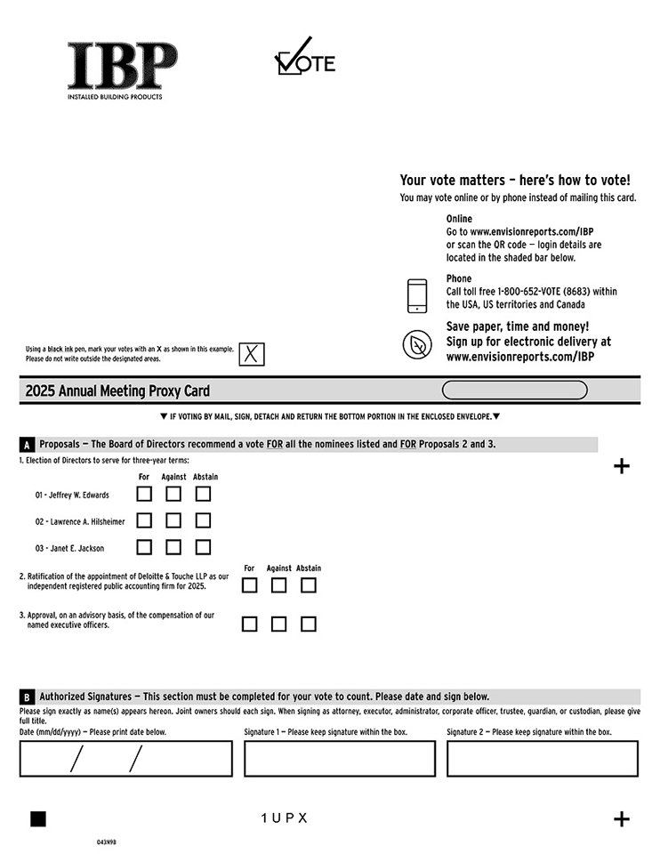
043N9B Your vote matters – here’s how to vote! You may vote online or by phone instead of mailing this card. Online Go to www.envisionreports.com/IBP or scan the QR code — login details are located in the shaded bar below. Phone Call toll free 1-800-652-VOTE (8683) within the USA, US territories and Canada Save paper, time and money! Sign up for electronic delivery at www.envisionreports.com/IBP Using a black ink pen, mark your votes with an X as shown in this example. Please do not write outside the designated areas. 2025 Annual Meeting Proxy Card q IF VOTING BY MAIL, SIGN, DETACH AND RETURN THE BOTTOM PORTION IN THE ENCLOSED ENVELOPE. Proposals — The Board of Directors recommend a vote FOR all the nominees listed and FOR Proposals 2 and 3. 1. Election of Directors to serve for three-year terms: For Against Abstain 01 - Jeffrey W. Edwards 02 - Lawrence A. Hilsheimer 03 - Janet E. Jackson 2. Ratification of the appointment of Deloitte & Touche LLP as our independent registered public accounting firm for 2025. 3. Approval, on an advisory basis, of the compensation of our named executive officers. For Against Abstain Authorized Signatures — This section must be completed for your vote to count. Please date and sign below. Please sign exactly as name(s) appears hereon. Joint owners should each sign. When signing as attorney, executor, administrator, corporate officer, trustee, guardian, or custodian, please give full title. Date (mm/dd/yyyy) — Please print date below. Signature 1 — Please keep signature within the box. Signature 2 — Please keep signature within the box. 1 UPX

Table of Contents
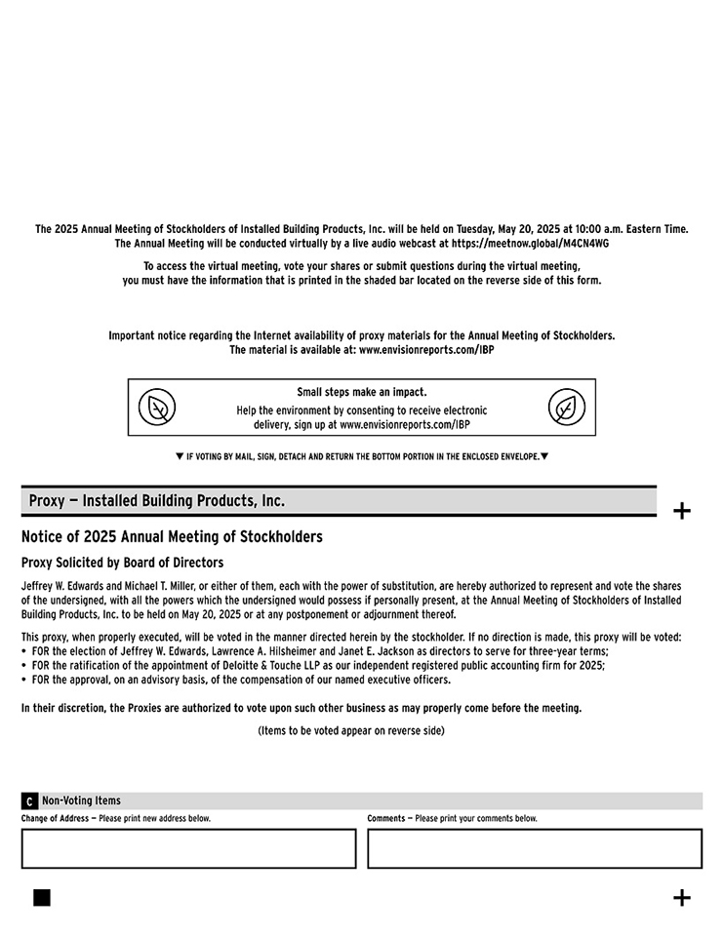
The 2025 Annual Meeting of Stockholders of Installed Building Products, Inc. will be held on Tuesday, May 20, 2025 at 10:00 a.m. Eastern Time. The Annual Meeting will be conducted virtually by a live audio webcast at https://meetnow.global/M4CN4WG To access the virtual meeting, vote your shares or submit questions during the virtual meeting, you must have the information that is printed in the shaded bar located on the reverse side of this form. Important notice regarding the Internet availability of proxy materials for the Annual Meeting of Stockholders. The material is available at: www.envisionreports.com/IBP Small steps make an impact. Help the environment by consenting to receive electronic delivery, sign up at www.envisionreports.com/IBP IF VOTING BY MAIL, SIGN, DETACH AND RETURN THE BOTTOM PORTION IN THE ENCLOSED ENVELOPE. Proxy — Installed Building Products, Inc. Notice of 2025 Annual Meeting of Stockholders Proxy Solicited by Board of Directors Jeffrey W. Edwards and Michael T. Miller, or either of them, each with the power of substitution, are hereby authorized to represent and vote the shares of the undersigned, with all the powers which the undersigned would possess if personally present, at the Annual Meeting of Stockholders of Installed Building Products, Inc. to be held on May 20, 2025 or at any postponement or adjournment thereof. This proxy, when properly executed, will be voted in the manner directed herein by the stockholder. If no direction is made, this proxy will be voted: • FOR the election of Jeffrey W. Edwards, Lawrence A. Hilsheimer and Janet E. Jackson as directors to serve for three-year terms; • FOR the ratification of the appointment of Deloitte & Touche LLP as our independent registered public accounting firm for 2025; • FOR the approval, on an advisory basis, of the compensation of our named executive officers. In their discretion, the Proxies are authorized to vote upon such other business as may properly come before the meeting. (Items to be voted appear on reverse side) Non-Voting Items Change of Address — Please print new address below. Comments — Please print your comments below.

Table of Contents
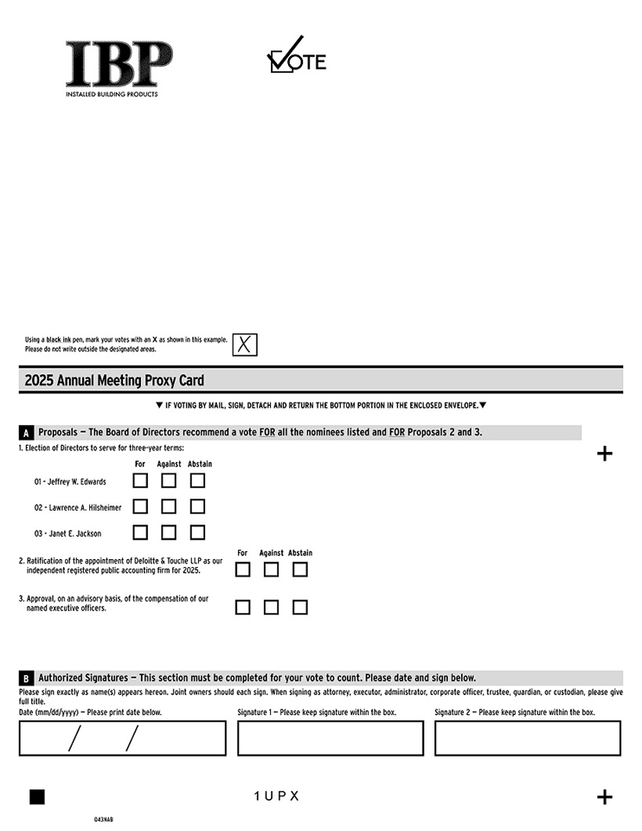
Using a black ink pen, mark your votes with an X as shown in this example. Please do not write outside the designated areas. 2025 Annual Meeting Proxy Card IF VOTING BY MAIL, SIGN, DETACH AND RETURN THE BOTTOM PORTION IN THE ENCLOSED ENVELOPE. Proposals — The Board of Directors recommend a vote FOR all the nominees listed and FOR Proposals 2 and 3. 1. Election of Directors to serve for three-year terms: 01 - Jeffrey W. Edwards 02 - Lawrence A. Hilsheimer 03 - Janet E. Jackson 2. Ratification of the appointment of Deloitte & Touche LLP as our independent registered public accounting firm for 2025. 3. Approval, on an advisory basis, of the compensation of our named executive officers. For Against Abstain Authorized Signatures — This section must be completed for your vote to count. Please date and sign below. Please sign exactly as name(s) appears hereon. Joint owners should each sign. When signing as attorney, executor, administrator, corporate officer, trustee, guardian, or custodian, please give full title. Date (mm/dd/yyyy) — Please print date below. Signature 1 — Please keep signature within the box. Signature 2 — Please keep signature within the box. 1 UPX 043NAB

Table of Contents
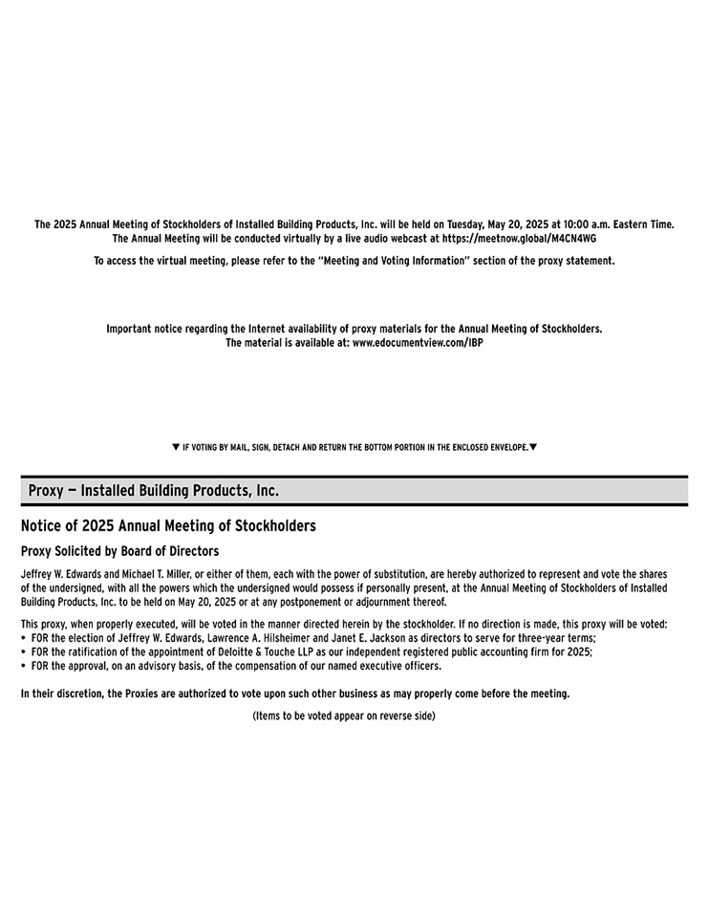
The 2025 Annual Meeting of Stockholders of Installed Building Products, Inc. will be held on Tuesday, May 20, 2025 at 10:00 a.m. Eastern Time. The Annual Meeting will be conducted virtually by a live audio webcast at https://meetnow.global/M4CN4WG To access the virtual meeting, please refer to the “Meeting and Voting Information” section of the proxy statement. Important notice regarding the Internet availability of proxy materials for the Annual Meeting of Stockholders. The material is available at: www.edocumentview.com/IBP IF VOTING BY MAIL, SIGN, DETACH AND RETURN THE BOTTOM PORTION IN THE ENCLOSED ENVELOPE. 1 UPX Proxy — Installed Building Products, Inc. Notice of 2025 Annual Meeting of Stockholders Proxy Solicited by Board of Directors Jeffrey W. Edwards and Michael T. Miller, or either of them, each with the power of substitution, are hereby authorized to represent and vote the shares of the undersigned, with all the powers which the undersigned would possess if personally present, at the Annual Meeting of Stockholders of Installed Building Products, Inc. to be held on May 20, 2025 or at any postponement or adjournment thereof. This proxy, when properly executed, will be voted in the manner directed herein by the stockholder. If no direction is made, this proxy will be voted: • FOR the election of Jeffrey W. Edwards, Lawrence A. Hilsheimer and Janet E. Jackson as directors to serve for three-year terms; • FOR the ratification of the appointment of Deloitte & Touche LLP as our independent registered public accounting firm for 2025; • FOR the approval, on an advisory basis, of the compensation of our named executive officers. In their discretion, the Proxies are authorized to vote upon such other business as may properly come before the meeting. (Items to be voted appear on reverse side)

